

**FACE RECOGNITIONS MODULE**

***Submitted by***

***ABHIJEET SEN***

***ABIR MAJI***

***MEGHA AGARWAL***

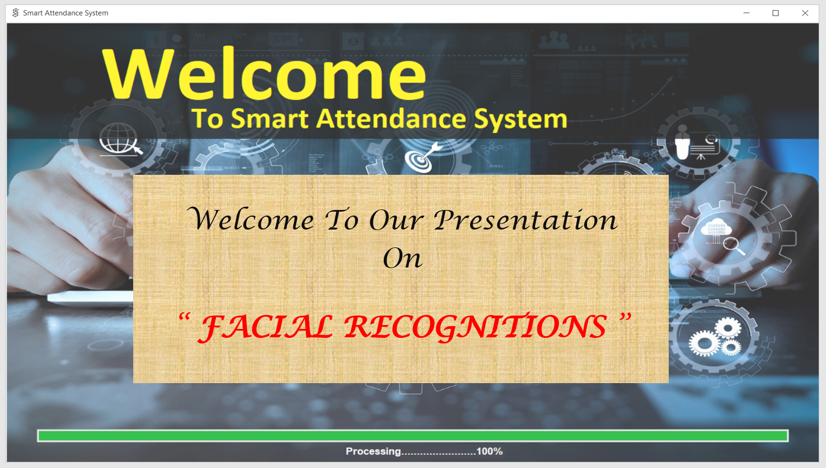

***TABLE OF CONTENTS***

|  |  |  |
| --- | --- | --- |
| **CHAPTER NO.** | **TITLE** | **PAGE NO** |
|  | **ABSTRACT** | **8** |
|  | **LIST OF FIGURES** | **9** |
| **1** | **INTRODUCTION** | **10** |
|  | 1.1 Objective | 10 |
| **2** | **SYSTEM ANALYSIS** | **11** |
|  | 2.1 Introduction | 11 |
|  | 2.2 Existing System  2.3 Proposed Sysem | 12  12 |
|  | 2.4 Feasibility Study | 12 |
|  | 2.4.1 Economical Feasibility | 13 |
|  | 2.4.2 Technical Feasibility | 13 |
|  | 2.4.3 Operational Feasibility | 13 |
| **3** | **SYSTEM SPECIFICATION** | **14** |
|  | 3.1 Hardware Specification | 14 |
|  | 3.2 Software Specification | 14 |
| **4** | **SOFTWARE DESCRIPTION** | **15** |
| **5** | **PROJECT DESCRIPTION** | **16** |
|  | 5.1 Problem Definition | 16 |
|  | 5.2 Overview of The Project | 16 |
|  | 5.3 Module Description | 16 |
|  | 5.3.1 Administrator Module | 17 |
|  | 5.3.2 Teachers Module | 18 |
|  | 5.4 System Flow Diagram | 19 |
|  | 5.5 Data Flow Diagram | 20 |
|  | 5.6 System Design | **22** |

|  |  |  |
| --- | --- | --- |
|  | 5.6.1 Use case Diagram | 16 |
|  | 5.6.2 Database Design | 23 |
|  | 5.6.3 Input Design | 27 |
|  | 5.6.4 Output Design | 27 |
| **6** | **SYSTEM TESTING** | **28** |
|  | 6.1 Introduction | **28** |
|  | 6.1.1 Steps | 28 |
|  | 6.2 Testing Methodologies | 28 |
|  | 6.2.1 Unit Testing | 29 |
|  | 6.2.2 SystemTesting | 29 |
|  | 6.2.4 Performance Testing | 29 |
|  | 6.3 Test Cases | 30 |
| **7** | **SYSTEM MAINTANANCE** | **34** |
| **8** | **CONCLUSION AND FUTURE**  **ENHANCEMENTS** | **35** |
|  | 8.1 Conclusion | 35 |
|  | 8.2 Scope For Future Development | 35 |
| **9** | **APPENDICES** | **36** |
|  | 9.1 Source code | 36 |
|  | 9.2 Screen Shots | 88 |
| **10** | **REFERENCES** | **108** |

***ABSTRACT***

**Smart attendance software** helps in maintaining the attendance of the student on the daily basis in the collages. It generates the attendance of the student on basis of presence in college. It is maintained on the daily basis of their attendance. The teachers, staffs will be provided with the separate username & password to keep the records of students. Report of the student’s attendance on monthly and semesterly basis is generated.

But our main motive is to promote facial recognitions.

***LIST OF FIGURES***

**Contents:- Page No.**

System Flow Diagram 20

Data Flow Diagram 21, 22

Use case Diagram 23

**1.1 OBJECTIVE:**

**CHAPTER 1**

***INTRODUCTION***

“Smart Attendance Software” is developed for maintaining the attendance of the student on the daily basis in the collages. Nowadays, In colleges there is a hassle about taking attendance of the students. Hence we dedicate this project to the colleges for solving this problems. Main concept behind Smart attendance software is to take the attendance of students in any college or university. Procedure for the attendance is to stand in front of the camera to have their attendance recorded, then the attendance of the respective person is noted down in the database. An accurate report based on the student attendance is generated here. This system will also help in evaluating attendance eligibility criteria of a student. Report of the student’s attendance on monthly and semesterly basis is generated. Also our aim is to solve the problems faced by the collages regarding attendance and overcome the difficulty of physical touch and make the circumstances intangible.

* 1. **INTRODUCTION**

**CHAPTER 2 *SYSTEM ANALYSIS***

Analysis can be defined as breaking up of any whole so as to find out their nature, function etc. It defines design as to make preliminary sketches of; to sketch a pattern or outline for plan. To plan and carry out especially by artistic arrangement or in a skillful wall. System analysis and design can be characterized as a set of techniques and processes, a community of interests, a culture and an intellectual orientation.

The various tasks in the system analysis include the following.

* + - Understanding application.
    - Planning.
    - Scheduling.
    - Developing candidate solution.
    - Performing trade studies.
    - Performing cost benefit analysis.
    - Recommending alternative solutions.
    - Selling of the system.
    - Supervising, installing and maintaining the system.

This system manages to the analysis of the report creation and develops automated entry of the student attendance. This project will helps to manage the attendance system for the college to calculate percentage and reports for eligibility criteria of examination asper monthly or semesterly attendance as well as it also help manage the record of teachers & students. The application attendance entry system will provide flexible report for all students.

**2.2 EXISTING SYSTEM**

The Existing system is a manual entry for the students. Here the attendance will be carried out in the hand written registers. It will be a tedious job to maintain the record for the user. The human effort is more here. The retrieval of the information is not as easy as the records are maintained in the hand written registers.

This application requires correct feed on input into the respective field. Suppose the wrong inputs are entered, the application resist to work. so the user find it difficult to use.

**2.3 PROPOSED SYSTEM:**

To overcome the drawbacks of the existing system, the proposed system has been evolved. This project aims to reduce the paper work and saving time to generate accurate results from the student’s attendance. The system provides with the best user interface.

The efficient reports can be generated by using this proposed system.

* + 1. **Advantages of Proposed System**
       - It is trouble-free to use.
       - It is a relatively fast approach to automated attendance
       - Is highly reliable, approximate result from user
       - Best user Interface
       - Efficient reports
  1. **FEASIBILITY STUDY:**

Feasibility analysis begins once the goals are defined. It starts by generating broad possible solutions, which are possible to give an indication of what the new system should look like. This is where creativity and imagination are used. Analysts must think up new ways of doing things- generate new ideas. There is no need to go into the detailed system operation yet. The solution should provide enough information to make reasonable estimates about project cost and give users an indication of how the new system will fit into the organization. It is important not to exert considerable effort at this stage only to find out that the project is not worthwhile or that there is a need significantly change the original goal.

Feasibility of a new system means ensuring that the new system, which we are going to implement, is efficient and affordable. There are various types of feasibility to be determined. They are,

* + 1. **Economically Feasibility:**

Development of this application is highly economically feasible. The only thing to be done is making an environment with an effective supervision.

It is cost effective in the sense that has eliminated the paper work completely. The system is also time effective because the calculations are automated which are made at the end of the month, semester or as per the user requirement.

* + 1. **Technical feasibility:**

The technical requirement for the system is economic and it need only one additional Hardware i.e. Camera. Technical evaluation must also assess whether the existing systems can be upgraded to use the new technology and whether the organization has the expertise to use it. This application can generate report to excel sheet.

* + 1. **Operational Feasibility:**

The system working is quite easy to use and learn due to its simple but attractive interface. User requires no special training for operating the system. Technical performance include issues such as determining whether the system can provide the right information for the Department personnel student details, and whether the system can be organized so that it always delivers this information at the right place and on time using intranet services. Acceptance revolves around the current system and its personnel.

**CHAPTER 3 *SYSTEM SPECIFICATION***

* 1. **HARDWARE REQUIREMENTS (Minimum Requirement)**
     + **Minimum RAM:-** 2GB
     + **Hard Disk:-** 128 GB
     + **Processor:-** Core 2 Duo E8400 or above
     + **Camera** – Any Camera
  2. **SOFTWARE REQUIREMENTS (Minimum Requirement)**
     + **Operating system :** Windows 10
     + **Front-Design:** Python
     + **Back-End Language :** SQL
     + **Back-End Connectivity:** MySQL

**CHAPTER 4 *SOFTWARE DESCRIPTION***

**SOFTWARE USED:-**

* **Microsoft Visual Studio Code** combines the simplicity of a source code editor with powerful developer tooling, like IntelliSense code completion and debugging.

First and foremost, it is an editor that gets out of your way. The delightfully frictionless edit-build-debug cycle means less time fiddling with your environment, and more time executing on your ideas. Available for macOS, Linux, and Windows.

* **XAMPP** is an acronym that stands for Cross-Platform, Apache, MySQL, PHP, and Perl, with the Ps standing for PHP and Perl, respectively. It’s an open-source web-solutions kit that provides Apache delivery for a variety of servers and command-line executables, as well as Apache api, MariaDB, PHP, and Perl modules.

**CHAPTER 5 *PROJECT DESCRIPTION***

* 1. **PROBLEM DEFINITION:**

This system developed will reduce the manual work and avoid redundant data. By maintaining the attendance manually, then efficient reports cannot be generated. The system can generate efficient monthly, consolidate report based on the attendance. As the attendances are maintained in registers it has been a tough task for admin and staff to maintain for long time. Instead the software can keep long and retrieve the information when needed.

* 1. **PROJECT OVERVIEW**

Smart Attendance Software basically has two main modules for proper functioning

* + - Admin module has the rights for creating any new entry of faculty and student details.
    - User has a rights of making daily attendance, generating report. Attendance report can be taken by given details of student details.
  1. **MODULE DESCRIPTION**

The system should be designed in such a way that only authorized people should be allowed to access some particular modules. The records should be modified by only administrators and no one else. The user should always be in control of the application and not the vice versa.

The user interface should be consistent so that the user can handle the application with ease and speed. The application should be visually, conceptually clear.

* + 1. **ADMINISTRATOR MODULE:**
       - **Student Details:**

This module deals with the allocation of registration no. and personal details for Students. It will generate of personal details of student and academic details of the students with the photos.

* + - * **Teachers Details:**
        + It helps to allot the personal details of the teachers.
        + It provides the facility to have a user name and password to the teachers .
      * **Attendance details:**
        + It will helps to see the attendance of a particular students asper filtered values.
        + It will helps to the get report of Monthly, Semesterly and consolidate of the attendance.
* **Report details:**

Report can be taken by monthly, semesterly and consolidate:

* Monthly report get all hour details of attendance starting date to ending date and display the status.
* Consolidate report get all student attendance details starting date to ending date status help for the eligibility criteria of the student to attend the examination.
  + 1. **TEACHERS MODULE:**
* **Attendance details:**
  + It assists the teacher to see attendance of the students asper required month.
* **Report details:**

1. Monthly report get all hour details of attendance starting date to ending date and display the status.
2. consolidate report get all student attendance details from starting date to ending date status help for the eligibility criteria of the student to attend the examination

# SYSTEM FLOW DIAGRAM:

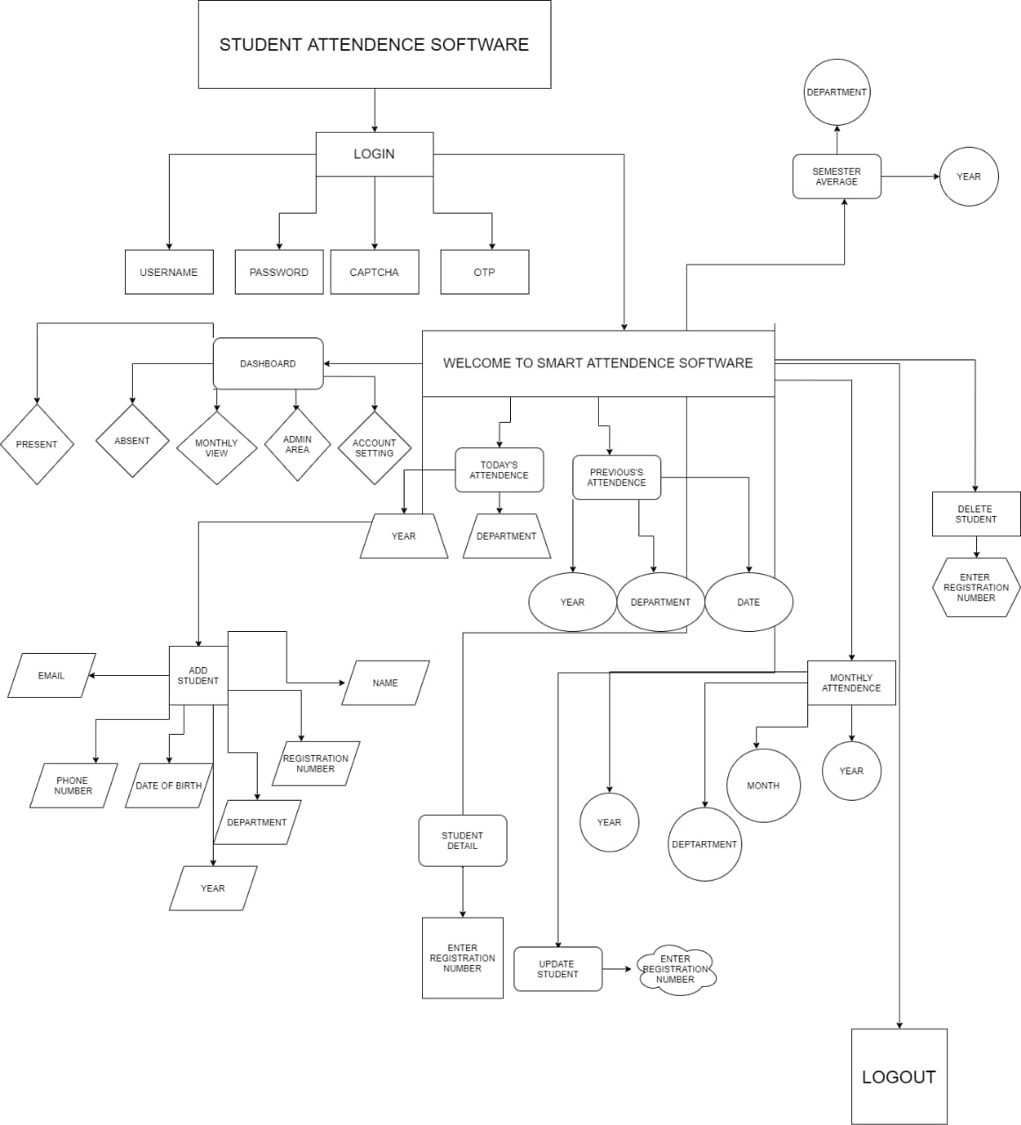

Figure 5.4-System Flow Diagram

# Data Flow Diagram

* + 1. **DFD level 0:**

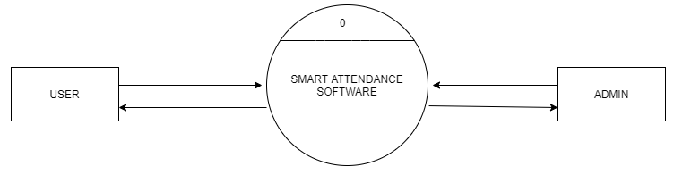

DATABASE

Figure 5.5.1-DataFlowDiagram Level1

* + 1. **DFD level 1:**

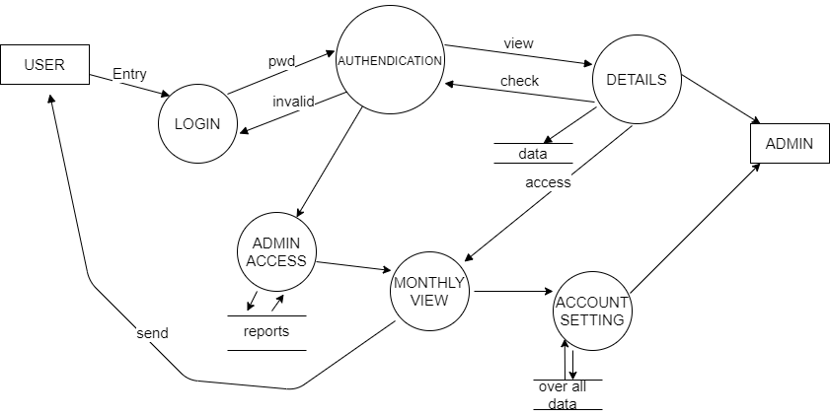

IN

Figure 5.5.2-DataFlowDiagram Level1

* + 1. **DFD level 2:**

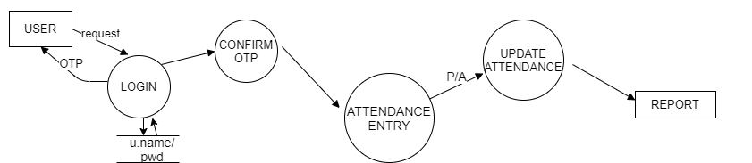

Figure 5.5.3.1-DataFlowDiagram Level2

# *SYSTEM DESIGN*

# *User Case Diagram*

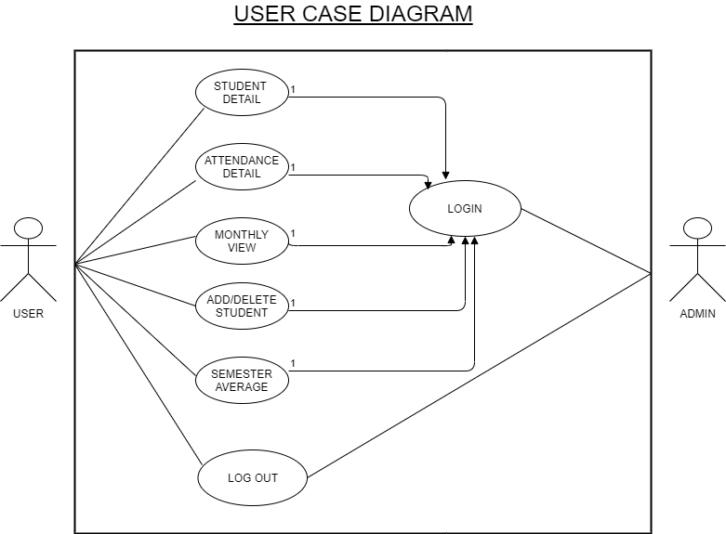

Figure:5.6.1 -Use case Diagram

* + 1. **Database Design:**

**Database Name:- stm**

**Tables:-**

* + - 1. **admin_credentials Table:**
         * To create a login details for the table.

|  |  |  |  |
| --- | --- | --- | --- |
| NAME | TYPE | NULL | DESCRIPTION |
| username | Text | NO | Stored login Id of  Admin |
| password | Text | NO | Stored Password |

**admin_credential_camera Table**

Table:5.7.2.1 -Admin Login Table

* + - * + To create username and password for the staff details.

|  |  |  |  |
| --- | --- | --- | --- |
| NAME | TYPE | NULL | DESCRIPTION |
| username | Text | NO | Stored login Id of  staff |
| password | Text | NO | Stored Password |

Table:5.7.2.2 – Staff Table

* + - 1. **attendance_details:**
         * To create table for Student Attendance details for our department.

|  |  |  |  |
| --- | --- | --- | --- |
| FIELDS | DATATYPE | NULL | DESCRIPTION |
| id | int(11) | Primarykey | id |
| registration_number | text | NotNull | Student Registration Number |
| attandance | text | NotNull | Students Attendance |
| date | text | NotNull | Date |

Table:5.7.2.3 –Students Attendance Table

* + - 1. **students_details table:**
         * To keep the records of the students.

|  |  |  |  |
| --- | --- | --- | --- |
| FIELDS | DATATYPE | NULL | DESCRIPTION |
| registration number | int(11) | Primary key | Registration Number |
| Name | text | Not Null | Students Name |
| department | text | Not Null | Students Department |
| year | text | Not Null | Students Year |
| dob | text | Not Null | Students Date of birth |
| contact | text | Not Null | Students Contact Number |
| email | text | Not Null | Students Email |
| Profile_pic | blob | Not Null | Students Photo |

Table:5.7.2.4 – Students Record Table

* + - 1. **Teacher_details table:**
         * To keep the record of the teachers .

|  |  |  |  |
| --- | --- | --- | --- |
| FIELDS | DATATYPE | NULL | DESCRIPTION |
| Teacher_id | text | NotNull | Registration Number |
| First_Name | text | NotNull | Teacher First Name |
| Last_Name | text | NotNull | Teachers Last Name |
| Department | text | NotNull | Teacher Department |
| Designation | text | NotNull | Teacher Designation |
| Email | text | NotNull | Teachers Email |
| Contact_Number | text | NotNull | Teacher Contact Number |
| Password | blob | NotNull | Teacher Login Password |

Table:5.7.2.5 -Attendance Table

**5.6.3 INPUT DESIGN**

Input design is part of overall system design that requires special attention designing input data is to make the data entered easy and free from **errors**. The input forms are designed using the controls available in .py Frame. Validation is made for each and every data that is entered.

Input design is the process of converting the user originated inputs to a computer based format. A system user interacting through a workstation must be able to tell the system whether to accept the input to produce reports. The collection of input data is considered to be most expensive part of the system design. Since the input has to be planned in such a manner so as to get relevant information, extreme care is taken to obtain pertinent information.

**5.6.4 OUTPUT DESIGN**

Output design this application “**Smart Attendance Software”** generally refers to the results and information that are generated by the system for many end-users. The output is designed in such a way that it is attractive, convenient and informative.

As the outputs are the most important sources of information to the users, better design should improve the system’s relationships with us and also will help in decision making. One of the most important factors of the system is the output it produces. This system refers to the results and information generated. Basically the output from a computer system is used to communicate the result of processing to the user.

Smart Attendance Software to show the report of students attendance according to month or semester wise. Taken as a whole report obtain on a teachers privileges only. This software will generate report in Excel format . If you want change any modification on existing values you can modify it

**CHAPTER 6 *SYSTEM TESTING***

* 1. **Introduction**

Once source code has been generated, software must be tested to uncover (and correct) as many errors as possible before delivery to customer. Our goal is to design a series of test cases that have a high likelihood of finding errors. To uncover the errors software techniques are used. These techniques provide systematic guidance for designing test that

* + 1. Exercise the internal logic of software components, and
    2. Exercise the input and output domains of the program to uncover errors In program function, behavior and performance.
    3. **Steps:** Software is tested from two different perspectives:
       1. Internal program logic is exercised using ―White box‖ test case design Techniques.
       2. Software requirements are exercised using ―block box‖ test case Design techniques.

In both cases, the intent is to find the maximum number of errors with the Minimum amount of effort and time.

* 1. **Testing Methodologies:**

A strategy for software testing must accommodate low-level tests that are necessary to verify that a small source code segment has been correctly implemented as well as high-level tests that validate major system functions against customer requirements. A strategy must provide guidance for the practitioner and a set of milestones for the manager. Because the steps of the test strategy occur at a time when deadline pressure begins to rise, progress must be measurable and problems must surface as early as possible. Following testing techniques are well known and the same strategy is adopted during this project testing.

* + 1. **Unit testing:**

Unit testing focuses verification effort on the smallest unit of software design- the software component or module. The unit test is white-box oriented. The unit testing implemented in every module of student attendance management System, by giving correct manual input to the system ,the data’s are stored in database and retrieved. If you want required module to access input or get the output from the End user, any error will accrued the time will provide handler to show what type of error will accrued .

* + 1. **System testing**:

System testing is actually a series of different tests whose primary purpose is to fully exercise the computer-based system. Below we have described the two types of testing which have been taken for this project, it is to check all modules worked on input basis .If you want change any values or inputs will change all information. so specified input is must.

**6.2.4 Performance Testing**

Performance testing is designed to test the run-time performance of software within the context of an integrated system. Performance testing occurs throughout all steps in the testing process. Even at the unit level, the performance of an individual module may be assessed as white-box tests are conducted.

This project reduce attendance table, codes. It will generate report fast.

* 1. **Test cases**

Test case is an object for execution for other modules in the architecture does not represent any interaction by itself. A test case is a set of sequential steps to execute a test operating on a set of predefined inputs to produce certain expected outputs. There are two types of test cases:-*manual* and *automated.* A manual test case is executed manually while an automated test case is executed using automation.

In system testing, test data should cover the possible values of each parameter based on the requirements. Since testing every value is impractical, a few values should be chosen from each equivalence class. An equivalence class is a set of values that should all be treated the same.

Ideally, test cases that check error conditions are written separately from the functional test cases and should have steps to verify the error messages and logs. Realistically, if functional test cases are not yet written, it is ok for testers to check for error conditions when performing normal functional test cases. It should be clear which test data, if any is expected to trigger errors.

**TEST CASE:**

* + 1. **Agent and admin login form**

|  |  |  |  |  |  |  |  |
| --- | --- | --- | --- | --- | --- | --- | --- |
| Sl  No | Test case id | Test case name | Test case desc | Step | Expected result | Actual Result | Test case status  pass/fail |
| 1 | Login admin | Validate login | To verify that login name on login page | Enter the login name and password and click login button | Login successful or an error message “invalid username or password”  must be displayed | Login successful | Pass |
| 2 | Login Teacher | Validate login | To verify that login name on login page | Enter the login name and password and click submit button | Login successful or an error message “invalid username or password” must be  displayed | Login successful | Pass |
| 3 | Password | Validate password | To verify that password on login page | Enter password and login name click  submit button | An error message “invalid username or password” must be displayed | An error message “invalid username or password” must be displayed | fail |

* + 1. **MASTER form**

|  |  |  |  |  |  |  |  |
| --- | --- | --- | --- | --- | --- | --- | --- |
| Sl.no | Test case id | Test  Case name | Test case desc | Step | Expected result | Actual Result | Test case status  pass/fail |
| 1 | Create student details | Validate allocation form | To allocate separate registration no for the  students | Nothing entered and click submit button | An error message will generate “all fields are required” | Inserted successfully | Pass |
| 2 | Create teacher details | Validate allocation form | To allocate separate username password for the  teacher | Nothing entered and click submit button | An error message will generate “all fields are required” | Inserted successfully | Pass |
| 3 | View  Attendance | Check details of students attendance | To verify that data stored on  database | Nothing entered and click search button | An error message will generate “enter required values in the fields” | Inserted successfully | Pass |
| 4 | View Students Details | Check details of all students | To verify that data stored on database | Nothing entered and click search button | An error message will generate “Please Enter The Fields To Proceed” | An error message return null will be  displayed | Pass |

* + 1. **Report form**

|  |  |  |  |  |  |  |  |
| --- | --- | --- | --- | --- | --- | --- | --- |
| Sl.  no | Test case id | Test case name | Test case desc | Step | Expected result | **Actual Resul**t | Test case status  pass/fail |
| 1 | Monthly or Semesterly report | Validate class attendance form | To select that source and destination | Nothing entered and click submit  button | An error message on not selected | Retrieved data successfully | Pass |

**CHAPTER 7**

***SYSTEM MAINTENANCE***

Software maintenance is far more than finding mistakes. Provision must be made for environment changes, which may affect either the computer, or other parts of the computer based systems. Such activity is normally called maintenance. It includes both the improvement of the system functions and the corrections of faults, which arise during the operation of a new system.

It may involve the continuing involvement of a large proportion of computer department recourses. The main task may be to adapt existing systems in a changing environment.

Back up for the entire database files are taken and stored in storage devices like flash drives, pen drives and disks so that it is possible to restore the system at the earliest. If there is a breakdown or collapse, then the system gives provision to restore database files. Storing data in a separate secondary device leads to an effective and efficient maintains of the system. The nominated person has sufficient knowledge of the organization’s computer passed based system to be able to judge the relevance of each proposed change.

**CHAPTER 8**

***CONCLUSION AND FUTURE ENHANCEMENT***

* 1. **Conclusion**

To conclude, Project Data Grid works like a component which can access all the databases and picks up different functions. It overcomes the many limitations incorporated in the attendance.

* + - Easy implementation Environment
    - Generate report Flexibly
  1. **Scope for future development**

The project has a very vast scope in future. The project can be implemented on intranet in future. Project can be updated in near future as and when requirement for the same arises, as it is very flexible in terms of expansion. With the proposed software of database Space Manager ready and fully functional the client is now able to manage and hence run the entire work in a much better, accurate and error free manner. The following are the future scope for the project.

* In further work, we intend to improve face detection effectiveness by using

the interaction among our system, the students and the teacher.

* Currently, the system has reached the accuracy level up to 80% for partial and dense images. It can

further be improved to obtain higher accuracy levels.

* Further, two or more IP cameras can be employed and each image can be processed separately. The

results of these can be merged to obtain better results and accuracy in denser area.

* For now the software is divided in two parts but in near future we will attach them to make it One.

|  |
| --- |
| **CHAPTER 9**  ***APPENDICES*** |
| **9.1 Source code:-** |

***First Page:-***

import tkinter as tk

from tkinter import*

from PIL import ImageTk

from tkinter.ttk import*

import time

import Login

class start_software:

    #Defining main() function

    def main():

        global fp_root

        fp_root=Tk()

        fp_root.title("Smart Attendance System")

        fp_root.geometry("1300x750+100+25")

        fp_root.iconbitmap("images\\software_icon.ico")

        bg=PhotoImage(file="images/log.png")

        bg_image=Label(fp_root,image=bg).place(x=0,y=0,relwidth=1,relheight=1)

        start_software.bar()

        fp_root.mainloop()

    #Define bar() function is used for loading bar and loading percentage

    def bar():

        load = Progressbar(fp_root,orient= HORIZONTAL,length=1200,mode='determinate')

        load.place(x=50,y=690)

        for i in range(0,11):

            lbl=tk.Label(fp_root,text=f"Processing........................{10*i}%",font="Arial 13 bold",bg='#20242F',fg="white").place(x=540,y=715)

            load['value']=10*i

            fp_root.update_idletasks()

            time.sleep(0.2)

        fp_root.destroy()

        Login.login_main()

start_software.main()

***Login Page:-***

# Import Module

from tkinter import*

from PIL import ImageTk

from tkinter import messagebox

from validate_email import validate_email

import admin_user_verification

import Dashboard

import set_user_credentials

import add_user

from connection import *

import random

import smtplib

from email.message import EmailMessage

from captcha.image import ImageCaptcha

# A class with init method

class login:

    # init method or constructor

    def __init__(self,root):

        self.root=root

        self.root.title("Login")

        self.root.geometry("1300x750+100+25")

        self.root.iconbitmap("images\\software_icon.ico")

        self.root.resizable(False,False)

        self.showPassword=PhotoImage(file="images/showPwd.png")

        self.hidePassword=PhotoImage(file="images/hidePwd.png")

        self.username_var = StringVar()

        self.pwd_var = StringVar()

        self.bg=ImageTk.PhotoImage(file="images/log_in_img.jpg")

        self.bg_image=Label(self.root,image=self.bg).place(x=0,y=0,relwidth=1,relheight=1)

        self.signup_frame()

        self.login_frame()

    #Teacher's login frame

    def login_frame(self):

        # Set Geometry

        Frame_signup=Frame(self.root,bg="white")

        Frame_signup.place(x=575,y=150,height=450,width=550)

        # Frame title and geometry

        title1=Label(Frame_signup,text="Log In Here",font=("Candara Light",35,"bold","underline"),fg="black",bg="white").place(x=170,y=10)

        description1=Label(Frame_signup,text="Teacher Login Area",font=("calibri",15,"bold"),fg="#a42d5c",bg="white").place(x=200,y=70)

        # Input field for Email Id

        lal_user=Label(Frame_signup,text="Email:",font=("Goudy old style",15,"bold"),fg="grey",bg="white").place(x=50,y=125)

        self.txt_user=Entry(Frame_signup,textvariable=self.username_var,font=("calibri",15),bg="lightgray")

        self.txt_user.place(x=50,y=155,width=450,height=35)

        # Input field for password

        lal_pwd=Label(Frame_signup,text="Password:",font=("Goudy old style",15,"bold"),fg="grey",bg="white").place(x=50,y=215)

        self.txt_pwd=Entry(Frame_signup,textvariable=self.pwd_var,font=("calibri",15),bg="lightgray")

        self.txt_pwd.place(x=50,y=245,width=450,height=35)

        self.txt_pwd.default_show_val = self.txt_pwd['show']

        self.txt_pwd['show'] = "*"

        # Button's

        show1_password = Button(self.txt_pwd,command=self.show_password,image=self.hidePassword,bd=0,bg="lightgray",activebackground="lightgray",cursor="hand2").place(x=415,y=5)

        forget_btn=Button(Frame_signup,text='Forget Password?',font='Arial 10 bold',fg='#a42d5c',bg='white',bd=0,cursor='hand2',command = self.go_to_forgot_password).place(x=380,y=285)

        login_btn=Button(Frame_signup,command=self.login,bd=0,cursor="hand2",text="Log In",fg="white",bg="#a42d5c",font=("times new roman",20)).place(x=50,y=350,width=450,height=50)

        # Frame title and geometry

        title1=Label(Frame_forgot_password,text="Forgot Password",font=("Candara Light",35,"bold","underline"),fg="black",bg="white").place(x=75,y=10)

        # Input field for Email Id

        emaild=Label(Frame_forgot_password,text="Enter Email:",font=("Goudy old style",15,"bold"),fg="grey",bg="white").place(x=50,y=100)

        self.emailid_forgot=Entry(Frame_forgot_password,font=("calibri",15),bg="lightgray")

        self.emailid_forgot.place(x=50,y=130,width=450,height=35)

        # Send Otp button

        send_btn=Button(Frame_forgot_password,command=self.forget_password_check,bd=0,cursor="hand2",text="Send Otp To Your Email Address",fg="white",bg="#a42d5c",font=("times new roman",15)).place(x=50,y=200,width=450,height=50)

        # Input field for Otp

        lal_otp=Label(Frame_forgot_password,text="Enter OTP",font=("Goudy old style",15,"bold"),fg="grey",bg="white").place(x=50,y=265)

        self.txt_otp_forgot_pwd=Entry(Frame_forgot_password,font=("calibri",15),bg="lightgray")

        self.txt_otp_forgot_pwd.place(x=50,y=295,width=450,height=35)

        # Otp verification button

        Verify_btn=Button(Frame_forgot_password,command=self.forgot_otp_check,bd=0,cursor="hand2",text="Verify OTP",fg="white",bg="#a42d5c",font=("times new roman",20)).place(x=50,y=350,width=450,height=50)

    # Define forgot_otp_check function is used for checking correct Otp

    def forgot_otp_check(self):

        if str(self.txt_otp_forgot_pwd.get())==str(self.otp):

            self.frame_password_update()

        else:

            messagebox.showerror("Error","Enter Valid Otp")

    # Function for input field's for update password

    def frame_password_update(self):

        Frame_password_update=Frame(self.root,bg="white")

        Frame_password_update.place(x=575,y=150,height=450,width=550)

        title1=Label(Frame_password_update,text="New Password Area",font=("Candara Light",35,"bold","underline"),fg="black",bg="white").place(x=65,y=10)

        # Update new password feild's

        lal_user=Label(Frame_password_update,text="New Password:",font=("Goudy old style",15,"bold"),fg="grey",bg="white").place(x=50,y=125)

        self.new_password=Entry(Frame_password_update,font=("calibri",15),bg="lightgray")

        self.new_password.place(x=50,y=155,width=450,height=35)

        lal_pwd=Label(Frame_password_update,text="Confirm Password:",font=("Goudy old style",15,"bold"),fg="grey",bg="white").place(x=50,y=215)

        self.confirm_password=Entry(Frame_password_update,font=("calibri",15),bg="lightgray")

        self.confirm_password.place(x=50,y=245,width=450,height=35)

        login_btn=Button(Frame_password_update,command=self.update_forget_password,bd=0,cursor="hand2",text="Change Password",fg="white",bg="#a42d5c",font=("times new roman",20)).place(x=50,y=325,width=450,height=50)

    # Function for checking if email address is valid or not

    def forget_password_check(self):

        cur=connection()

        cur.execute("Select * from teacher_details where Email =%s",(self.emailid.get()))

        rows=cur.fetchone()

        if rows!=None:

            self.otp_forgot = random.randrange(100000,1000000)

            self.forgot_otp_email()

        else:

            messagebox.showerror("Error","Enter Valid Email id")

    # Function for sending Otp to email

    def forgot_otp_email(self):

        subject =f"Smart Attendance Software Account {self.otp_forgot} is your verification code for secure access"

        # Message to be sent to email

        message=f"Hi,\nGreetings!\nYou are just a step away from accessing your Smart Attendance Software account \nWe are sharing a verification code to access your account.\nOnce you have verified the code, you'll be prompted to set a new password immediately. This is to ensure that only you have access to your account. \n\nYour OTP: {self.otp_forgot} \n\nBest Regards,\nTeam Smart Attendance Software"

        # Send email through SMTP server

        server = smtplib.SMTP('smtp.gmail.com', 587)

        server.starttls()

        server.login('smartattendanceteam.official@gmail.com', 'smartattendance@team')

        email = EmailMessage()

        email['From'] = 'smartattendanceteam.official@gmail.com'

        email['Subject'] = subject

        email.content(message)

        server.send_message(email)

        messagebox.showinfo("OTP","OTP successfully send")

    def forget_password(self):

        Frame_forgot_password=Frame(self.root,bg="white")

        Frame_forgot_password.place(x=575,y=150,height=450,width=550)

        title1=Label(Frame_forgot_password,text="Find Your Account",font=("Candara Light",35,"bold","underline"),fg="black",bg="white").place(x=80,y=10)

        description1=Label(Frame_forgot_password,text="Please enter your valid details to find your account.",font=("calibri",14,"bold"),fg="#a42d5c",bg="white").place(x=70,y=70)

        lal_email=Label(Frame_forgot_password,text="Enter Your Email:",font=("Goudy old style",15,"bold"),fg="grey",bg="white").place(x=50,y=125)

        self.txt_email=Entry(Frame_forgot_password,textvariable=self.username_var,font=("calibri",15),bg="lightgray")

        self.txt_email.place(x=50,y=155,width=450,height=35)

        lal_pwd=Label(Frame_forgot_password,text="Password:",font=("Goudy old style",15,"bold"),fg="grey",bg="white").place(x=50,y=215)

        self.txt_pwd=Entry(Frame_forgot_password,textvariable=self.pwd_var,font=("calibri",15),bg="lightgray")

        self.txt_pwd.place(x=50,y=245,width=450,height=35)

    # Function for Show & Hide Password

    def show_password(self):

        if self.txt_pwd['show']=="*":

            self.txt_pwd['show'] = ""

            show1_password = Button(self.txt_pwd,command=self.show_password,image=self.showPassword,bd=0,bg="lightgray",activebackground="lightgray",cursor="hand2").place(x=415,y=5)

        else:

            self.txt_pwd['show'] = "*"

            hide_password = Button(self.txt_pwd,command=self.show_password,image=self.hidePassword,bd=0,bg="lightgray",activebackground="lightgray",cursor="hand2").place(x=415,y=5)

    # Function for verification of teacher's

    def login_frame2(self):

        self.captcha_generator()

        set_user_credentials.set_username = self.email

        set_user_credentials.set_password = self.password

        Frame_signup2=Frame(self.root,bg="white")

        Frame_signup2.place(x=575,y=150,height=450,width=550)

        self.outPng = PhotoImage(file="out.png")

        Label(Frame_signup2,image=self.outPng).place(x=50,y=115,height=60,width=200)

        # Recaptcha Generate Button

        resend_btn=Button(Frame_signup2,command=self.login_frame2,bd=0,cursor="hand2",text="↻",fg="white",bg="#a42d5c",font=("times new roman",20)).place(x=260,y=130,width=30,height=30)

        self.txt_captcha=Entry(Frame_signup2,font=("calibri",24),bg="lightgray")

        self.txt_captcha.place(x=300,y=115,width=200,height=60)

        title2=Label(Frame_signup2,text="Verify Here",font=("Candara Light",35,"bold","underline"),fg="black",bg="white").place(x=170,y=10)

        description2=Label(Frame_signup2,text="Verification Area",font=("calibri",15,"bold"),fg="#a42d5c",bg="white").place(x=200,y=70)

        # Button for Check Captcha send Otp to email address

        send_btn=Button(Frame_signup2,command=self.check_captcha,bd=0,cursor="hand2",text="Verify Captcha and Send OTP",fg="white",bg="#a42d5c",font=("times new roman",15)).place(x=50,y=200,width=450,height=50)

        lal_otp=Label(Frame_signup2,text="Enter OTP",font=("Goudy old style",15,"bold"),fg="grey",bg="white").place(x=50,y=265)

        self.txt_otp=Entry(Frame_signup2,font=("calibri",15),bg="lightgray")

        self.txt_otp.place(x=50,y=295,width=450,height=35)

        Verify_btn=Button(Frame_signup2,command=self.checkotp,bd=0,cursor="hand2",text="Verify OTP",fg="white",bg="#a42d5c",font=("times new roman",20)).place(x=50,y=350,width=450,height=50)

    # Send email after checking captcha

    def send_email(self):

        subject =f"Smart Attendance Software Account {self.otp} is your verification code for secure access"

        message=f"Hi,\nGreetings!\nYou are just a step away from accessing your Smart Attendance Software account\n\nYour OTP: {self.otp} \n\nBest Regards,\nTeam Smart Attendance Software"

        server = smtplib.SMTP('smtp.gmail.com', 587)

        server.starttls()

        server.login('smartattendanceteam.official@gmail.com', 'smartattendance@team')

        email = EmailMessage()

        email['From'] = 'smartattendanceteam.official@gmail.com'

        email['To'] = str(self.email)

        email['Subject'] = subject

        email.set_content(message)

        server.send_message(email)

        messagebox.showinfo("OTP","OTP successfully send")

    # After Verification of Otp redirecting to Dashboard page

    def checkotp(self):

        otp_verify=str(self.txt_otp.get())

        if otp_verify==otp:

            messagebox.showinfo("Success","Log In")

            self.root.destroy()

            Dashboard.Dashboard_Main()

        else:

            messagebox.showerror("Incorrect","Enter valid Data")

    # Function for get into adding new user

    def signup_frame(self):

        Frame_login=Frame(self.root,bg="#a42d5c")

        Frame_login.place(x=175,y=150,height=450,width=450)

        title2=Label(Frame_login,text="Welcome",font=("Candara Light",50),fg="white",bg="#a42d5c").place(x=70,y=110)

        description2=Label(Frame_login,text="Attend today and achieve tomorrow",font=("calibri",15,"bold"),fg="white",bg="#a42d5c").place(x=45,y=190)

        signup_btn=Button(Frame_login,cursor="hand2",text="Add User",bd=0,bg="white",fg="black",font=("times new roman",20),command=self.add_user).place(x=75 ,width=250,height=50)

    # Verification box for admin

    def add_user(self):

        if admin_user_verification.btn_state_verification_box==0:

            admin_user_verification.verification_admin_main(self.root.title())

# Verify admin box

def admin_verified():

    cur = connection()

    cur.execute("select * from admin_credentials where username= %s and password= %s",(admin_user_verification.admin_user.get(),admin_user_verification.admin_pwd.get()))

    row= cur.fetchone()

    admin_name=admin_user_verification.admin_user.get()

    admin_pwd=admin_user_verification.admin_pwd.get()

    if admin_name=="" or admin_pwd=="":

        messagebox.showwarning("Warning","All feilds are required",parent= admin_user_verification.vbox_root)

    elif row != None:

        admin_user_verification.cancel_clicked()

        root_Login.destroy()

        add_user.add_user_main()

    else:

        messagebox.showerror("Error","Wrong input",parent= admin_user_verification.vbox_root)

def login_main():

    global root_Login

    root_Login=Tk()

    admin_user_verification.btn_state_verification_box=0

    obj=login(root_Login)

    root_Login.mainloop()

***Add User:-***

# import module

from tkinter import*

from PIL import ImageTk

from tkinter import messagebox

import csv

from validate_email import validate_email

import Login

from connection import *

class Add_User:

    def __init__(self,add_user_root):

        self.window=add_user_root

        self.window.geometry("1300x750+100+25")

        self.window.title("Add User")

        self.window.iconbitmap("images\\software_icon.ico")

        self.window.resizable(0,0)

        # self.window.configure.lineargradient('#FEAC5E','#C779D0','#4BC0C8')

        self.fname_var = StringVar()

        self.lname_var = StringVar()

        self.department_var = StringVar()

        self.post_var = StringVar()

        self.email_var = StringVar()

        self.phn_no_var= StringVar()

        self.password_var = StringVar()

        backimg=ImageTk.PhotoImage(file="images/rgbg.jpg")

        back_img=Label(self.window,image=backimg).place(x=0,y=0,relwidth=1,relheight=1)

        f1img=ImageTk.PhotoImage(file="images/rg.jpg")

        f1_img=Label(self.window,image=f1img).place(x=250,y=50,height=650,width=300)

        lal1=Label(self.window,text='Get Started',font='Arial 20 bold',bg='#145860',fg='white').place(x=325,y=640)

        frame1=Frame(self.window,bg='white').place(x=550,y=50,height=650,width=500)

        btn1=Button(self.window,text='Log In',font='Arial 10 bold',bg='blue',fg='white',bd=0,cursor='hand2',command=self.returnWindow).place(x=950,y=75)

        lbl2=Label(self.window,text='Register',font='Arial 20 bold',bg='white').place(x=600,y=130)

        # Entry box's

        lbl3=Label(self.window,text='First Name',font='Arial 10 bold',bg='white').place(x=600,y=200)

        lbl4=Label(self.window,text='Last Name',font='Arial 10 bold',bg='white',bd=0).place(x=830,y=200)

        self.f_name=Entry(self.window,textvariable=self.fname_var,font="Arial 12",bg='lightgray')

        self.f_name.place(x=600,y=230,height=30,width=180)

        self.l_name=Entry(self.window,textvariable=self.lname_var,font="Arial 12",bg='lightgray')

        self.l_name.place(x=830,y=230,height=30,width=180)

        lbl5=Label(self.window,text='Department',font='Arial 10 bold',bg='white').place(x=600,y=280)

        lbl6=Label(self.window,text='Designation',font='Arial 10 bold',bg='white',bd=0).place(x=830,y=280)

        self.department=Entry(self.window,textvariable=self.department_var,font="Arial 12",bg='lightgray')

        self.department.place(x=600,y=310,height=30,width=180)

        self.post=Entry(self.window,textvariable=self.post_var,font="Arial 12",bg='lightgray')

        self.post.place(x=830,y=310,height=30,width=180)

        lbl7=Label(self.window,text='Email Id ',font='Arial 10 bold',bg='white',bd=0).place(x=600,y=360)

        lbl10=Label(self.window,text='Contact No. ',font='Arial 10 bold',bg='white',bd=0).place(x=830,y=360)

        self.email=Entry(self.window,textvariable=self.email_var,font="Arial 12",bg='lightgray')

        self.email.place(x=600,y=390,height=30,width=180)

        self.phn_no=Entry(self.window,textvariable=self.phn_no_var,font="Arial 12",bg='lightgray')

        self.phn_no.place(x=830,y=390,height=30,width=180)

        lbl8=Label(self.window,text='Password',font='Arial 10 bold',bg='white').place(x=600,y=440)

        lbl9=Label(self.window,text='Confirm Password',font='Arial 10 bold',bg='white',bd=0).place(x=830,y=440)

        self.password=Entry(self.window,textvariable=self.password_var,font="Arial 12",bg='lightgray',show="*")

        self.password.place(x=600,y=470,height=30,width=180)

        self.c_password=Entry(self.window,font="Arial 12",bg='lightgray',show="*")

        self.c_password.place(x=830,y=470,height=30,width=180)

        btn2=Button(self.window,text='Sign Up',font='Arial 15 bold',bg='blue',fg='white',bd=0,cursor='hand2',command=self.register_data).place(x=600,y=540,height=50,width=410)

        lbl10=Label(self.window,text='Already a Member?',font='Arial 10 bold',bg='white').place(x=600,y=610)

        btn3=Button(self.window,text='Log In',font='Arial 10 bold underline',fg='blue',bg='white',bd=0,cursor='hand2',command=self.returnWindow).place(x=965,y=610)

        self.window.mainloop()

    # Check email address is correct or not

    def email_validate(self):

        return(a)

    # Checking all entry fields and inserting data in database

    def register_data(self):

        email_validate_check=self.email_validate()

        if self.f_name.get()=="" or self.l_name.get()=="" or self.department.get()=="" or self.post.get()=="" or self.email.get()=="" or self.password.get()=="" or self.c_password.get()=="":

            messagebox.showerror("Error","All fields are required")

        elif email_validate_check!=1:

            messagebox.showerror("Error","Email doesnot exists")

        elif len(self.password.get()) < 8 or len(self.password.get()) > 16:

            messagebox.showerror("Error","The Password Should Be Between 8 to 16 characters")

        else:

            try:

                try:

                    import random

                    self.teacher_id_var=None

                    if self.department.get()=="Computer Science And Technology":

                        self.teacher_id_var=f"CSTAIEMP{t_code}"

                    elif self.department.get()=="Mechanical Engineering":

                        self.teacher_id_var=f"MEAIEMP{t_code}"

                    elif self.department.get()=="Electrical Engineering":

                        self.teacher_id_var=f"EEAIEMP{t_code}"

                    elif self.department.get()=="Civil Engineering":

                        self.teacher_id_var=f"CEAIEMP{t_code}"

                    elif self.department.get()=="Admin":

                        self.teacher_id_var=f"ADAIEMP{t_code}"

                    if self.teacher_id_var!= None:

                        con= givi_me_connection()

                        cur=con.cursor()

                        cur.execute("select * from teacher_details where Email=%s",self.email.get())

                        row = cur.fetchone()

                        if row!= None:

                            messagebox.showerror("Error","User Already Registered")

                    else:

                        messagebox.showerror("Error","Please Enter Correct Department ")

                except:

                    messagebox.showerror("Error","Please Enter Correct Department ")

            except Exception as e:

                messagebox.showerror("Error","Some Error Occured \nPlease Try Again After Sometime")

                print(e)

    # If login failed return to login page

    def returnWindow(self):

        self.window.destroy()

        Login.login_main()

def add_user_main():

    global add_user_root

    add_user_root=Tk()

    obj=Add_User(add_user_root)

    add_user_root.mainloop()

***Dashboard:-***

# import module

from tkinter import *

import Common_Requirements_File

from PIL import ImageTk

from tkinter import messagebox

import time as tm

import admin_user_verification

import account_settings_verification

import Admin_Area_File

import set_user_credentials

import current_attendance

import monthly_view

from connection import*

inital=[0,0,0,0]

import datetime

# A class with init method

class Dashboard:

    # init method or constructor

    def __init__(self,root_dashboard):

        self.root_dashboard=root_dashboard

        self.root_dashboard.title("Dashboard")

        self.presentIcon=PhotoImage(file="images/present.png")

        self.absentIcon=PhotoImage(file="images/absent.png")

        self.month_attendanceIcon=PhotoImage(file="images/monthly_attendance.png")

        self.admin_userIcon=PhotoImage(file="images/admin_user_icon.png")

        self.settingsIcon=PhotoImage(file="images/settings.png")

        self.handIcon=PhotoImage(file="images/hand.png")

        self.first_row()

        self.second_row()

        # import navbar & sidebar

        p_obj=Common_Requirements_File.Common_Requirements(self.root_dashboard)

        p_obj.header()

        p_obj.left_nav_bar_setting()

        p_obj.right_nav_bar_setting()

    # def click_event(Self,event):

    #     Common_Requirements_File.

    # Present, Absent & Monthly view card view

    def first_row(self):

        x=105

        self.options = {

            self.presentIcon : ["Present","_________________________________________________________________",self.goToCurrentPresent],

            self.absentIcon : ["Absent","_________________________________________________________________",self.goToCurrentAbsent],

            self.month_attendanceIcon : ["Monthly View ","_________________________________________________________________",self.goToMonthlyView],

        }

        for i in self.options:

            shadow_frame = Frame(self.root_dashboard,bg="gray").place(x=(x+4),y=154,height=180,width=360)

            t_present = Frame(self.root_dashboard,bg='white')

            t_present.place(x=x,y=150,height=180,width=360)

            t_present_icon=Label(self.root_dashboard,image=i,relief="solid",bd=1).place(x=(x+20),y=115)

            t_present_lbl = Label(t_present,text=f"{self.options[i][0]}",font="Arial 15",bg="white",fg="#A8A8A8",anchor="e").place(x=210,y=10,width=130)

            t_present_line = Label(t_present,text=f"{self.options[i][1]}",bg="white",fg="#A8A8A8").place(x=20,y=100,width=320)

            t_present_view = Button(self.root_dashboard,text="Show All",image=self.handIcon,compound=LEFT,font="Arial 10 underline",bg="white",fg="blue",bd=0,activebackground='white',activeforeground='green',cursor='hand2',command=self.options[i][2]).place(x=(x+20),y=280)

            x+=465

    # Directing to present,absent & monthly_view pages

    def goToCurrentPresent(self):

        self.root_dashboard.destroy()

        current_attendance.Current_Attendance_Main("Present")

    def goToCurrentAbsent(self):

        self.root_dashboard.destroy()

        current_attendance.Current_Attendance_Main("Absent")

    def goToMonthlyView(self):

        self.root_dashboard.destroy()

        monthly_view.current_monthly_view_main()

    # Admin area & Account Settings card view

    def second_row(self):

        x=829

        self.options_second_row = {

            self.admin_userIcon : ["Admin Area","___________________________________________________________________________",self.add_user],

            self.settingsIcon : ["Account Settings","___________________________________________________________________________",self.account_settings]

        }

        for i in self.options_second_row:

            shadow_frame = Frame(self.root_dashboard,bg="gray").place(x=(x+5),y=425,height=250,width=420)

            t_update = Frame(self.root_dashboard,bg='white')

            t_update.place(x=x,y=420,height=250,width=420)

            t_present_icon=Label(self.root_dashboard,image=i,relief="solid",bd=1).place(x=(x+75),y=380)

            t_present_lbl = Label(t_update,text=f"{self.options_second_row[i][0]}",font="Arial 15",bg="white",fg="#A8A8A8").place(x=20,y=139)

            t_present_line = Label(t_update,text=f"{self.options_second_row[i][1]}",bg="white",fg="#A8A8A8").place(x=20,y=177)

            t_settings_view = Button(self.root_dashboard,text="Click Here",image=self.handIcon,compound=LEFT,font="Arial 10 underline",bg="white",fg="blue",bd=23,activebackground='white',activeforeground='green',cursor='hand2',command=self.options_second_row[i][2]).place(x=(x+90),y=820)

            x+=640

    # Admin verfication for add new user's

    def add_user(self):

        if admin_user_verification.btn_state_verification_box==0:

            admin_user_verification.verification_admin_main(self.root_dashboard.title())

    # Loginer account settings

    def account_settings(self):

        if account_settings_verification.btn_state_account_verification_box==0:

            account_settings_verification.account_settings_verification_main(root_Dashboard)

def Dashboard_Deiconify():

    root_Dashboard.deiconify()

def dest():

    root_Dashboard.destroy()

# Verify admin verfication box

def admin_verified():

    admin_name=admin_user_verification.admin_user.get()

    admin_pwd=admin_user_verification.admin_pwd.get()

    cur = connection()

    cur.execute("select * from admin_credentials where username= %s and password= %s",(admin_name,admin_pwd))

    row= cur.fetchone()

    if admin_name=="" or admin_pwd=="":

        messagebox.showwarning("Warning","All feilds are required",parent= admin_user_verification.vbox_root)

    else:

        messagebox.showerror("Error","Wrong input",parent= admin_user_verification.vbox_root)

def Dashboard_Main():

    account_settings_verification.btn_state_account_verification_box=0

    admin_user_verification.btn_state_verification_box=0

    global root_Dashboard

    root_Dashboard=Tk()

    obj = Dashboard(root_Dashboard)

    root_Dashboard.mainloop()

***Current Attendence:-***

# import module

from tkinter import *

from tkinter import ttk

from PIL import ImageTk

from connection import*

import datetime

import Common_Requirements_File

import Dashboard

class current_attendance:

    def __init__(self,root_current_attendance,attendance_of):

        self.root_current_attendance = root_current_attendance

        self.root_current_attendance.title("Current Attendence")

        self.attendance_of=attendance_of

        # print(self.attendance_of)

        p_obj=Common_Requirements_File.Common_Requirements(self.root_current_attendance)

        p_obj.header()

        p_obj.left_nav_bar_setting()

        p_obj.right_nav_bar_setting()

    # Back to dashboard

    def go_to_dashboard(self):

        self.root_current_attendance.destroy()

        Dashboard.Dashboard_Main()

    # Function used for viewing table

    def tree_view(self):

        now = datetime.datetime.now()

        yearLabel = Label(self.root_current_attendance,bg='dimgray',font="Arial 18 bold",text=f"{self.attendance_of} - {now.strftime('%Y-%m-%d')}",fg="White")

        yearLabel.place(x=73,y=180,height=70,width=1370)

        # Fetching data

        cur = connection()

        cur.execute("select s.department , s.year , s.registration_number, s.Name, a.attandance from student_details s left join attendance_details  a.registration_number=s.registration_number where a.date=%s and a.attandance=%s order by s.department,s.year,s.registration_number",self.attendance_of))

        rows = cur.fetchall()

        # Table for attendence view

        tree=ttk.Treeview(self.root_current_attendance)

        tree.place(x=773,y=950,height=450,width=1354)

        Scrollbar_x=ttk.Scrollbar(self.root_current_attendance,orient='horizontal',command=tree.xview)

        Scrollbar_y=ttk.Scrollbar(self.root_current_attendance,orient='vertical',command=tree.yview)

        s = ttk.Style(self.root_current_attendance)

        s.theme_use("clam")

        s.configure(".", font=('Arial', 12))

        s.configure("Treeview.Heading", foreground="blue",font=('Arial', 11,"bold"),xscrollcommand=Scrollbar_x.set,yscrollcommand=Scrollbar_y.set)

        Scrollbar_x.place(x=73,y=700,width=1370)

        Scrollbar_y.place(x=1429,y=250,height=450)

        tree.config(xscrollcommand=Scrollbar_x.set)

        tree.config(yscrollcommand=Scrollbar_y.set)

        tree["columns"]=("slno","Department","Year","Registration Number","Name","Attendance")

        tree.column("slno", width=100, minwidth=100, anchor="center")

        tree.column("Department",width=350, minwidth=350, anchor="center")

        tree.column("Year", width=150, minwidth=150, anchor="center")

        tree.column("Registration Number", minwidth=250, anchor="center")

        tree.column("Name", width=250, minwidth=250, anchor="center")

        tree.column("Attendance", width=250, minwidth=250, anchor="center")

        tree['show']='headings'

        tree.heading("slno", text="Slno")

        tree.heading("Department", text="Department")

        tree.heading("Year", text="Year")

        tree.heading("Registration Number", text="Registration Number")

        tree.heading("Name", text="Student Name")

        tree.heading("Attendance", text="Attendence")

        # Putting data in each rows

        j=1

        for row in rows:

            tree.insert('',values=(j,row[0],row[1],row[2],row[3],row[4]))

            j+=1

def Current_Attendance_Main(attendance_of):

    global root_current_attendance

    # year = '2nd Year'

    # department = 'Electrical Engineering'

    root_current_attendance=Tk()

    obj = current_attendance(root_current_attendance,attendance_of)

    root_current_attendance.mainloop()

***Monthly View:-***

# import module

from tkinter import *

from typing import Type

import connection

from tkinter import ttk

from PIL import ImageTk

import Common_Requirements_File

import datetime

from calendar import monthrange

from tkinter import messagebox

import export_file_process

class current_monthly_view:

    def __init__(self,current_monthly_view_root):

        self.current_monthly_view_root = current_monthly_view_root

        self.current_monthly_view_root.title("Monthly View")

        self.reverse_image=PhotoImage(file="images/reverse.png")

        self.forward_image=PhotoImage(file="images/forward.png")

        self.capIcon = PhotoImage(file="images/export.png")

        self.now = datetime.datetime.now()

        self.day=self.now.day

        self.month=self.now.month

        self.year=self.now.year

        self.search_box()

        self.p_obj=Common_Requirements_File.Common_Requirements(self.current_monthly_view_root)

        self.p_obj.header()

        self.p_obj.left_nav_bar_setting()

        self.p_obj.right_nav_bar_setting()

    # function used for searching Month, Department & year wish attendance

    def search_box(self):

        frm = Frame(self.current_monthly_view_root,bg='white')

        frm.place(x=450,y=190,height=400,width=600)

        title1=Label(frm,text="Monthly Attendence",font=("Candara Light",35,"bold","underline"),fg="black",bg="white").pack(side=TOP)

        self.dept_values=['Enter the Department','Computer Science And Technology','Civil Engineering','Electrical Engineering','Mechanical Engineering']

        self.year_values=['Enter the Year','1st Year','2nd Year','3rd Year']

        self.month_values=['January','February','March','April','May','June','July','August','September','October','November','December']

        self.dyear_values=[i for i in range(1947,self.year+1)]

        lal_user=Label(frm,text="Year:",font=("Goudy old style",16,"bold"),bg="white").place(x=50,y=70)

        self.cyear = ttk.Combobox(frm, value=self.year_values,font="calibri 12",state='readonly')

        self.cyear.place(x=50,y=100,width=500,height=30)

        self.cyear.current(0)

        lal_pwd=Label(frm,text="Department:",font=("Goudy old style",16,"bold"),bg="white").place(x=50,y=150)

        self.dept = ttk.Combobox(frm, value=self.dept_values,font="calibri 12",state='readonly')

        self.dept.place(x=50,y=180,width=500,height=30)

        self.dept.current(0)

        lal_date=Label(frm,text="Month:",font=("Goudy old style",16,"bold"),bg="white").place(x=50,y=245)

        self.cmonth = ttk.Combobox(frm, value=self.month_values,font="calibri 12",state='readonly')

        self.cmonth.place(x=130,y=245,height=30,width=150)

        self.cmonth.current(self.month-1)

        lal_dyear=Label(frm,text="Year:",font=("Goudy old style",16,"bold"),bg="white").place(x=340,y=245)

        self.dyear = ttk.Combobox(frm, value=self.dyear_values,font="calibri 12",state='readonly')

        self.dyear.place(x=400,y=245,height=30,width=150)

        self.dyear.current(len(self.dyear_values)-1)

        s_btn=Button(frm,bd=0,cursor="hand2",text="Search",fg="white",bg="gray",font=("times new roman",20,"bold"),activebackground="gray",activeforeground="white",command=self.process_data).place(x=50,y=320,width=500,height=50)

    # process_data function used for getting data from entries

    def process_data(self):

        if self.dept.get()==self.dept_values[0] or self.cyear.get()==self.year_values[0]:

            messagebox.showerror("Error","Enter required values in the fields")

        else:

            self.year=self.dyear.get()

            if selected_month == self.now.month and int(self.dyear.get())==self.now.year:

                self.day=self.now.day

            else:

                self.month=selected_month

                self.day=monthrange(int(self.year),self.month)[1]

            self.make_tree()

    # function used for showing previous month attendence

    def show_previous_month_details(self):

        if self.month==1:

            self.year=int(self.year)-1

            self.month=12

            else:

                self.day=monthrange(int(self.year),self.month)[1]

        self.make_tree()

    # function used for showing next month attendence

    def show_next_month_details(self):

        if self.month == 12 and int(self.year)== self.now.year:

            False

            else:

                self.month=self.month+1

                if self.month==self.now.month and int(self.year)==self.now.year:

                    self.day=self.now.day

                else:

                    self.day=monthrange(int(self.year),self.month)[1]

            self.make_tree()

    def make_tree(self):

        try:

            self.bottom_search_box(self.cyear.get(),self.dept.get(),self.cmonth.get(),self.dyear.get())

            yearLabel = Label(self.current_monthly_view_root,font="Arial 15",text=f"{self.month_values[self.month-1]} - {self.year}")

            yearLabel.place(x=670,y=75,height=60,width=164)

            # Button's for showing month wish attendence

            previous_btn = Button(self.current_monthly_view_root,image=self.reverse_image,command=self.show_previous_month_details)

            previous_btn.place(x=300,y=85,height=40,width=40)

            next_btn = Button(self.current_monthly_view_root,image=self.forward_image,command=self.show_next_month_details)

            next_btn.place(x=1174,y=85,height=40,width=40)

            self.tree=ttk.Treeview(self.current_monthly_view_root)

            self.tree.place(x=300,y=150,height=450,width=900)

            Scrollbar_x=ttk.Scrollbar(self.current_monthly_view_root,orient='horizontal',command=self.tree.xview)

            Scrollbar_y=ttk.Scrollbar(self.current_monthly_view_root,orient='vertical',command=self.tree.yview)

            s = ttk.Style(self.current_monthly_view_root)

            s.theme_use("clam")

            s.configure(".", font=('Arial', 12))

            s.configure("Treeview.Heading", foreground="blue",font=('Arial', 11,"bold"),xscrollcommand=Scrollbar_x.set,yscrollcommand=Scrollbar_y.set)

            Scrollbar_x.place(x=300,y=600,width=914)

            Scrollbar_y.place(x=1200,y=150,height=450)

            self.tree.config(xscrollcommand=Scrollbar_x.set)

            self.tree.config(yscrollcommand=Scrollbar_y.set)

    # function for creating columns

    def make_column(self):

        for i in range (self.day+2):

            if i == 0:

                self.tree["columns"] = self.tree["columns"] + ("slno")

            elif i == 1:

                self.tree["columns"] = self.tree["columns"] + ("Registration Number",)

            else:

                self.tree["columns"] = self.tree["columns"] + (i-1,)

        self.tree['show']='headings'

    # export_table function used for make montly excel sheet

    def export_table(self):

        exported_file_name=f"{self.current_monthly_view_root.title()}-{self.month_values[self.month-1]}-{self.year}"

        status,file_location=export_file_process.save(self.tree["columns"],self.excel_data,exported_file_name)

        if status=="done":

            messagebox.showinfo("Information",f"File exported successfully to the following location in your device:\n{file_location}")

        elif status=="not done":

            messagebox.showerror("Error","Some error occured, file not exported")

        elif status=="not data available":

            messagebox.showinfo("Information","No data available to export\nPlease !! try with another criteria")

    # Fetching month & date

    def give_me_date(self,i):

        self.date=''

        if len(str(i))==1:

            if len(str(self.month))==1:

                self.date=str(self.year)+"-0"+str(self.month)+"-0"+str(i-1)

            else:

                self.date=str(self.year)+"-"+str(self.month)+"-0"+str(i-1)

            else:

                if str(i)=='10' :

                    self.date=str(self.year)+"-0"+str(self.month)+"-0"+str(i-1)

                else:

                    self.date=str(self.year)+"-"+str(self.month)+"-"+str(i-1)

        return self.date;

    def insert_value(self):

        self.excel_data=[]

        cur = connection.connection()

        cur.execute("select distinct(s.registration_number) from student_details s left join attendance_details a on a.registration_number=s.registration_number where s.department=%s and s.year=%s order by s.registration_number",(self.dept.get(),self.cyear.get()))

        self.rows = cur.fetchall()

        j=1

        val=[]

        for row in self.rows:

                    date = self.give_me_date(i)

                    cur = connection.connection()

                    cur.execute("select attandance from attendance_details where registration_number=%s and date= %s",(row[0],date))

                    x = cur.fetchall()

                    if len(x)==0:

                        val.append("NA")

                    else:

                        val.append(x[0][0])

            self.tree.insert('','end',values=tuple(val))

            j+=1

            val.clear()

        export_btn=Button(self.current_monthly_view_root,image=self.capIcon,text="EXPORT",cursor="hand2",font="bold 10",compound=LEFT,command=self.export_table)

        export_btn.place(x=1385,y=710,width=100)

    # Search for another month, department, year monthly attendence

    def bottom_search_box(self,cyear,cdept,cmonth,dyear):

        frm = Frame(self.current_monthly_view_root)

        frm.place(x=300,y=650,height=80,width=914)

        self.cyear = ttk.Combobox(frm, value=self.year_values,font="calibri 12",state='readonly')

        self.cyear.place(width=150,height=30)

        self.cyear.current(self.year_values.index(cyear))

        self.dept = ttk.Combobox(frm, value=self.dept_values,font="calibri 12",state='readonly')

        self.dept.place(x=253,width=150,height=30)

        self.dept.current(self.dept_values.index(cdept))

        self.cmonth = ttk.Combobox(frm, value=self.month_values,font="calibri 12",state='readonly')

        self.cmonth.place(x=506,width=150,height=30)

        self.cmonth.current(self.month_values.index(cmonth))

        self.dyear = ttk.Combobox(frm, value=self.dyear_values,font="calibri 12",state='readonly')

        self.dyear.place(x=761,width=150,height=30)

        self.dyear.current(self.dyear_values.index(int(dyear)))

        s_btn=Button(frm,bd=0,cursor="hand2",text="Search",fg="white",bg="gray",font=("times new roman",15,"bold"),activebackground="gray",activeforeground="white",command=self.process_data).place(x=370,y=45,width=176,height=30)

def current_monthly_view_main():

    current_monthly_view_root = Tk()

    obj=current_monthly_view(current_monthly_view_root)

    current_monthly_view_root.mainloop()

***Admin Area:-***

# import module

from tkinter import *

import Common_Requirements_File

import Dashboard

import admin_account_settings

import admin_add_user

import view_teacher

import delete_teacher

# A class with init method

class Admin_Area:

    def __init__(self,root):

        self.root_admin_area=root

        self.root_admin_area.title("Admin Area")

        self.backIcon=PhotoImage(file="images/back.png")

        self.capIcon = PhotoImage(file="images/cap1.png")

        self.add_teacher = PhotoImage(file="images/add_teacher.png")

        self.teacher = PhotoImage(file="images/teacher.png")

        self.deleteteacher = PhotoImage(file="images/delete_teacher.png")

        self.accountsetting = PhotoImage(file="images/admin_account_setting.png")

        btn = Button(self.root_admin_area,text="Go To User Area    ",image=self.backIcon ,compound=RIGHT,font= "Arial 15 bold", bg="#6600FF", fg="white",command=self.go_to_user)

        btn.place(x=1240,y=80, height=40,width=240)

        self.admin_area_frame1()

        # import sidebar

        p_obj=Common_Requirements_File.Common_Requirements

        p_obj.admin_area_header()

    # Back to dashboard page

    def go_to_user(self):

        self.root_admin_area.destroy()

        Dashboard.Dashboard_Main()

    # create button's Add Teacher, Delete Teacher, View Teacher & Account Settings

    def admin_area_frame1(self):

        btn = Button(self.root_admin_area,text="Add Teacher",image=self.add_teacher,compound=TOP,font= "Arial 20 bold", bg="#BE975B", fg="white",command=self.goToAddTeacher)

        btn.place(x=400,y=125, height=250,width=300)

        btn1 = Button(self.root_admin_area,text="Delete Teacher",image=self.deleteteacher,compound=TOP,font= "Arial 20 bold", bg="#BE975B", fg="white",command=self.goToDeleteTeacher)

        btn1.place(x=800,y=125, height=250,width=300)

        btn2 = Button(self.root_admin_area,text="View Teacher",image=self.teacher,compound=TOP,font= "Arial 20 bold", bg="#B9975B", fg="white",command=self.goToViewTeacher)

        btn2.place(x=400,y=425, height=250,width=300)

        btn3 = Button(self.root_admin_area,text="Account Settings",image=self,compound=TOP,font= "Arial 20 bold", bg="#B9975B", fg="white",command=self.goToAdminAccountSettings)

        btn3.place(x=800,y=425, height=250,width=300)

    # Directing to their pages

    def goToViewTeacher(self):

        self.root_admin_area.destroy()

        view_teacher.admin_view_teacher_main()

    def goToAddTeacher(self):

        self.root_admin_area.destroy()

        admin_add_user.admin_add_user_main()

    def goToDeleteTeacher(self):

        self.root_admin_area.destroy()

        delete_teacher.Delete_Teacher_Main()

def Admin_Area_Main():

    root_admin_area=Tk()

    obj = Admin_Area(root_admin_area)

    root_admin_area.mainloop()

***Add Teacher:-***

# import module

from tkinter import *

import Common_Requirements_File

import Dashboard

import Admin_Area_File

from PIL import ImageTk

from tkinter import messagebox

from validate_email import validate_email

from connection import *

class Admin_Add_User:

    def __init__(self,admin_add_user_root):

        self.admin_add_user_root=admin_add_user_root

        self.admin_add_user_root.title("Add Teacher")

        self.backIcon=PhotoImage(file="images/back.png")

        self.capIcon = PhotoImage(file="images/cap1.png")

        self.fname_var = StringVar()

        self.lname_var = StringVar()

        self.department_var = StringVar()

        self.post_var = StringVar()

        self.email_var = StringVar()

        self.password_var = StringVar()

        self.ph_no_var = StringVar()

        self.c_password_var = StringVar()

        # Button for going back to Admin page or Dashboard page

        btn = Button(self.admin_add_user_root,text="            Go Back  ",image=self.backIcon ,compound=RIGHT,font= "Arial 15 bold", bg="#6600FF", fg="white",command=self.frame_back)

        btn.place(x=1280,y=80, height=40,width=200)

        p_obj=Common_Requirements_File.Common_Requirements(self.admin_add_user_root)

        p_obj.admin_area_header()

        self.add_user_frame()

    # Function for going back to their pages

    def go_to_user(self):

        self.admin_add_user_root.destroy()

        Dashboard.Dashboard_Main()

    def go_to_admin(self):

        self.admin_add_user_root.destroy()

        Admin_Area_File.Admin_Area_Main()

    # create form for adding new teacher's

    def add_user_frame(self):

        frm = Frame(self.admin_add_user_root,bg='white')

        frm.place(x=450,y=125,height=550,width=600)

        lbl2=Label(frm,text='Register Teacher',font='Arial 20 bold',bg='white').place(x=190,y=30)

        lbl3=Label(frm,text='First Name',font='Arial 11 bold',bg='white').place(x=20,y=110)

        lbl4=Label(frm,text='Last Name',font='Arial 11 bold',bg='white',bd=0).place(x=300,y=110)

        self.f_name=Entry(frm,textvariable=self.fname_var,font="Arial 12 bold",bg='lightgray')

        self.f_name.place(x=20,y=140,height=30,width=260)

        self.l_name=Entry(frm,textvariable=self.lname_var,font="Arial 12 bold",bg='lightgray')

        self.l_name.place(x=300,y=140,height=30,width=260)

        lbl5=Label(frm,text='Department',font='Arial 11 bold',bg='white').place(x=20,y=190)

        lbl6=Label(frm,text='Designation',font='Arial 11 bold',bg='white',bd=0).place(x=300,y=190)

        self.department=Entry(frm,textvariable=self.department_var,font="Arial 12 bold",bg='lightgray')

        self.department.place(x=20,y=220,height=30,width=260)

        self.post=Entry(frm,textvariable=self.post_var,font="Arial 12 bold",bg='lightgray')

        self.post.place(x=300,y=220,height=30,width=260)

        lbl7=Label(frm,text='Email Id',font='Arial 11 bold',bg='white',bd=0).place(x=20,y=270)

        self.email=Entry(frm,textvariable=self.email_var,font="Arial 12 bold",bg='lightgray')

        self.email.place(x=20,y=300,height=30,width=260)

        lbl10=Label(frm,text='Contact Number',font='Arial 11 bold',bg='white',bd=0).place(x=300,y=270)

        self.phn_no=Entry(frm,textvariable=self.ph_no_var,font="Arial 12 bold",bg='lightgray')

        self.phn_no.place(x=300,y=300,height=30,width=260)

        lbl8=Label(frm,text='Password',font='Arial 11 bold',bg='white').place(x=20,y=350)

        lbl9=Label(frm,text='Confirm Password',font='Arial 11 bold',bg='white',bd=0).place(x=300,y=350)

        self.password=Entry(frm,textvariable=self.password_var,font="Arial 12 bold",bg='lightgray',show="*")

        self.password.place(x=20,y=380,height=30,width=260)

        self.c_password=Entry(frm,font="Arial 12",bg='lightgray',show="*",textvariable=self.c_password_var)

        self.c_password.place(x=300,y=380,height=30,width=260)

        btn2=Button(frm,text='Sign Up',font='Arial 15 bold',bg='gray',fg='white',bd=0,cursor='hand2',command=self.register_data).place(x=20,y=460,height=50,width=540)

    # Checking input details and putting data in database

    def register_data(self):

        email_validate_check=self.email_validate()

        if self.f_name.get()=="" or self.l_name.get()=="" or self.department.get()=="" or self.post.get()=="" or self.email.get()=="" or self.password.get()=="" or self.c_password.get()=="":

            messagebox.showerror("Error","All fields are required")

        elif email_validate_check!=1:

            messagebox.showerror("Error","Email doesnot exists")

        elif len(self.password.get()) < 8 or len(self.password.get()) > 16:

            messagebox.showerror("Error","The Password Should Be Between 8 to 16 characters")

        elif self.password.get()!=self.c_password.get():

            messagebox.showerror("Error","password not match")

        else:

            try:

                        if row!= None:

                            messagebox.showerror("Error","User Already Registered")

                        else:

                            cur.execute("insert into teacher_details values(%s,%s,%s,%s,%s,%s,%s,%s)",(

                                                        self.teacher_id_var,

                                                        self.fname_var.get(),

                                                        self.lname_var.get(),

                                                        self.department_var.get(),

                                                        self.post_var.get(),

                                                        self.email_var.get(),

                                                        self.phn_no.get(),

                                                        self.password_var.get()

                                ))

                            con.close()

                            messagebox.showinfo("Info","Registered")

                            print(self.fname_var.get())

                            self.fname_var.set("")

                            self.lname_var.set("")

                            self.department_var.set("")

                            self.post_var.set("")

                            self.email_var.set("")

                            self.ph_no_var.set("")

                            self.password_var.set("")

                            self.c_password_var.set("")

                    else:

                        messagebox.showerror("Error","Please Enter Correct Department ")

                except:

                    messagebox.showerror("Error","Please Enter Correct Department ")

            except Exception as e:

                messagebox.showerror("Error","Some Error Occured \nPlease Try Again After Sometime")

def admin_add_user_main():

    admin_add_user_root=Tk()

    obj=Admin_Add_User(admin_add_user_root)

    admin_add_user_root.mainloop()

Delete Teachers:-

# import module

from fetch_data import email

from tkinter import *

from tkinter import ttk

from PIL import ImageTk

from connection import*

import datetime

import Common_Requirements_File

import set_user_credentials

from tkinter import messagebox

import Dashboard

import Admin_Area_File

class delete_teacher:

    def __init__(self,root_delete_teacher):

        self.root_delete_teacher = root_delete_teacher

        self.root_delete_teacher.title("Delete Teacher")

        self.username=set_user_credentials.set_username

        self.password=set_user_credentials.set_password

        self.backIcon=PhotoImage(file="images/back.png")

        self.id_var = StringVar()

        self.name_var = StringVar()

        self.dept_var= StringVar()

        self.phone_var = StringVar()

        self.mail_var = StringVar()

        self.search_var = StringVar()

        btn = Button(self.root_delete_teacher,text="            Go Back  ",image=self.backIcon ,compound=RIGHT,font= "Arial 15 bold", bg="#6600FF", fg="white",command=self.frame_back)

        btn.place(x=1280,y=80, height=40,width=200)

        btn = Button(self.root_delete_teacher,text="View All Teachers" ,font= "Arial 15 bold", bg="gray", fg="white",activebackground='gray',activeforeground='white',command=self.viewAllTeachers)

        btn.place(x=280,y=650, height=40,width=200)

        self.search_box()

        self.list_of_teachers()

        p_obj=Common_Requirements_File.Common_Requirements(self.root_delete_teacher)

        p_obj.admin_area_header()

        p_obj.right_nav_bar_setting()

    def frame_back(self):

        frm = Frame(self.root_delete_teacher)

        frm.place(x=1230,y=80,height=100,width=250)

        btn = Button(frm,text="Go To Admin Area    ",image=self.backIcon ,compound=RIGHT,font= "Arial 15 bold", bg="#6600FF", fg="white",command=self.go_to_admin)

        btn.place(x=10, height=40,width=240)

        btn1 = Button(frm,text="Go To User Area    ",image=self.backIcon ,compound=RIGHT,font= "Arial 15 bold", bg="#6600FF", fg="white",command=self.go_to_user)

        btn1.place(x=10, y=50, height=40,width=240)

    # Function for search

    def search(self):

        if self.search_var.get()=="":

            messagebox.showerror("Error","Please Enter before clicking ")

        else:

            cur=connection()

            q2 = self.email.get()

            cur.execute("SELECT teacher_id, First_Name, Last_Name, Department, Designation, Email, Contact_Number FROM teacher_details WHERE Email LIKE '%"+q2+"%'  ")

            rows = cur.fetchall()

            if len(rows)!=0:

            else:

                messagebox.showerror("Error","Enter a write value")

                self.update_screen()

    # function for displaying all teacher's

    def list_of_teachers(self):

        cur = connection()

        cur.execute("select * from teacher_details")

        rows = cur.fetchall()

        self.tree=ttk.Treeview(self.root_delete_teacher)

        self.tree.place(x=60,y=210,height=400,width=620)

        Scrollbar_x=ttk.Scrollbar(self.root_delete_teacher,orient='horizontal',command=self.tree.xview)

        Scrollbar_y=ttk.Scrollbar(self.root_delete_teacher,orient='vertical',command=self.tree.yview)

        s = ttk.Style(self.root_delete_teacher)

        s.theme_use("clam")

        s.configure(".", font=('Arial', 12))

        s.configure("Treeview.Heading", foreground="blue",font=('Arial', 11,"bold"),xscrollcommand=Scrollbar_x.set,yscrollcommand=Scrollbar_y.set)

        Scrollbar_x.place(x=60,y=610,width=634)

        Scrollbar_y.place(x=680,y=210,height=400)

        self.tree.config(xscrollcommand=Scrollbar_x.set)

        self.tree.config(yscrollcommand=Scrollbar_y.set)

        self.tree["columns"]=("Teacher Id","First Name","Last Name","Department","Designation","Email","Contact Number")

        self.tree.column("Teacher Id",minwidth=100,width=100, anchor="center")

        self.tree.column("First Name",minwidth=100,width=100, anchor="center")

        self.tree.column("Last Name",minwidth=100, width=100,anchor="center")

        self.tree.column("Department", minwidth=300,width=300, anchor="center")

        self.tree.column("Designation",minwidth=100, width=100,anchor="center")

        self.tree.column("Email",minwidth=300, width=300,anchor="center")

        self.tree.column("Contact Number",minwidth=100, width=100,anchor="center")

        self.tree['show']='headings'

        self.tree.heading("Teacher Id", text="Teacher Id")

        self.tree.heading("First Name", text="First Name")

        self.tree.heading("Last Name", text="Last Name")

        self.tree.heading("Department", text="Department")

        self.tree.heading("Designation", text="Designation")

        self.tree.heading("Email", text="Email")

        self.tree.heading("Contact Number", text="Contact Number")

        self.tree.bind("<ButtonRelease-1>",self.get_cursor)

        j=1

        for row in rows:

            self.tree.insert('','end',values=(row[0],row[1],row[2],row[3],row[4],row[5],row[6]))

            j+=1

    # Function used for displaying teacher details & deleting teacher details

    def delete_frame(self):

        self.found_frm = Frame(self.root_delete_teacher,bg='white',highlightbackground="gray", highlightthickness=1)

        self.found_frm.place(x=780,y=210,height=414,width=620)

        Label(self.found_frm,text="Teacher Details",font=("Candara Light",30,"bold","underline"),fg="black",bg='white').place(x=175,y=10)

        Label(self.found_frm,text="Name : ",font=("times new roman",18),bg="white", fg="black").place(x=20,y=80)

        Label(self.found_frm,text=f"{self.content[1]} {self.content[2]}",font=("times new roman",18),bg="white", fg="black").place(x=200,y=80)

        Label(self.found_frm,text="Department : ",font=("times new roman",18),bg="white", fg="black").place(x=20,y=120)

        Label(self.found_frm,text=f"{self.content[3]}",font=("times new roman",18),bg="white", fg="black").place(x=200,y=120)

        Label(self.found_frm,text="Designation : ",font=("times new roman",18),bg="white", fg="black").place(x=20,y=165)

        Label(self.found_frm,text=f"{self.content[4]}",font=("times new roman",18),bg="white", fg="black").place(x=200,y=165)

        Label(self.found_frm,text="Email : ",font=("times new roman",18),bg="white", fg="black").place(x=20,y=210)

        Label(self.found_frm,text=f"{self.content[5]}",font=("times new roman",18),bg="white", fg="black").place(x=200,y=210)

        Label(self.found_frm,text="Contact Number : ",font=("times new roman",18),bg="white", fg="black").place(x=20,y=255)

        Label(self.found_frm,text=f"{self.content[6]}",font=("times new roman",18),bg="white", fg="black").place(x=200,y=255)

        del_btn=Button(self.found_frm,bd=0,cursor="hand2",text="Delete",fg="white",bg="Red",font=("times new roman",20,"bold"),activebackground="gray",activeforeground="white",command=self.delete_teacher_data).place(x=210,y=350,width=200,height=30)

    def update_screen(self):

        self.found_frm = Frame(self.root_delete_teacher,bg='#f0f0f0')

        self.found_frm.place(x=780,y=210,height=414,width=620)

    def delete(self):

        con=givi_me_connection()

        cur= con.cursor()

        del_query="DELETE FROM teacher_details WHERE Email = %s "

        con.commit()

        self.delete(selected_item)

        messagebox.showinfo("Success")

def Delete_Teacher_Main():

    global root_account_settings

    root_delete_teacher=Tk()

    obj = delete_teacher(root_delete_teacher)

    root_delete_teacher.mainloop()

***View Teachers:-***

# import module

from tkinter import *

import Common_Requirements_File

from tkinter import ttk

from connection import*

import Dashboard

import Admin_Area_File

from PIL import ImageTk

class Admin_View_Teacher:

    def __init__(self,admin_view_teacher_root):

        self.admin_view_teacher_root =admin_view_teacher_root

        self.admin_view_teacher_root.title("View Teacher")

        self.backIcon=PhotoImage(file="images/back.png")

        self.capIcon = PhotoImage(file="images/cap1.png")

        btn = Button(self.admin_view_teacher_root,text="            Go Back  ",image=self.backIcon ,compound=RIGHT,font= "Arial 15 bold", bg="#6600FF", fg="white",command=self.frame_back)

        btn.place(x=1280,y=80, height=40,width=200)

        p_obj=Common_Requirements_File.Common_Requirements(self.admin_view_teacher_root)

        p_obj.admin_area_header()

        self.view_teacher()

    # Displaying full teacher's details in table

    def view_teacher(self):

        cur = connection()

        cur.execute("select * from teacher_details order by Department")

        rows = cur.fetchall()

        yearLabel = Label(self.admin_view_teacher_root,bg='dimgray',font="Arial 18 bold",text="Teacher Details",fg="White")

        yearLabel.place(x=376,y=140,height=70,width=800)

        tree=ttk.Treeview(self.admin_view_teacher_root)

        Scrollbar_x=ttk.Scrollbar(self.admin_view_teacher_root,orient='horizontal',command=tree.xview)

        Scrollbar_y=ttk.Scrollbar(self.admin_view_teacher_root,orient='vertical',command=tree.yview)

        Scrollbar_x.place(x=73,y=700,width=1370)

        Scrollbar_y.place(x=1429,y=250,height=450)

        tree.config(xscrollcommand=Scrollbar_x.set)

        tree.config(yscrollcommand=Scrollbar_y.set)

        tree["columns"]=("slno","Teacher Id","First Name","Last Name","Department","Designation","Contact Number","Email")

        tree.column("slno", width=50, minwidth=50, anchor="center")

        tree.column("Teacher Id",width=150, minwidth=150, anchor="center")

        tree.column("First Name",width=150, minwidth=150, anchor="center")

        tree.column("Last Name", width=125, minwidth=125, anchor="center")

        tree.column("Department", minwidth=325, anchor="center")

        tree.column("Designation", width=150, minwidth=125, anchor="center")

        tree.column("Contact Number", width=150, minwidth=150, anchor="center")

        tree.column("Email", width=350, minwidth=350, anchor="center")

        tree['show']='headings'

        tree.heading("slno", text="Slno")

        tree.heading("Teacher Id", text="Teacher Id")

        tree.heading("First Name", text="First Name")

        tree.heading("Last Name", text="Last Name")

        tree.heading("Department", text="Department")

        tree.heading("Designation", text="Designation")

        tree.heading("Contact Number", text="Contact Number")

        tree.heading("Email", text="email")

        j=1

        for row in rows:

            tree.insert('','end',values=(j,row[0],row[1],row[2],row[3],row[4],row[6],row[5]))

            j+=1

    def frame_back(self):

        frm = Frame(self.admin_view_teacher_root)

        frm.place(x=1230,y=80,height=100,width=250)

        btn = Button(frm,text="Go To Admin Area    ",image=self.backIcon ,compound=RIGHT,font= "Arial 15 bold", bg="#6600FF", fg="white",command=self.go_to_admin)

        btn.place(x=10, height=40,width=240)

        btn1 = Button(frm,text="Go To User Area    ",image=self.backIcon ,compound=RIGHT,font= "Arial 15 bold", bg="#6600FF", fg="white",command=self.go_to_user)

        btn1.place(x=10, y=50, height=40,width=240)

    def go_to_user(self):

        self.admin_view_teacher_root.destroy()

        Dashboard.Dashboard_Main()

    def go_to_admin(self):

        self.admin_view_teacher_root.destroy()

        Admin_Area_File.Admin_Area_Main()

def admin_view_teacher_main():

    admin_view_teacher_root=Tk()

    obj=Admin_View_Teacher(admin_view_teacher_root)

    admin_view_teacher_root.mainloop()

***Admin Account Settings:-***

# import module

from tkinter import *

from tkinter import ttk

from PIL import ImageTk

from connection import *

import datetime

import Common_Requirements_File

import set_user_credentials

from tkinter import messagebox

import Dashboard

import Admin_Area_File

class admin_account_settings:

    def __init__(self,root_admin_account_settings):

        self.root_admin_account_settings = root_admin_account_settings

        self.root_admin_account_settings.title("Admin Account Settings")

        self.frame1()

        self.username=set_user_credentials.set_username

        self.password=set_user_credentials.set_password

        self.backIcon=PhotoImage(file="images/back.png")

        btn = Button(self.root_admin_account_settings,text="            Go Back  ",image=self.backIcon ,compound=RIGHT,font= "Arial 15 bold", bg="#6600FF", fg="white",command=self.frame_back)

        btn.place(x=1280,y=80, height=40,width=200)

        p_obj=Common_Requirements_File.Common_Requirements(self.root_admin_account_settings)

        p_obj.admin_area_header()

    def frame_back(self):

        frm = Frame(self.root_admin_account_settings)

        frm.place(x=1230,y=80,height=100,width=250)

        btn = Button(frm,text="Go To Admin Area    ",image=self.backIcon ,compound=RIGHT,font= "Arial 15 bold", bg="#6600FF", fg="white",command=self.go_to_admin)

        btn.place(x=10, height=40,width=240)

        btn1 = Button(frm,text="Go To User Area    ",image=self.backIcon ,compound=RIGHT,font= "Arial 15 bold", bg="#6600FF", fg="white",command=self.go_to_user)

        btn1.place(x=10, y=50, height=40,width=240)

    def go_to_user(self):

        self.root_admin_account_settings.destroy()

        Dashboard.Dashboard_Main()

    def go_to_admin(self):

        self.root_admin_account_settings.destroy()

        Admin_Area_File.Admin_Area_Main()

    # Update form

    def frame1(self):

        frm = Frame(self.root_admin_account_settings,bg='white')

        frm.place(x=450,y=190,height=400,width=600)

        title1=Label(frm,text="Update Account",font=("Candara Light",35,"bold","underline"),fg="black",bg="white").pack(side=TOP)

        data_update_values=['Select','username','password']

        # Select category User id or Password which you want to update

        lal_select_detatils=Label(frm,text="Select Details To Change",font=("Goudy old style",18,"bold"),bg="white").place(x=50,y=80)

        self.select_detatils = ttk.Combobox(frm, value=data_update_values,font="calibri 12",state='readonly')

        self.select_detatils .place(x=50,y=120,width=500,height=25)

        self.select_detatils .current(0)

        self.mystr = StringVar()

        lal_old_data=Label(frm,text="Previous Data",font=("Goudy old style",18,"bold"),bg="white").place(x=50,y=165)

        self.old_data = Entry(frm,font=("calibri",15, "bold"),fg="black",borderwidth=2,textvariable=self.mystr, state=DISABLED)

        self.old_data.place(x=50,y=200,width=500,height=25)

        lal_new_data=Label(frm,text="New Data",font=("Goudy old style",18,"bold"),bg="white").place(x=50,y=240)

        self.new_data = Entry(frm,font=("calibri",12),borderwidth=2)

        self.new_data.place(x=50,y=280,width=500,height=25)

        s_btn=Button(frm,bd=0,cursor="hand2",text="Update",fg="white",bg="dimgray",font=("times new roman",20,"bold"),activebackground="gray",activeforeground="white",command=self.update_details).place(x=50,y=330,width=500,height=50)

        self.select_detatils.bind("<<ComboboxSelected>>", self.previous_details)

    # Function used for showing current details after selecting which one you wanna update

    def previous_details(self,event):

        if self.select_detatils.get() != "Select":

            cur=connection()

            cur.execute("select "+self.select_detatils.get()+" from admin_credentials")

        else:

            self.mystr.set("")

def Admin_Account_Settings_Main():

    global root_account_settings

    root_admin_account_settings=Tk()

    obj = admin_account_settings(root_admin_account_settings)

    root_admin_account_settings.mainloop()

***Account Settings:-***

# Import module

from tkinter import *

from tkinter import ttk

from PIL import ImageTk

from connection import*

import datetime

import Common_Requirements_File

import set_user_credentials

from tkinter import messagebox

import Dashboard

class account_settings:

    def __init__(self,root_account_settings):

        self.root_account_settings = root_account_settings

        self.root_account_settings.title("Account Settings")

        self.frame1()

        self.username=set_user_credentials.set_username

        self.password=set_user_credentials.set_password

        self.p_obj=Common_Requirements_File.Common_Requirements(self.root_account_settings)

        self.p_obj.header()

        self.p_obj.left_nav_bar_setting()

    # Function used for back to dashboard page

    def go_to_dashboard(self):

        self.root_current_attendance.destroy()

        Dashboard.Dashboard_Main()

    # Update form

    def frame1(self):

        frm = Frame(self.root_account_settings,bg='white')

        frm.place(x=450,y=190,height=400,width=600)

        title1=Label(frm,text="Update Account",font=("Candara Light",35,"bold","underline"),fg="black",bg="white").pack(side=TOP)

        data_update_values=['Select','First_Name','Last_Name','Department','Designation','Email','Contact_Number','Password']

        lal_select_detatils=Label(frm,text="Select Details To Change",font=("Goudy old style",18,"bold"),bg="white").place(x=50,y=80)

        self.select_detatils = ttk.Combobox(frm, value=data_update_values,font="calibri 12",state='readonly')

        self.select_detatils .place(x=50,y=120,width=500,height=25)

        self.select_detatils .current(0)

        lal_old_data=Label(frm,text="Previous Data",font=("Goudy old style",18,"bold"),bg="white").place(x=50,y=165)

        self.old_data = Entry(frm,font=("calibri",15, "bold"),fg="black",borderwidth=2,textvariable=self.mystr, state=DISABLED)

        self.old_data.place(x=50,y=200,width=500,height=25)

        lal_new_data=Label(frm,text="New Data",font=("Goudy old style",18,"bold"),bg="white").place(x=50,y=240)

        self.new_data = Entry(frm,font=("calibri",12),borderwidth=2)

        self.new_data.place(x=50,y=280,width=500,height=25)

        s_btn=Button(frm,bd=0,cursor="hand2",text="Update",fg="white",bg="dimgray",font=("times new roman",20,"bold"),activebackground="gray",activeforeground="white",command=self.update_details).place(x=50,y=330,width=500,height=50)

        self.select_detatils.bind("<<ComboboxSelected>>")

    def previous_details(self,event):

        if self.select_detatils.get() != "Select":

            cur=connection()

            cur.execute("select "+self.select_detatils.get()" from teacher_details where email=%s and password=%s",(self.username,self.password))

            self.mystr.set(previoust_data)

        else:

            self.mystr.set("")

    # Update in database

    def update_details(self):

        if self.select_detatils.get()=="Select" or self.new_data.get()=="":

            messagebox.showerror("Error","All feilds are required")

        elif self.old_data.get()==self.new_data.get():

            messagebox.showerror("Error","You are updating the same thing")

        else:

            msg = messagebox.askquestion("Question","Do you surely need to update")

            if msg == 'yes':

                cur = con.cursor()

                cur.execute("update teacher_details set "+self.select_detatils.get()+" =%s where email=%s and password =%s",(self.new_data.get(),self.username,self.password))

                con.commit()

                messagebox.showinfo("Updated","Details Updated")

                self.p_obj.header()

                self.frame1()

def Account_Settings_Main():

    global root_account_settings

    root_account_settings=Tk()

    obj = account_settings(root_account_settings)

    root_account_settings.mainloop()

***Today Attendance:-***

# import module

from tkinter import *

from tkinter import ttk

from PIL import ImageTk

import Common_Requirements_File

import todays_attendance_details

from tkinter import messagebox

class todays_attendance:

    def __init__(self,root_todays_attendance):

        self.root_todays_attendance = root_todays_attendance

        self.root_todays_attendance.title("Today's Attendence")

        self.frame1()

        p_obj=Common_Requirements_File.Common_Requirements(self.root_todays_attendance)

        p_obj.header()

        p_obj.left_nav_bar_setting()

        p_obj.right_nav_bar_setting()

    # Input box for entering Department & Year

    def frame1(self):

        frm = Frame(self.root_todays_attendance,bg='white')

        frm.place(x=450,y=190,height=400,width=600)

        title1=Label(frm,text="Today's Attendence",font=("Candara Light",35,"bold","underline"),fg="black",bg="white").pack(side=TOP)

        dept_values=['Enter the Department','Computer Science And Technology','Civil Engineering','Electrical Engineering','Mechanical Engineering']

        year_values=['Enter the Year','1st Year','2nd Year','3rd Year']

        lal_user=Label(frm,text="Year:",font=("Goudy old style",18,"bold"),bg="white").place(x=50,y=90)

        self.year = ttk.Combobox(frm, value=year_values,font="calibri 18",state='readonly')

        self.year.place(x=50,y=130,width=500,height=35)

        self.year.current(0)

        lal_pwd=Label(frm,text="Department:",font=("Goudy old style",18,"bold"),bg="white").place(x=50,y=195)

        self.dept = ttk.Combobox(frm, value=dept_values,font="calibri 18",state='readonly')

        self.dept.place(x=50,y=235,width=500,height=35)

        s_btn=Button(frm,bd=0,cursor="hand2",text="Search",fg="white",bg="gray",font=("times new roman",20,"bold"),activebackground="gray",activeforeground="white".place(x=50,y=320,width=500,height=50)

    # Getting values from input field

    def pick(self):

        dept_values=['Computer Science And Technology','Civil Engineering','Electrical Engineering','Mechanical Engineering']

        year_values=['1st Year','2nd Year','3rd Year']

        dept_name=self.dept.get()

        year=self.year.get()

        if dept_name in dept_values and year in year_values:

            todays_attendance_details.Todays_Attendance_Details_Main(year,dept_name)

        else:

            # Warning box if any input missing

            messagebox.showerror("Error","Enter correct values in the fields")

def Todays_Attendance_Main():

    global root_todays_attendance

    root_todays_attendance=Tk()

    obj = todays_attendance(root_todays_attendance)

    root_todays_attendance.mainloop()

***Today Attendance Details:-***

# import module

from tkinter import *

from tkinter import ttk

from PIL import ImageTk

from connection import*

import datetime

import Common_Requirements_File

from datetime import date

class todays_attendance_details:

    def __init__(self,root_todays_attendance_details,year,department):

        self.root_todays_attendance_details = root_todays_attendance_details

        self.root_todays_attendance_details.title("Today's Attendence Details")

        self.year=year

        self.department=department

        self.tree_view()

        p_obj=Common_Requirements_File.Common_Requirements(self.root_todays_attendance_details)

        p_obj.header()

        p_obj.left_nav_bar_setting()

        p_obj.right_nav_bar_setting()

    # Fetching data & Displaying in table

    def tree_view(self):

        now = datetime.datetime.now()

        # Displaying title asper search

        yearLabel = Label(self.root_todays_attendance_details,bg='Black',font="Arial 15",text=f"{now.strftime('%Y-%m-%d')}",fg="White")

        yearLabel.place(x=320,y=90,height=80,width=864)

        cur = connection()

        cur.execute("select s.registration_number, s.Name, a.attandance from student_details s left join attendance_details a.registration_number=s.registration_number where s.department=%s and s.year= %s and a.date=%s order by s.registration_number",(self.department,self.year,now.strftime('%Y-%m-%d')))

        rows = cur.fetchall()

        # studentsPreesent = cur.execute("select * from attendance_details where attandance= %s",('Present'))

        # Count's total number of students, Total number of students present, Total number of students Absent & displaying it

        for row in rows:

            if 'Present' in row[2]:

                present1=1

            if 'Absent' in row[2]:

                absent=1

        labelData = Label(self.root_todays_attendance_details,bg='gray',font="Arial 13",text=f"Total number of students = {len(rows)}\t\tPresent = {present1}\tAbsent = {absent}",fg="White")

        labelData.place(x=320,y=200,height=40,width=864)

        # Display columns and table values

        tree=ttk.Treeview(self.root_todays_attendance_details)

        tree.place(x=320,y=250,height=450)

        Scrollbar_x=ttk.Scrollbar(self.root_todays_attendance_details,orient='horizontal',command=tree.xview)

        Scrollbar_y=ttk.Scrollbar(self.root_todays_attendance_details,orient='vertical',command=tree.yview)

        s = ttk.Style(self.root_todays_attendance_details)

        s.theme_use("clam")

        s.configure(".", font=('Arial', 12))

        s.configure("Treeview.Heading", foreground="blue",font=('Arial', 11,"bold"),xscrollcommand=Scrollbar_x.set,yscrollcommand=Scrollbar_y.set)

        Scrollbar_x.place(x=320,y=700,width=864)

        Scrollbar_y.place(x=1170,y=250,height=450)

        tree.config(xscrollcommand=Scrollbar_x.set)

        tree.config(yscrollcommand=Scrollbar_y.set)

        tree["columns"]=("slno","Registration Number","Name","Attendance")

        tree.column("slno", width=100, minwidth=100, anchor="center")

        tree.column("Registration Number", width=250, minwidth=250, anchor="center")

        tree.column("Name", width=250, minwidth=250, anchor="center")

        tree.column("Attendance", width=250, minwidth=250, anchor="center")

        tree['show']='headings'

        tree.heading("slno", text="Slno")

        tree.heading("Registration Number", text="Registration Number")

        tree.heading("Name", text="Student Name")

        tree.heading("Attendance", text="Attendence")

        j=1

        for row in rows:

            tree.insert('','end',values=(j,row[0],row[1],row[2]))

            j+=1

def Todays_Attendance_Details_Main(year,department):

    global root_todays_details_attendance

    # year = '2nd Year'

    # department = 'Electrical Engineering'

    root_todays_attendance_details=Tk()

    obj = todays_attendance_details(root_todays_attendance_details,year,department)

    root_todays_attendance_details.mainloop()

***Previous Attendence:-***

# import module

from tkinter import *

from tkcalendar import Calendar

from tkinter import ttk

from PIL import ImageTk

import Common_Requirements_File

import previous_attendance_details

from tkinter import messagebox

class previous_attendance:

    def __init__(self,root_todays_attendance):

        self.root_previous_attendance = root_previous_attendance

        self.root_previous_attendance.title("Previous Attendence")

        self.previousDate = StringVar()

        self.left_frame()

        self.date_Picker()

        p_obj=Common_Requirements_File.Common_Requirements(self.root_previous_attendance)

        p_obj.header()

        p_obj.left_nav_bar_setting()

        p_obj.right_nav_bar_setting()

    # Input box for entering Department & Year

    def left_frame(self):

        frm = Frame(self.root_previous_attendance,bg='white')

        frm.place(x=60,y=190,height=400,width=600)

        title1=Label(frm,text="Previous's Attendence",font=("Candara Light",35,"bold","underline"),fg="black",bg="white").pack(side=TOP)

        dept_values=['Enter the Department','Computer Science And Technology','Civil Engineering','Electrical Engineering','Mechanical Engineering']

        year_values=['Enter the Year','1st Year','2nd Year','3rd Year']

        lal_user=Label(frm,text="Year:",font=("Goudy old style",18,"bold"),bg="white").place(x=50,y=90)

        self.year = ttk.Combobox(frm, value=year_values,font="calibri 12",state='readonly')

        self.year.place(x=50,y=130,width=500,height=25)

        self.year.current(0)

        lal_pwd=Label(frm,text="Department:",font=("Goudy old style",18,"bold"),bg="white").place(x=50,y=160)

        self.dept = ttk.Combobox(frm, value=dept_values,font="calibri 12",state='readonly')

        self.dept.place(x=50,y=200,width=500,height=25)

        self.dept.current(0)

        lal_date=Label(frm,text="Date:",font=("Goudy old style",18,"bold"),bg="white").place(x=50,y=230)

        self.date = Entry(frm,textvariable=self.previousDate,font=("calibri",12),borderwidth=2)

        self.date.place(x=50,y=270,width=500,height=25)

        s_btn=Button(frm,bd=0,cursor="hand2",text="Search",fg="white",bg="gray",font=("times new roman",20,"bold"),activebackground="gray",activeforeground="white",command=self.pick).place(x=50,y=320,width=500,height=50)

    # Getting values from input field

    def pick(self):

        dept_values=['Computer Science And Technology','Civil Engineering','Electrical Engineering','Mechanical Engineering']

        year_values=['1st Year','2nd Year','3rd Year']

        dept_name=self.dept.get()

        pDate=self.date.get()

        year=self.year.get()

        if dept_name in dept_values and year in year_values and pDate!="":

            # self.root.after_cancel(after_time)

            self.root_previous_attendance.destroy()

        elif pDate=="":

            messagebox.showerror("Error","All feilds are required")

        else:

            messagebox.showerror("Error","Enter correct values in the fields")

    # Calender

    def date_Picker(self):

        dateFrame=Frame(self.root_previous_attendance,bd=1,relief="solid",bg='#D1D5D8')

        dateFrame.place(x=840,y=190,height=400,width=600)

        lal_setDate=Label(dateFrame,text="Select the date from the calendar",font=("arial",16,"bold"),bg="#D1D5D8").place(height=40,width=597)

        self.cal = Calendar(dateFrame, year = 2021, month = 1, day = 1,date_pattern='y-mm-dd')

        self.cal.place(x=50,y=40,height=300,width=500)

        btnDate=Button(dateFrame, text = "Get Date",fg="white",bg="#9c9c9c",font=("times new roman",14,"bold"),activebackground="#9c9c9c",activeforeground="white", command = self.grad_date)

        btnDate.place(x=50,y=348,width=500,height=40)

def Previous_Attendance_Main():

    global root_previous_attendance

    root_previous_attendance=Tk()

    obj = previous_attendance(root_previous_attendance)

    root_previous_attendance.mainloop()

***Previous Attendance Details:-***

# import module

from tkinter import *

from tkcalendar import Calendar

from tkinter import ttk

from PIL import ImageTk

import Common_Requirements_File

import datetime

import connection

class previous_attendance:

    def __init__(self,root_todays_attendance_details,year,department,pdate):

        self.root_previous_attendance_details = root_previous_attendance_details

        self.root_previous_attendance_details.title("Previous Attendence Details")

        self.year=year

        self.department=department

        self.pdate=pdate

        self.previous_tree_view()

        p_obj=Common_Requirements_File.Common_Requirements(self.root_previous_attendance_details)

        p_obj.header()

        p_obj.left_nav_bar_setting()

        p_obj.right_nav_bar_setting()

    #Display Previous Attendance Table

    def previous_tree_view(self):

        now = datetime.datetime.now()

        yearLabel = Label(self.root_previous_attendance_details,bg='Black',font="Arial 15",text=f" {self.pdate}",fg="White")

        yearLabel.place(x=320,y=90,height=80,width=864)

        cur = connection.connection()

        cur.execute("select s.registration_number, s.Name, a.attandance from student_details s left join attendance_details a on a.registration_number=s.registration_number where s.department=%s and s.year= %s and a.date=%s order by s.registration_number",(self.department,self.year,self.pdate))

        rows = cur.fetchall()

        labelData = Label(self.root_previous_attendance_details,bg='gray',font="Arial 13",text=f"Total number of students = {len(rows)}\t\tPresent = {present1}\tAbsent = {absent}",fg="White")

        labelData.place(x=320,y=200,height=40,width=864)

        tree=ttk.Treeview(self.root_previous_attendance_details)

        tree.place(x=320,y=250,height=450)

        Scrollbar_x=ttk.Scrollbar(self.root_previous_attendance_details,orient='horizontal',command=tree.xview)

        Scrollbar_y=ttk.Scrollbar(self.root_previous_attendance_details,orient='vertical',command=tree.yview)

        s = ttk.Style(self.root_previous_attendance_details)

        s.theme_use("clam")

        s.configure(".", font=('Arial', 12))

        s.configure("Treeview.Heading", foreground="blue",font=('Arial', 11,"bold"),xscrollcommand=Scrollbar_x.set,yscrollcommand=Scrollbar_y.set)

        Scrollbar_x.place(x=320,y=700,width=864)

        Scrollbar_y.place(x=1170,y=250,height=450)

        tree.config(xscrollcommand=Scrollbar_x.set)

        tree.config(yscrollcommand=Scrollbar_y.set)

        tree["columns"]=("slno","Registration Number","Name","Attendance")

        tree.column("slno", width=100, minwidth=100, anchor="center")

        tree.column("Registration Number", width=250, minwidth=250, anchor="center")

        tree.column("Name", width=250, minwidth=250, anchor="center")

        tree.column("Attendance", width=250, minwidth=250, anchor="center")

        tree['show']='headings'

        tree.heading("slno", text="Slno")

        tree.heading("Registration Number", text="Registration Number")

        tree.heading("Name", text="Student Name")

        tree.heading("Attendance", text="Attendence")

        j=1

        for row in rows:

            tree.insert('','end',values=(j,row[0],row[1],row[2]))

            j+=1

def Previous_Attendance_Details_Main(year,department,pdate):

    global root_previous_attendance_details

    # year = '2nd Year'

    # department = 'Electrical Engineering'

    # pdate = '2021-02-02'

    root_previous_attendance_details=Tk()

    obj = previous_attendance(root_previous_attendance_details,year,department,pdate)

    root_previous_attendance_details.mainloop()

Add Students:-

# import module

from connection import *

from tkinter import *

from tkinter import ttk

import Common_Requirements_File

import Dashboard

import Admin_Area_File

from PIL import ImageTk,Image

from tkinter import filedialog

from tkinter import messagebox

import csv

from validate_email import validate_email

import shutil

class Add_Student:

    def __init__(self,add_student_root):

        self.add_student_root = add_student_root

        self.add_student_root.title("Add Student")

        self.add_student_frame()

        self.p_obj=Common_Requirements_File.Common_Requirements(self.add_student_root)

        self.p_obj.header()

        self.p_obj.left_nav_bar_setting()

        self.p_obj.right_nav_bar_setting()

    # Create from for adding new student's

    def add_student_frame(self):

        self.name_var = StringVar()

        self.roll_var = StringVar()

        self.department_var = StringVar()

        self.year_var = StringVar()

        self.phone_var = StringVar()

        self.email_var = StringVar()

        self.dob_var = StringVar()

        self.filename=''

        self.frm = Frame(self.add_student_root,bg='white')

        self.frm.place(x=450,y=100,height=620,width=600)

        title1=Label(self.frm,text="Add Student",font=("Candara Light",35,"bold","underline"),fg="black",bg="white").pack(side=TOP)

        # Upload Student profile photo from file

        s_btn=Button(self.frm,bd=0,cursor="hand2" ,text="Upload Photo",fg="white",bg="dimgray",font=("arial",10,"bold"),activebackground="gray",activeforeground="white",command=self.upload_student).place(x=250,y=80,width=100,height=30)

        f_name=Label(self.frm,text="Name ",font=("times new roman",15),bg="white", fg="black").place(x=22,y=150)

        self.txt_frame=Entry(self.frm,font=("time new roman",15),bg="lightgrey",textvariable=self.name_var).place(x=30,y=180,width=550)

        roll=Label(self.frm,text="Reg No.  ",font=("times new roman",15),bg="white", fg="black").place(x=22,y=230)

        self.txt_roll=Entry(self.frm,font=("time new roman",15),bg="lightgrey",textvariable=self.roll_var).place(x=30,y=260,width=250)

        self.dept_values=['Select','Computer Science and Technology','Electrical Engineering','Civil Engineering','Mechanical Engineering']

        self.year_values=['Select','1st Year','2nd Year','3rd Year']

        lal_select_dept=Label(self.frm,text="Department ",font=("times new roman",15),bg="white",fg='black').place(x=320,y=230)

        self.select_dept = ttk.Combobox(self.frm, value=self.dept_values,font="calibri 12",state='readonly',textvariable=self.department_var)

        self.select_dept.place(x=320,y=260,width=250,height=25)

        self.select_dept.current(0)

        year=Label(self.frm,text="Year",font=("times new roman",15),bg="white",fg='black').place(x=22,y=310)

        self.year = ttk.Combobox(self.frm, value=self.year_values,font="calibri 12",state='readonly', textvariable=self.year_var)

        self.year.place(x=30,y=340,width=250,height=25)

        self.year.current(0)

        dob=Label(self.frm,text="Date of Birth ",font=("times new roman",15),bg="white", fg="black").place(x=320,y=310)

        self.txt_dob=Entry(self.frm,font=("time new roman",15),textvariable=self.dob_var ,bg="lightgrey").place(x=320,y=340,width=250)

        phone=Label(self.frm,text="Phone ",font=("times new roman",15),bg="white", fg="black").place(x=30,y=390)

        self.txt_phone=Entry(self.frm,font=("time new roman",15),bg="lightgrey",textvariable=self.phone_var).place(x=30,y=420,width=550)

        email=Label(self.frm,text="Email ",font=("times new roman",15),bg="white", fg="black").place(x=30,y=470)

        self.txt_email=Entry(self.frm,font=("time new roman",15),bg="lightgrey",textvariable= self.email_var).place(x=30,y=500,width=550)

        submit_btn=Button(self.frm,bd=0,cursor="hand2",text="Submit",fg="white",bg="gray",font=("times new roman",20,"bold"),activebackground="gray",activeforeground="white",command=self.check_data).place(x=30,y=550,width=550,height=40)

    def check_data(self):

        if self.name_var.get()=="" or self.phone_var.get()=="" or self.email_var.get()=="" or self.department_var.get() == "Select" or self.year_var.get()=="Select" or self.dob_var.get()=="" or self.filename=="":

            messagebox.showerror("Error","All fields are required")

        else:

            try:

                try:

                    con=givi_me_connection()

                    cur=con.cursor()

                    with open(self.filename,'rb') as f:

                        data = f.read()

                    cur.execute("insert into student_details values(%s,%s,%s,%s,%s,%s)",(

                                                    self.roll_var.get(),

                                                    self.name_var.get(),

                                                    self.department_var.get(),

                                                    self.year_var.get(),

                                                    self.dob_var.get(),

                                                    self.phone_var.get(),

                                                    self.email_var.get(),

                                                    data

                    ))

                    con.commit()

                    con.close()

                    messagebox.showinfo("Info","Registered")

                    self.add_student_frame()

                    self.p_obj.close_search_frame()

            except Exception:

                pass

    # Getting and uploading students profile photo asper Photo formate

    def upload_student(self):

        self.filename = filedialog.askopenfilename(initialdir=":/downloads", title = "Select a file",filetypes=(("png files","*.png"),("jpg files","*.jpg"),("jpeg files","*.jpeg")))

def add_student_main():

    add_student_root=Tk()

    obj = Add_Student(add_student_root)

    add_student_root.mainloop()

***Students Details:-***

# import module

from tkinter import *

from tkinter import ttk

from typing import Set

import Common_Requirements_File

from PIL import ImageTk,Image,ImageFile

ImageFile.LOAD_TRUNCATED_IMAGES = True

from tkinter import messagebox

from connection import *

import os

from datetime import *

import student_monthly_attendence

import student_semesterly_average

class student_details:

    def __init__(self,student_details_root,no):

        self.student_details_root = student_details_root

        self.student_details_root.title("Students Details")

        self.regno_var = StringVar()

        self.the_number=StringVar()

        if no != False:

            self.the_number = no

            self.regno(self.the_number)

            self.filter()

        else:

            self.regno()

        p_obj=Common_Requirements_File.Common_Requirements(self.student_details_root)

        p_obj.header()

        p_obj.left_nav_bar_setting()

        p_obj.right_nav_bar_setting()

    # Search box

    def regno(self,the_number=""):

        self.frm = Frame(self.student_details_root,bg='white')

        self.frm.place(x=550,y=100,height=100,width=400)

        regno=Label(self.frm,text="Enter Registration Number : ",font=("times new roman",15),bg="white", fg="black").place(x=10,y=15)

        self.txt_frame=Entry(self.frm,font=("time new roman",15),bg="lightgrey",textvariable=self.regno_var)

        self.txt_frame.insert(END, the_number)

        self.txt_frame.place(x=10,y=50,width=330)

        s_btn=Button(self.frm,bd=0,cursor="hand2" ,text="🔍",fg="green",bg="white",font=(15),activebackground="white",activeforeground="white",command=self.filter).place(x=350,y=50,width=30,height=25)

    # Function used for fetching data from database

    def check_regno(self,registration_number):

        if student_monthly_attendence.btn_state_monthly_view==1:

            student_monthly_attendence.btn_state_monthly_view=0

            student_monthly_attendence.student_monthly_attendence_root.destroy()

        if student_semesterly_average.btn_state_semesterly_view==1:

            student_semesterly_average.btn_state_semesterly_view=0

            student_semesterly_average.student_semersterly_average_root.destroy()

        if registration_number=="":

            self.not_found()

            messagebox.showerror("Error","Please Enter The Fields To Proceed")

        else:

            try:

                cur=connection()

                self.m=cur.execute("Select * from student_details where registration_number=%s",(registration_number))

                self.rows = cur.fetchall()

                if len(self.rows) == 0:

                    self.not_found()

            except Exception as es :

                messagebox.showerror("Error","Error Detected")

   # Display search data in frame

    def found_data(self,rows):

        self.found_frm = Frame(self.student_details_root,bg='white')

        self.found_frm.place(x=300,y=250,height=400,width=500)

        self.rec_data=self.rows[0][7]

        with open(f'student_images/{self.rows[0][0]}.jpg','wb') as f:

            f.write(self.rec_data)

        image = Image.open(f"student_images/{self.rows[0][0]}.jpg")

        resize_image = image.resize((125, 100))

        img = ImageTk.PhotoImage(resize_image)

        label1 = Label(self.found_frm,image=img)

        Label(self.found_frm,text=f"Student Details of {rows[0][0]}",font=("Candara Light",20,"bold","underline"),fg="black",bg='white').place(x=30,y=30)

        Label(self.found_frm,text="Reg No. : ",font=("arial",15),bg="white", fg="black").place(x=20,y=100)

        Label(self.found_frm,text=f"{rows[0][0]}",font=("arial",15),bg="white", fg="black").place(x=150,y=100)

        Label(self.found_frm,text="Name : ",font=("arial",15),bg="white", fg="black").place(x=20,y=140)

        Label(self.found_frm,text=f"{rows[0][1]}",font=("arial",15),bg="white", fg="black").place(x=150,y=140)

        Label(self.found_frm,text="Department : ",font=("arial",15),bg="white", fg="black").place(x=20,y=180)

        Label(self.found_frm,text=f"{rows[0][2]}",font=("arial",15),bg="white", fg="black").place(x=150,y=180)

        Label(self.found_frm,text="Year : ",font=("arial",15),bg="white", fg="black").place(x=20,y=220)

        Label(self.found_frm,text=f"{rows[0][3]}",font=("arial",15),bg="white", fg="black").place(x=150,y=220)

        Label(self.found_frm,text="Date of Birth : ",font=("arial",15),bg="white", fg="black").place(x=20,y=260)

        Label(self.found_frm,text=f"{rows[0][4]}",font=("arial",15),bg="white", fg="black").place(x=150,y=260)

        Label(self.found_frm,text="Number : ",font=("arial",15),bg="white", fg="black").place(x=20,y=300)

        Label(self.found_frm,text=f"{rows[0][5]}",font=("arial",15),bg="white", fg="black").place(x=150,y=300)

        Label(self.found_frm,text="Email : ",font=("arial",15),bg="white", fg="black").place(x=20,y=340)

        Label(self.found_frm,text=f"{rows[0][6]}",font=("arial",15),bg="white", fg="black").place(x=150,y=340)

    # Display the attendence details of current semester

    def attendance_view(self):

        self.attendance_view_frame = Frame(self.student_details_root,bg='white')

        self.attendance_view_frame.place(x=850,y=250,height=300,width=410)

        todays_date = date.today()

        if self.rows[0][3]=="1st Year":

            if todays_date.month>6:

                self.sem="1st Semester"

            else:

                self.sem="2nd Semester"

        elif self.rows[0][3] == "2nd Year":

            if todays_date.month>6:

                self.sem="3rd Semester"

            else:

                self.sem="4th Semester"

        elif self.rows[0][3] == "3rd Year":

            if todays_date.month>6:

                self.sem="5th Semester"

            else:

                self.sem="6th Semester"

        if self.sem=="1st Semester" or self.sem=="3rd Semester" or self.sem=="5th Semester":

            sem_start=7

        else:

            sem_start=1

        cur=connection()

        for i in range(sem_start,todays_date.month+1):

            self.get_attendence_details_month=cur.execute("Select * from attendance_details where registration_number=%s and date like '%s-%%"+str(i)+"-%%'",(self.rows[0][0],todays_date.year))

            self.get_attendence_details_month_row = cur.fetchall()

            for attendence_measure in self.get_attendence_details_month_row:

                if attendence_measure[2]== "Present":

                    self.semester_present=self.semester_present+1

                else:

                    self.semester_absent=self.semester_absent+1

            if len(self.get_attendence_details_month_row)!=0:

                self.semester_average_percentage=(self.semester_present/self.semester_total)

                self.semester_average_percentage=round(self.semester_average_percentage,2)

        Label(self.attendance_view_frame,text="The Attendence Details Of \nCurrent Semester",font=("Candara Light",18,"bold","underline"),bg="white").place(x=55,y=30)

        Label(self.attendance_view_frame,text=f"Total Number Of Days\t     : {self.semester_total}",font="arial 15 ",bg="white").place(x=15,y=120)

        Label(self.attendance_view_frame,text=f"No. Of Days Present\t     : {self.semester_present}",font="arial 15 ",bg="white").place(x=15,y=150)

        Label(self.attendance_view_frame,text=f"No. Of Days Absent\t     : {self.semester_absent}",font="arial 15 ",bg="white").place(x=15,y=180)

        Label(self.attendance_view_frame,text=f"Average Semester Attendence    : {self.semester_average_percentage}",font="arial 15 ",bg="white").place(x=15,y=210)

        self.monthly_attendence_btn = Button(self.student_details_root,text="Monthly Attendence",font="arial 13 ",command=self.goToStudentMonthlyAttendence,bg="gray",activebackground="gray")

        self.monthly_attendence_btn.place(x=850,y=590,height=60,width=180)

        self.monthly_attendence_btn=Button(self.student_details_root,text="Semesterly Average",font="arial 13 ",bg="gray",command=self.goToStudentSemesterlyAverage,activebackground="gray")

        self.monthly_attendence_btn.place(x=1080,y=590,height=60,width=180)

    # To view student Monthly & Semesterly attendence view

    def goToStudentMonthlyAttendence(self):

        if student_monthly_attendence.btn_state_monthly_view == 0:

            student_monthly_attendence.student_monthly_aatendence_main(self.rows)

    def goToStudentSemesterlyAverage(self):

        if student_semesterly_average.btn_state_semesterly_view == 0:

            student_semesterly_average.student_semersterly_average_main(self.rows)

def student_details_main(no=False):

    student_monthly_attendence.btn_state_monthly_view=0

    student_semesterly_average.btn_state_semesterly_view=0

    student_details_root=Tk()

    obj = student_details(student_details_root,no)

    student_details_root.mainloop()

***Update Students:-***

# Import module

from tkinter import *

from tkinter import ttk

import Common_Requirements_File

from PIL import ImageTk,Image

from tkinter import messagebox

from connection import *

import pymysql

class update_Student:

    def __init__(self,update_student_root):

        self.update_student_root = update_student_root

        self.update_student_root.title("Update Student")

        self.regno_var = StringVar()

        # self.update_student_frame()

        self.regno()

        p_obj=Common_Requirements_File.Common_Requirements(self.update_student_root)

        p_obj.header()

        p_obj.left_nav_bar_setting()

        p_obj.right_nav_bar_setting()

    # Checking search box value

    def check_regno(self):

        if self.regno_var.get()=="":

            messagebox.showerror("Error","Please Enter The Fields To Proceed")

        else:

            try:

                cur=connection()

                cur.execute("Select * from student_details where registration_number=%s",(self.regno_var.get()))

                self.rows = cur.fetchall()

                if len(self.rows) == 0:

                    self.not_found()

                    messagebox.showerror("Error","Sorry, We cannot find a student with this registration")

                else:

                    self.update_studet_frame(self.rows)

            except Exception as es :

                messagebox.showerror("Error",f"Error due to: {str}")

    # Display searched details in frame

    def found_data(self,rows):

        self.found_frm = Frame(self.update_student_root,bg='white')

        self.found_frm.place(x=300,y=250,height=400,width=435)

        Label(self.found_frm,text=f"Student Details of {rows[0][0]}",font=("Candara Light",25,"bold","underline"),fg="black",bg='white').pack(side=TOP)

        Label(self.found_frm,text="Reg No. : ",font=("times new roman",15),bg="white", fg="black").place(x=20,y=95)

        Label(self.found_frm,text=f"{rows[0][0]}",font=("times new roman",14),bg="white", fg="black").place(x=140,y=95)

        Label(self.found_frm,text="Name : ",font=("times new roman",15),bg="white", fg="black").place(x=20,y=135)

        Label(self.found_frm,text=f"{rows[0][1]}",font=("times new roman",14),bg="white", fg="black").place(x=140,y=135)

        Label(self.found_frm,text="Department : ",font=("times new roman",15),bg="white", fg="black").place(x=20,y=175)

        Label(self.found_frm,text=f"{rows[0][2]}",font=("times new roman",14),bg="white", fg="black").place(x=140,y=175)

        Label(self.found_frm,text="Year : ",font=("times new roman",15),bg="white", fg="black").place(x=20,y=215)

        Label(self.found_frm,text=f"{rows[0][3]}",font=("times new roman",14),bg="white", fg="black").place(x=140,y=215)

        Label(self.found_frm,text="Date of Birth : ",font=("times new roman",15),bg="white", fg="black").place(x=20,y=255)

        Label(self.found_frm,text=f"{rows[0][4]}",font=("times new roman",14),bg="white", fg="black").place(x=140,y=255)

        Label(self.found_frm,text="Number : ",font=("times new roman",15),bg="white", fg="black").place(x=20,y=295)

        Label(self.found_frm,text=f"{rows[0][5]}",font=("times new roman",14),bg="white", fg="black").place(x=140,y=295)

        Label(self.found_frm,text="Email : ",font=("times new roman",15),bg="white", fg="black").place(x=20,y=335)

        Label(self.found_frm,text=f"{rows[0][6]}",font=("times new roman",14),bg="white", fg="black").place(x=140,y=335)

    def update_studet_frame(self,rows):

        frm_update = Frame(self.update_student_root,bg='white')

        frm_update.place(x=775,y=250,height=400,width=425)

        title1=Label(frm_update,text="Update student",font=("Candara Light",25,"bold","underline"),fg="black",bg="white").pack(side=TOP)

        data_update_values=['Select','Name','department','year','dob','contact','email']

        lal_select_detatils=Label(frm_update,text="Select Details To Change",font=("Goudy old style",15,"bold"),bg="white").place(x=25,y=80)

        self.select_detatils = ttk.Combobox(frm_update, value=data_update_values,font="calibri 12",state='readonly')

        self.select_detatils .place(x=25,y=120,width=375,height=25)

        self.select_detatils .current(0)

        self.mystr = StringVar()

        lal_old_data=Label(frm_update,text="Previous Data",font=("Goudy old style",15,"bold"),bg="white").place(x=25,y=165)

        self.old_data = Entry(frm_update,font=("calibri",12, "bold"),fg="black",borderwidth=2,textvariable=self.mystr, state=DISABLED)

        self.old_data.place(x=25,y=200,width=375,height=25)

        lal_new_data=Label(frm_update,text="New Data",font=("Goudy old style",15,"bold"),bg="white").place(x=25,y=240)

        self.new_data = Entry(frm_update,font=("calibri",12),borderwidth=2)

        self.new_data.place(x=25,y=280,width=375,height=25)

        s_btn=Button(frm_update,bd=0,cursor="hand2",text="Update",fg="white",bg="dimgray",font=("times new roman",20,"bold"),activebackground="gray",activeforeground="white",command=self.update_details).place(x=25,y=330,width=375,height=40)

    def previous_details(self,event):

        if self.select_detatils.get() != "Select":

            cur=connection()

            cur.execute("select "+self.select_detatils.get()+" from student_details where registration_number= %s ",(self.rows[0][0]))

            row=cur.fetchone()

            previoust_data=row[0]

            self.mystr.set(previoust_data)

        else:

            self.mystr.set("")

    def update_details(self):

        if:

            msg = messagebox.askquestion("Question","Do you surely need to update")

            if msg == 'yes':

                con= givi_me_connection()

                cur = con.cursor()

                cur.execute("update student_details set "+self.select_detatils.get()+" =%s where registration_number= %s",(self.new_data.get(),self.regno_var.get()))

                con.commit()

                messagebox.showinfo("Updated","Details Updated")

                cur.execute("Select * from student_details where registration_number=%s",(self.regno_var.get()))

                rows = cur.fetchall()

                self.found_data(rows)

                self.update_studet_frame(self.rows)

def update_student_main():

    update_student_root=Tk()

    obj = update_Student(update_student_root)

    update_student_root.mainloop()

***Delete Students:-***

# import module

from tkinter import *

from tkinter import ttk

import Common_Requirements_File

from PIL import ImageTk,Image,ImageFile

ImageFile.LOAD_TRUNCATED_IMAGES = True

from tkinter import messagebox

from connection import *

import pymysql

import os

class Delete_Students:

    def __init__(self,delete_student_root):

        self.delete_student_root = delete_student_root

        self.delete_student_root.title("Delete Student")

        self.regno_var = StringVar()

        self.x=StringVar()

        self.regno()

        p_obj=Common_Requirements_File.Common_Requirements(self.delete_student_root)

        p_obj.header()

        p_obj.left_nav_bar_setting()

        p_obj.right_nav_bar_setting()

    def regno(self):

        self.frm = Frame(self.delete_student_root,bg='white')

        self.frm.place(x=550,y=100,height=100,width=400)

        regno=Label(self.frm,text="Enter Registration Number : ",font=("times new roman",15),bg="white", fg="black").place(x=10,y=15)

        self.txt_frame=Entry(self.frm,font=("time new roman",15),bg="lightgrey",textvariable=self.regno_var).place(x=10,y=50,width=330)

        s_btn=Button(self.frm,bd=0,cursor="hand2" ,text="🔍",fg="green",bg="white",font=(15),activebackground="white",activeforeground="white",command=self.check_regno).place(x=350,y=50,width=30,height=25)

    # Getting students details

    def check_regno(self):

        if self.get()=="":

            messagebox.showerror("Error","Please Enter The Fields To Proceed")

        else:

            try:

                cur=connection()

                self.m=cur.execute("Select * from student_details where registration_number=%s",(self.regno_var.get()))

                if len(self.rows) == 0:

                    self.not_found()

                    messagebox.showerror("Error","Sorry, We cannot find a student with this registration")

                else:

                    self.found_data(self.rows)

            except Exception:

                messagebox.showerror("Error","Some Error Occured")

    # Display data in frame

    def found_data(self,rows):

        self.found_frm = Frame(self.delete_student_root,bg='white')

        self.found_frm.place(x=450,y=220,height=500,width=600)

        self.rec_data=self.rows[0][7]

        with open(f'student_images/{self.rows[0][0]}.jpg','wb') as f:

            f.write(self.rec_data)

        image = Image.open(f"student_images/{self.regno_var.get()}.jpg")

        resize_image = image.resize((150, 125), Image.ANTIALIAS)

        img = ImageTk.PhotoImage(resize_image)

        label1 = Label(self.found_frm,image=img)

        label1.image = img

        label1.place(x=425,y=50,height=125,width=150)

        # Profile picture

        os.remove(f"student_images/{self.get()}.jpg")

        Label(self.found_frm,text=f"Details of {rows[0][0]}",font=("Candara Light",25,"bold","underline"),fg="black",bg='white').place(x=30,y=20)

        Label(self.found_frm,text="Reg No. : ",font=("times new roman",18),bg="white", fg="black").place(x=20,y=100)

        Label(self.found_frm,text=f"{rows[0][0]}",font=("times new roman",18),bg="white", fg="black").place(x=200,y=100)

        Label(self.found_frm,text="Name : ",font=("times new roman",18),bg="white", fg="black").place(x=20,y=140)

        Label(self.found_frm,text=f"{rows[0][1]}",font=("times new roman",18),bg="white", fg="black").place(x=200,y=140)

        Label(self.found_frm,text="Year : ",font=("times new roman",18),bg="white", fg="black").place(x=20,y=180)

        Label(self.found_frm,text=f"{rows[0][3]}",font=("times new roman",18),bg="white", fg="black").place(x=200,y=180)

        Label(self.found_frm,text="Department : ",font=("times new roman",18),bg="white", fg="black").place(x=20,y=220)

        Label(self.found_frm,text=f"{rows[0][2]}",font=("times new roman",18),bg="white", fg="black").place(x=200,y=220)

        Label(self.found_frm,text="Date of Birth : ",font=("times new roman",18),bg="white", fg="black").place(x=20,y=260)

        Label(self.found_frm,text=f"{rows[0][4]}",font=("times new roman",18),bg="white", fg="black").place(x=200,y=260)

        Label(self.found_frm,text="Number : ",font=("times new roman",18),bg="white", fg="black").place(x=20,y=300)

        Label(self.found_frm,text=f"{rows[0][5]}",font=("times new roman",18),bg="white", fg="black").place(x=200,y=300)

        Label(self.found_frm,text="Email : ",font=("times new roman",18),bg="white", fg="black").place(x=20,y=340)

        Label(self.found_frm,text=f"{rows[0][6]}",font=("times new roman",18),bg="white", fg="black").place(x=200,y=340)

        # Delete Button

        del_btn=Button(self.found_frm,bd=0,cursor="hand2",text="Delete",fg="white",bg="Red",font=("times new roman",20,"bold"),activebackground="gray",activeforeground="white",command=self.delete_student).place(x=210,y=415,width=200,height=30)

    # Deleting data from database

    def delete_student(self):

        msg = messagebox.askquestion("Question",f"Do you surely want to Delete {self.rows} ")

        if msg == 'yes':

            try:

                con =givi_me_connection()

                cur=con.cursor()

                cur.execute("Delete from student_details where registration_number=%s",(self.rows)

                con.commit()

                messagebox.showinfo("Deleted","Deleted Sucessfully")

                self.regno_var.set('')

            except Exception:

                messagebox.showerror("Error","Sorry Some Error Occured")

    # Refresh screen button

    def update_screen(self):

        self.found_frm = Frame(self.delete_student_root,bg='#f0f0f0')

        self.found_frm.place(x=450,y=220,height=500,width=600)

    def not_found(self):

        self.not_frm = Frame(self.delete_student_root,bg='#f0f0f0')

        self.not_frm.place(x=450,y=220,height=500,width=600)

def delete_student_main():

    delete_student_root=Tk()

    obj = Delete_Students(delete_student_root)

    delete_student_root.mainloop()

***Semester Average:-***

# import module

from tkinter import *

from datetime import *

from tkinter import ttk

from connection import *

from dateutil.relativedelta import relativedelta

btn_state_semesterly_view=0

class student_semesterly_attendence:

    def __init__(self,student_semersterly_average_root,reg_no):

        self.student_semersterly_average_root=student_semersterly_average_root

        self.student_semersterly_average_root.title("Student Semesterly Average")

        self.student_semersterly_average_root.geometry("600x300+30+445")

        self.student_semersterly_average_root.iconbitmap("images\\software_icon.ico")

        self.student_semersterly_average_root.resizable(0,0)

        self.student_semersterly_average_root.configure(bg='lightgray')

        self.student_semersterly_average_root.protocol("WM_DELETE_WINDOW", self.on_closing)

        self.now = datetime.now()

        self.day=self.now.day

        self.month=self.now.month

        self.year=self.now.year

        self.reg_no=reg_no

        # connecting to database

        cur=connection()

        self.get_attendence_details_student=cur.execute("Select * from student_details where registration_number=%s ",(reg_no))

        self.get_attendence_details_student_row = cur.fetchall()

        self.registration_number=self.get_attendence_details_student_row[0][0]

        self.student_year=self.get_attendence_details_student_row[0][3]

        self.year_values=['Enter the Year','1st Year','2nd Year','3rd Year']

        self.month_values=['January','February','March','April','May','June','July','August','September','October','November','December']

    # Defining frame_display function is for diplaying student's Semester attendence as per current semester

    def frame_display(self):

        self.sem=""

        self.sem_no=""

        if self.student_year=="1st Year":

            if todays_date.month>6:

                self.sem="1st Semester"

                self.sem_no=1

            else:

                self.sem="2nd Semester"

                self.sem_no=2

        elif self.student_year == "2nd Year":

            if todays_date.month>6:

                self.sem="3rd Semester"

                self.sem_no=3

            else:

                self.sem="4th Semester"

                self.sem_no=4

        elif self.student_year == "3rd Year":

            if todays_date.month>6:

                self.sem="5th Semester"

                self.sem_no=5

            else:

                self.sem="6th Semester"

                self.sem_no=6

        self.tree=ttk.Treeview(self.student_semersterly_average_root)

        self.tree.place(x=50,y=120,height=120,width=500)

        Scrollbar_x=ttk.Scrollbar(self.student_semersterly_average_root,orient='horizontal',command=self.tree.xview)

        Scrollbar_y=ttk.Scrollbar(self.student_semersterly_average_root,orient='vertical',command=self.tree.yview)

        s = ttk.Style(self.student_semersterly_average_root)

        s.theme_use("clam")

        s.configure(".", font=('Arial', 12))

        s.configure("Treeview.Heading", foreground="blue",font=('Arial', 11,"bold"),xscrollcommand=Scrollbar_x.set,yscrollcommand=Scrollbar_y.set)

        Scrollbar_x.place(x=50,y=240,width=514)

        Scrollbar_y.place(x=550,y=120,height=134)

        self.tree.config(xscrollcommand=Scrollbar_x.set)

        self.tree.config(yscrollcommand=Scrollbar_y.set)

        Label(self.student_semersterly_average_root,text="Semesterly Average",font=("Candara Light",24,"bold","underline"),bg='lightgray').place(x=160,y=30)

        self.make_column()

        self.insert_value()

    def make_column(self):

        for i in range (self.sem_no+2):

            if i == 0:

                self.tree["columns"] = self.tree["columns"] + ("slno")

            elif i == 1:

                self.tree["columns"] = self.tree["columns"] + ("Registration Number",)

            else:

                self.tree["columns"] = self.tree["columns"]

        self.tree['show']='headings'

        for i in range (self.sem_no+2):

            if i == 0:

                self.tree.column("slno", anchor="center",width=50, minwidth=50)

                self.tree.heading("slno", text="Sl/No")

            elif i == 1:

                self.tree.column("Registration Number", anchor="center")

                self.tree.heading("Registration Number", text="Registration Number")

            else:

                self.tree.column(i-1, anchor="center",width=70, minwidth=100)

                self.tree.heading(i-1, text=f"SEM }")

    def getSemValues(self):

        cur = connection()

        reg_no=self.registration_number

        cur.execute("select year from student_details where registration_number=%s",(reg_no))

        student_year = cur.fetchall()

        now = datetime.now()

        current_month = now.month

        current_year=now.year

        student_sem=""

        sem_ending=""

        semesters={}

        if current_month>=1 and current_month<=6:

            if student_year[0][0] == "1st Year":

                student_sem=2

            elif student_year[0][0] == "2nd Year":

                student_sem=4

            elif student_year[0][0] == "3rd Year":

                student_sem=6

            sem_ending=str(current_year)+"-06-31"

        elif current_month>=7 and current_month<=12:

            if student_year[0][0] == "1st Year":

                student_sem=1

            elif student_year[0][0] == "2nd Year":

                student_sem=3

            elif student_year[0][0] == "3rd Year":

                student_sem=5

            sem_ending=str(current_year)+"-12-31"

        sem_ending=datetime. strptime(sem_ending, '%Y-%m-%d').date()

        sem_month_dates={1:["-07-01","-12-31"],2:["-01-01","-06-30"],3:["-07-01","-12-31"],4:["-01-01","-06-30"],5:["-07-01","-12-31"],6:["-01-01","-06-30"]}

        for i in reversed(range(student_sem)):

            sem_starting=sem_ending + relativedelta(months=-6)

            sem_starting_year=str(sem_starting).split("-")

            sem_ending=(datetime. strptime(sem_starting_date, '%Y-%m-%d').date())

        sem_avg={}

        for sem in semesters:

            try:

                cur.execute("select count(attandance) from attendance_details where registration_number=%s and attandance=%s and date between %s AND %s",(reg_no,"Present",semesters.get(sem)[0],semesters.get(sem)[1]))

                total_present_days_of_student = cur.fetchall()

                cur.execute("select count(date) from attendance_details where registration_number=%s and date between %s AND %s",(reg_no,semesters.get(sem)[0],semesters.get(sem)[1]))

                total_w_days_of_student=cur.fetchall()

                avg = (total_present_days_of_student[0][0]/total_w_days_of_student[0][0])*100

                sem_avg[sem]=str(round(avg,2))+"%"

            except:

                 self.semester_average=sem_avg

    def insert_value(self):

        self.rows=[]

        self.rows.append(self.registration_number)

        j=1

        val=[]

        for row in self.rows:

            for i in range (self.sem_no+2):

                if i == 0:

                    val.append(j)

                else:

                    for i in range(1,self.sem_no+1):

                        self.getSemValues()

                        val.append(self.semester_average[i])

            self.tree.insert('','end',values=tuple(val))

            j+=1

    def on_closing(self):

        global student_semersterly_average_root,btn_state_semesterly_view

        btn_state_semesterly_view=0

        student_semersterly_average_root.destroy()

def student_semersterly_average_main(reg_no):

    global student_semersterly_average_root,btn_state_semesterly_view

    student_semersterly_average_root=Toplevel()

    btn_state_semesterly_view = student_semersterly_average_root.winfo_exists()

    obj=student_semesterly_attendence(student_semersterly_average_root,reg_no)

    student_semersterly_average_root.mainloop()

* 1. **SCREEN SHOTS:**

***Smart Attendance Software***

* **FRONT PAGE:**

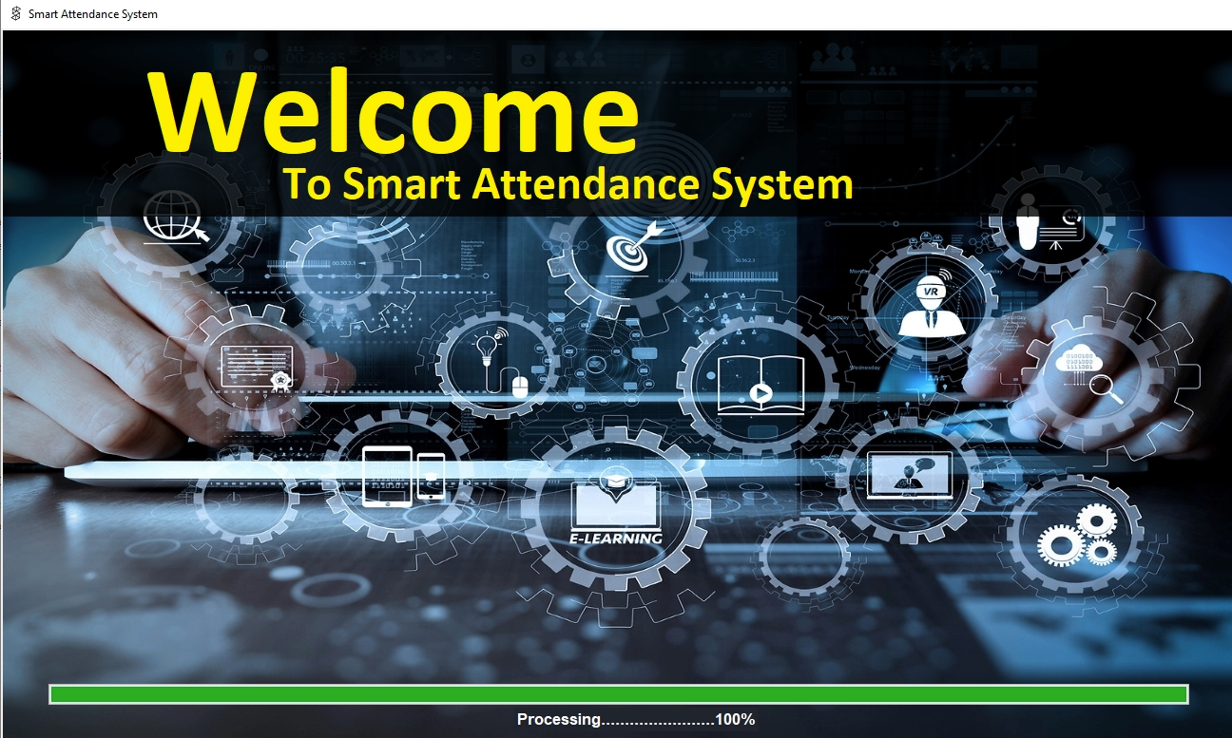

Front Page

* **TEACHER LOGIN PAGE:**

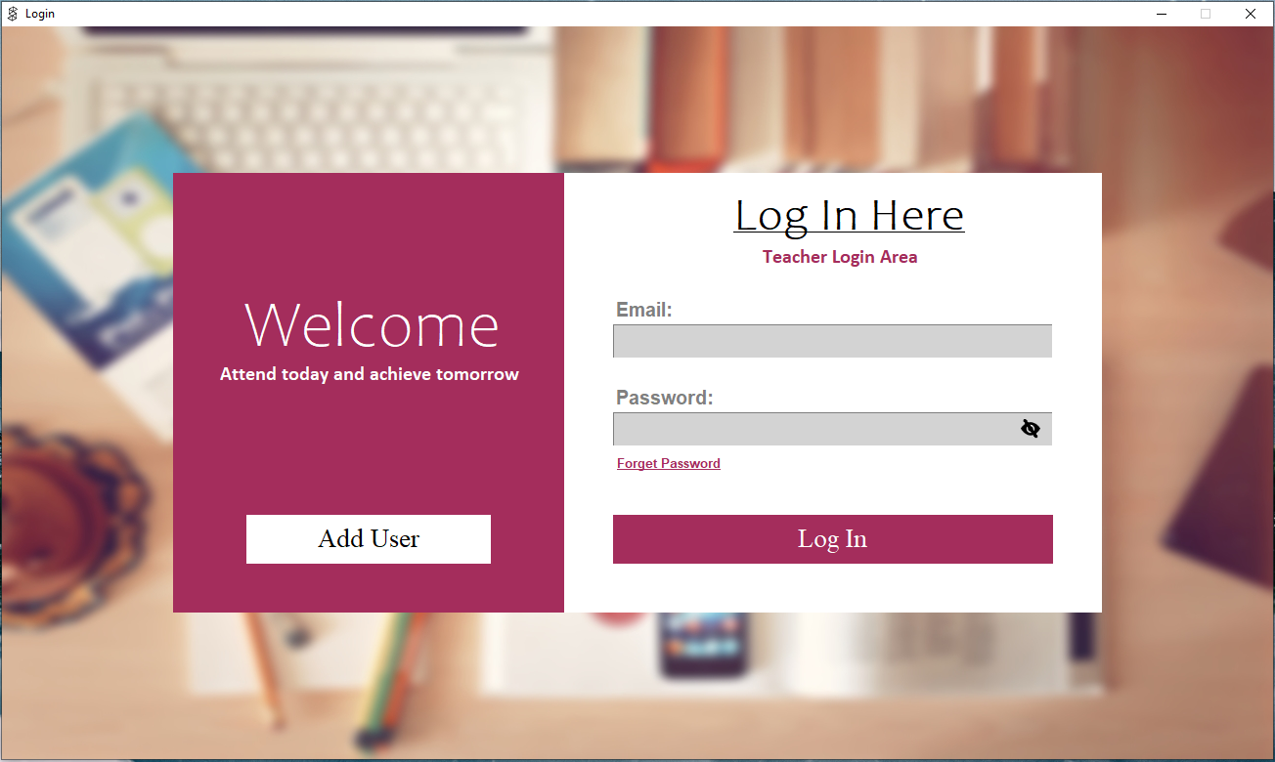

Login Page

* **FORGOT PAGE:**

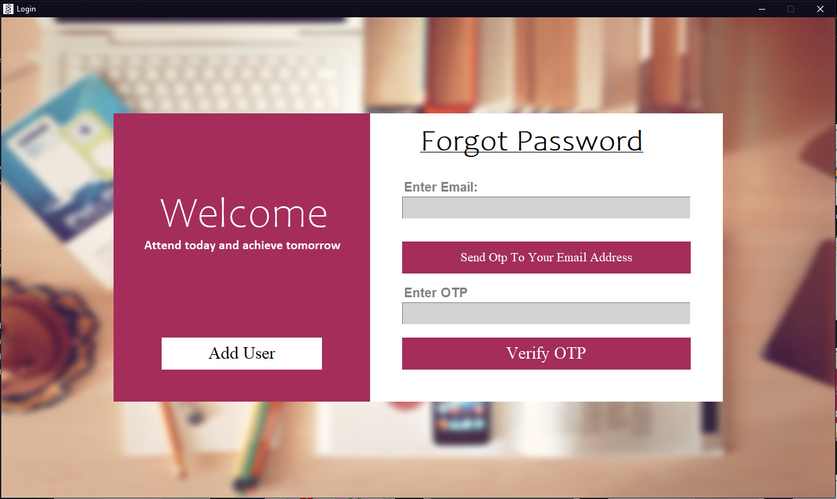

Forgot Password Page

* **ADD USER:**

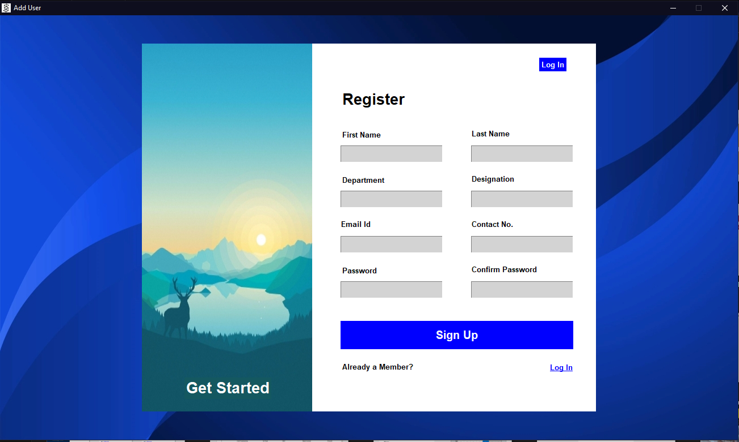

Add New User

* **TEACHERS DASHBOARD:**

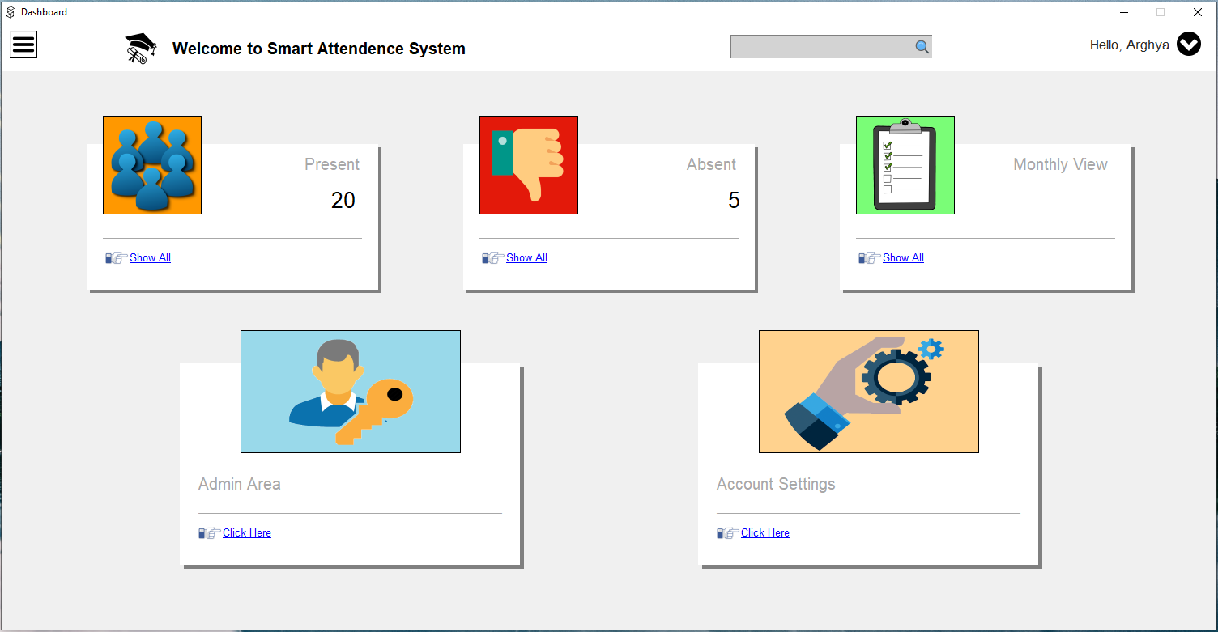

Teachers dashboard pages

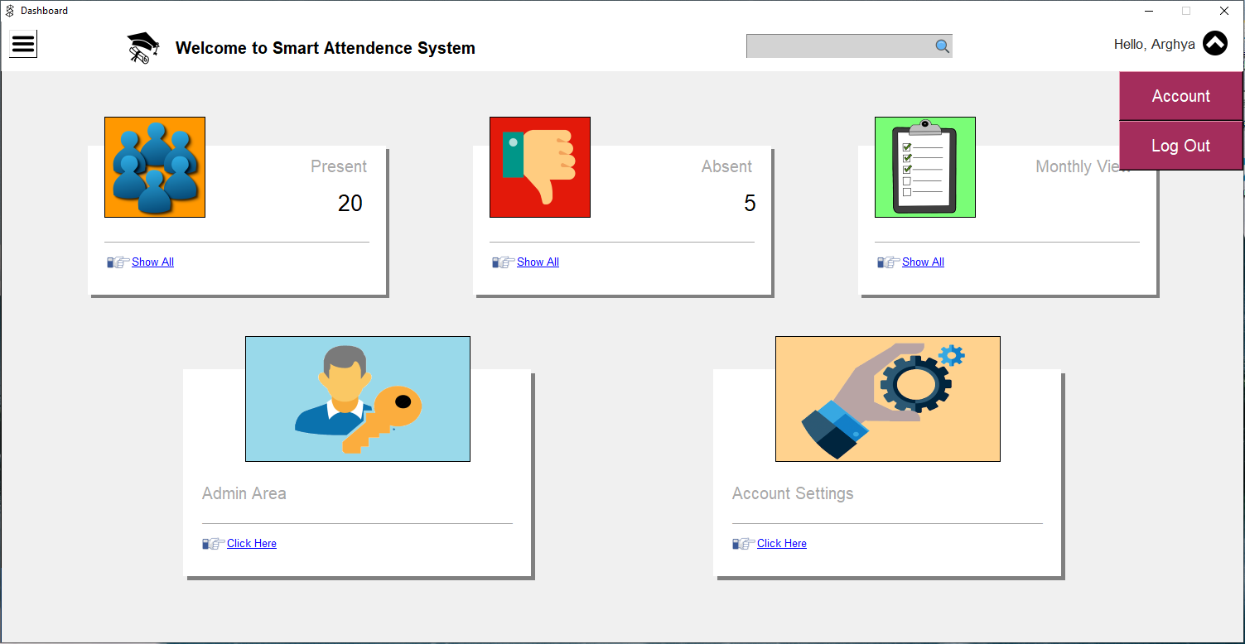

Account and Log Out Options

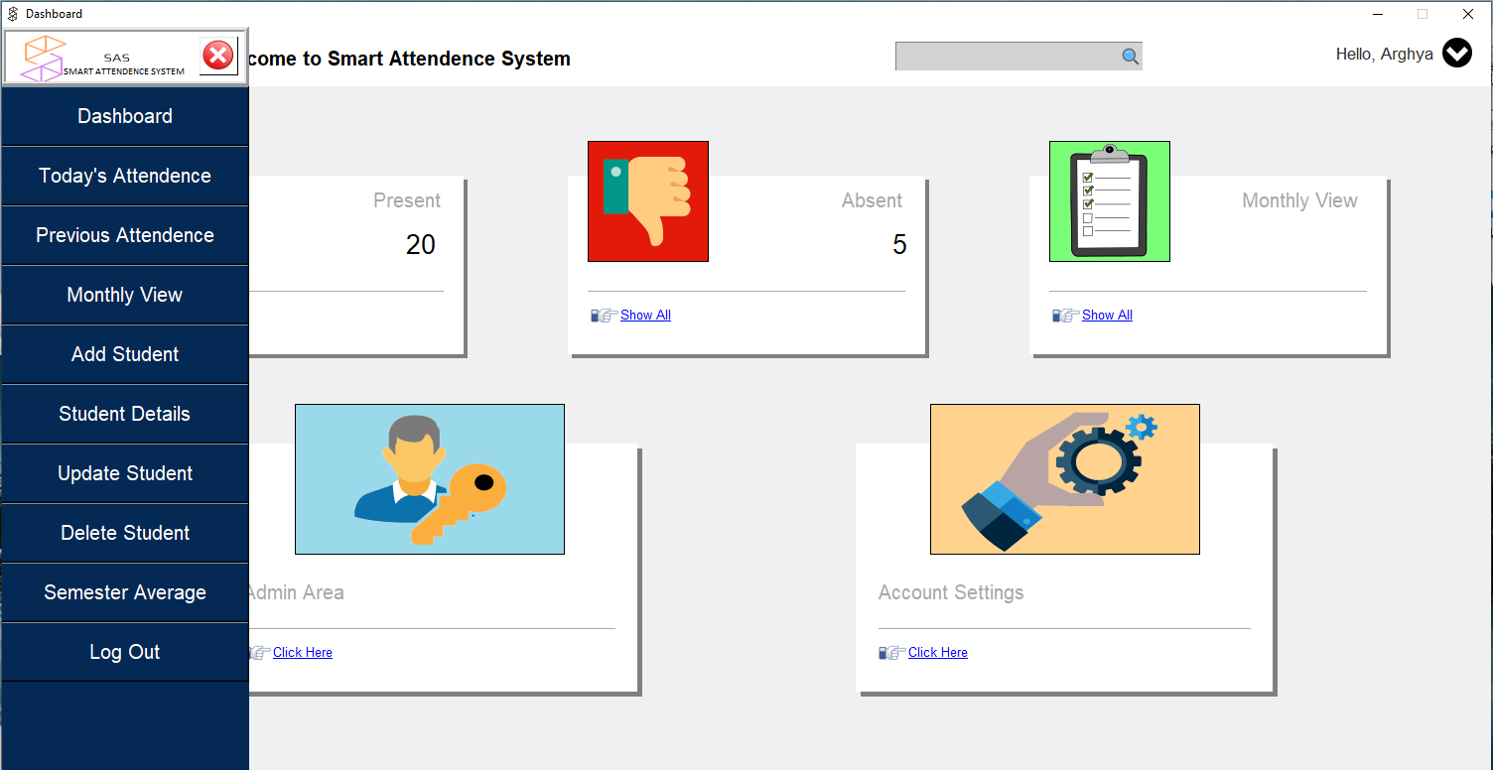

Teachers dashboard pages sidebar

* **PRESENT STUDENTS:**

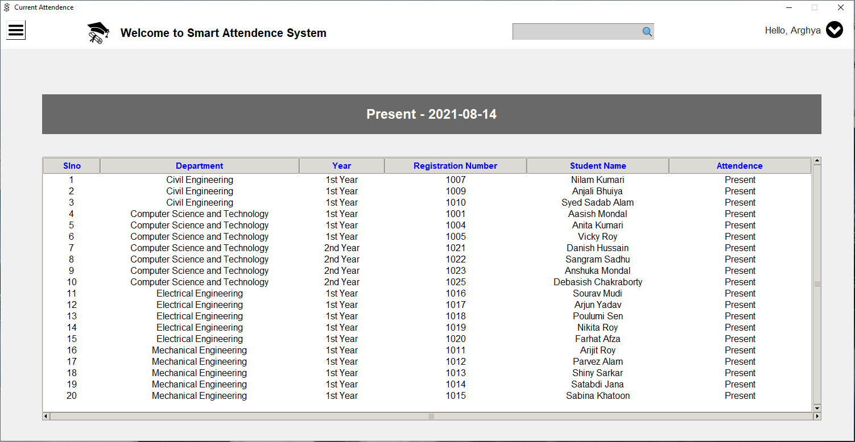

Present Students

* **ABSENT STUDENTS:**

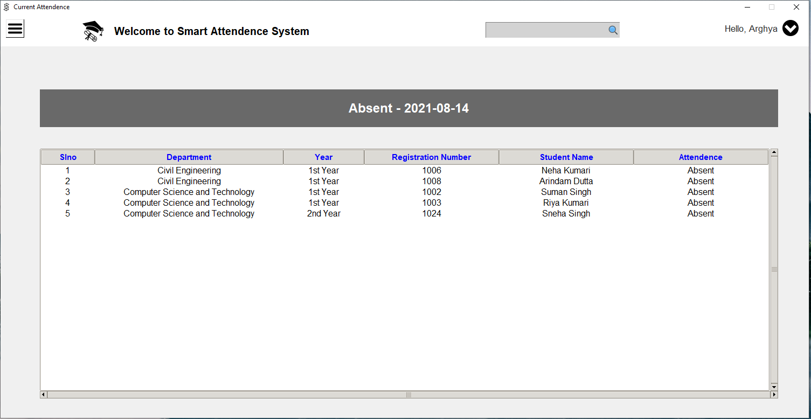

Absent Students

* **MONTHLY VIEW:**

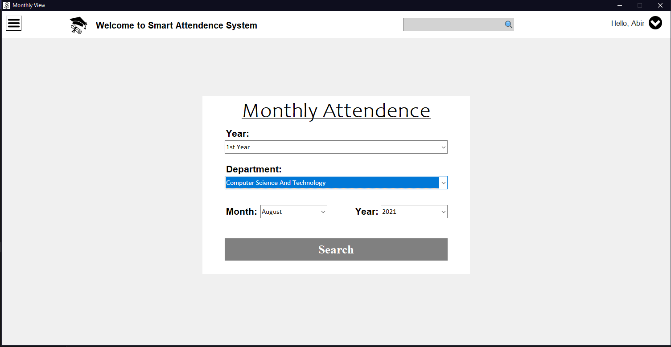

Monthly Attendance Search Students

**MONTHLY SEARCHED DATA:**

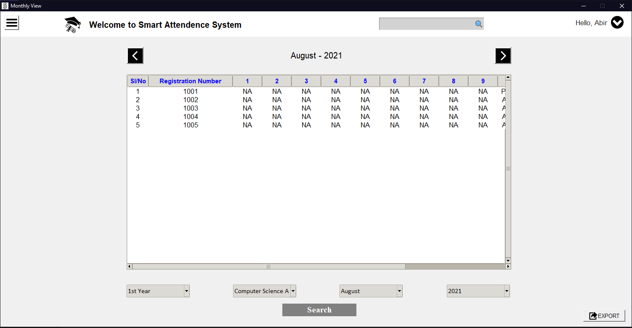

Monthly Searched Data

* **ADMIN AREA:**

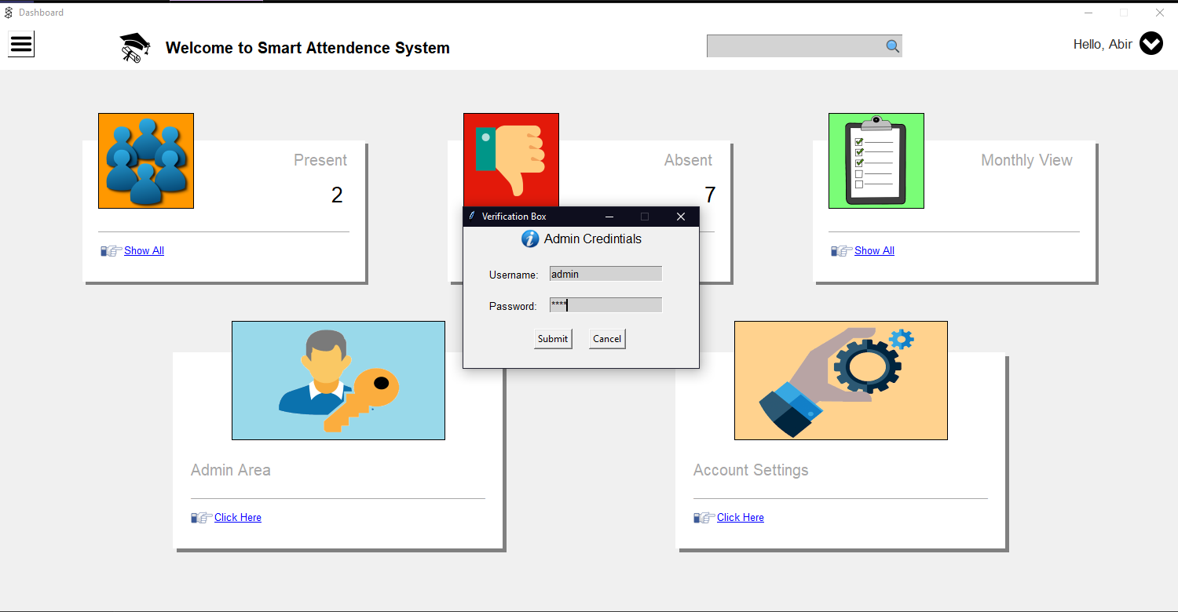

Admin Panel Verification Box

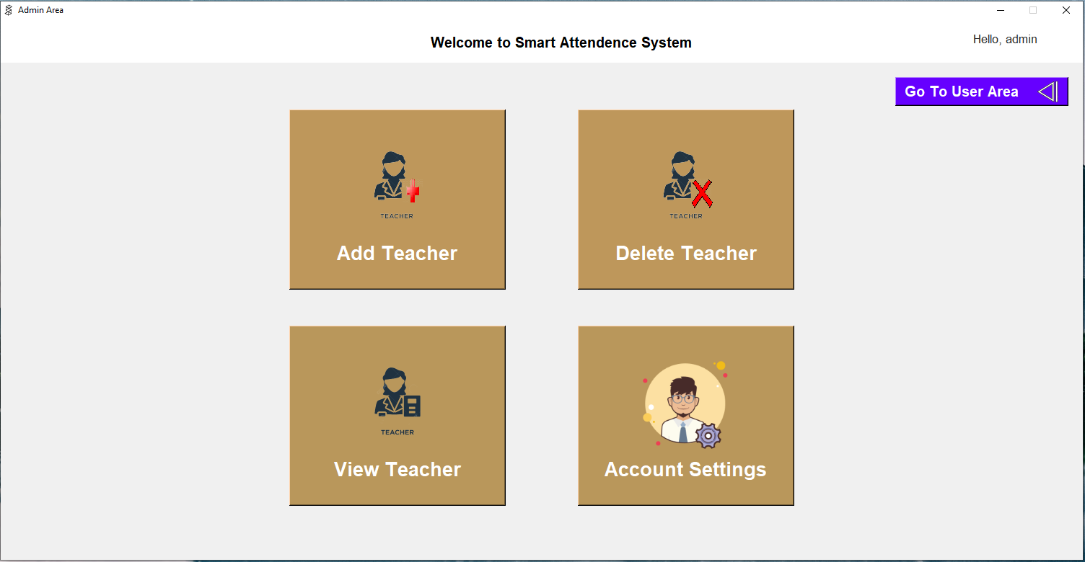

F

Admin Panel

* **ADD TEACHER:**

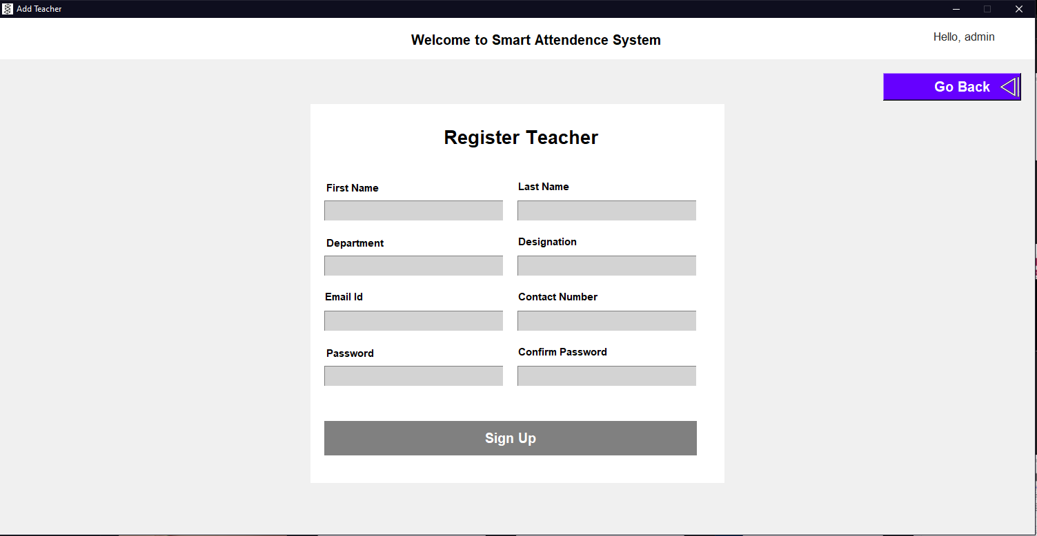

Add Teacher

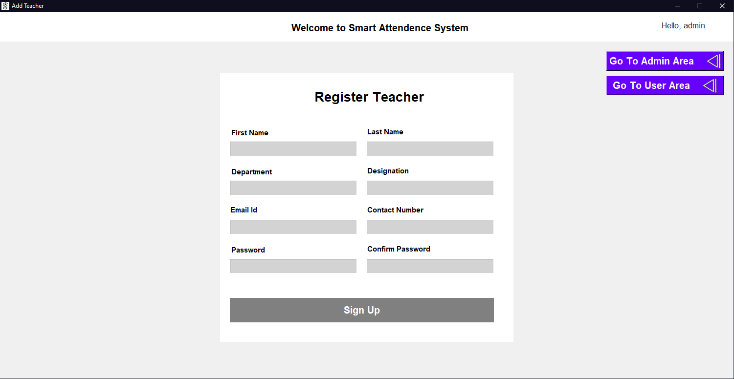

Add Teacher Page Options To Go Back

* **DELETE TEACHERS:-**

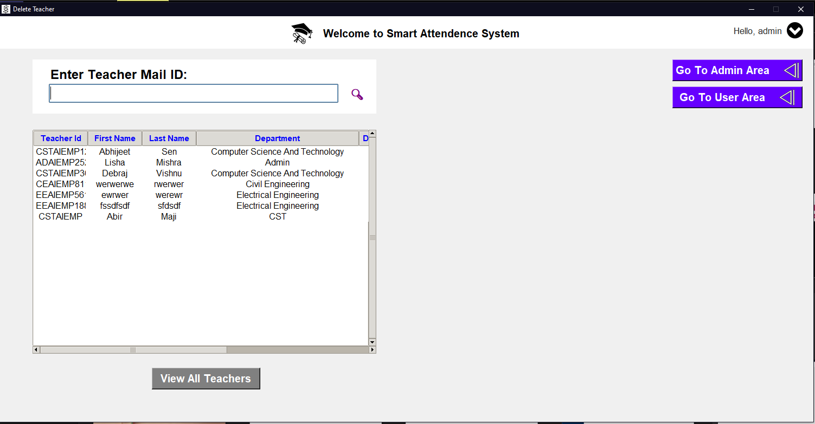

All Teachers Records

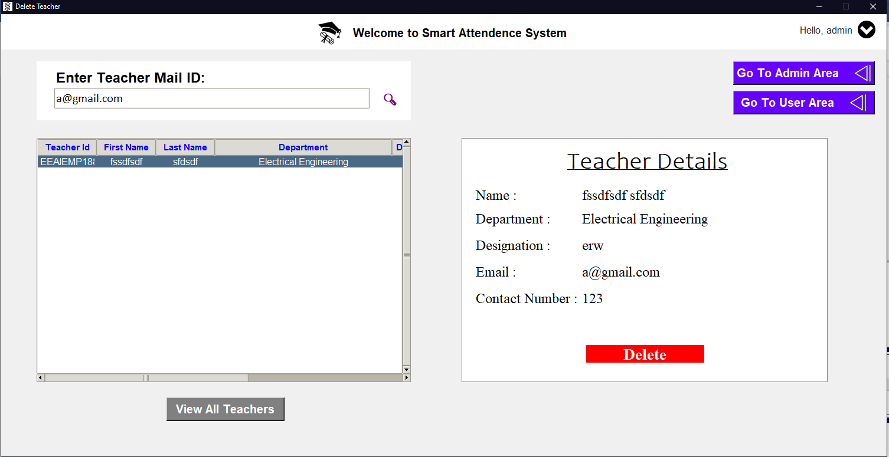

Searched Delete Teacher Data

* **VIEW TEACHER:**

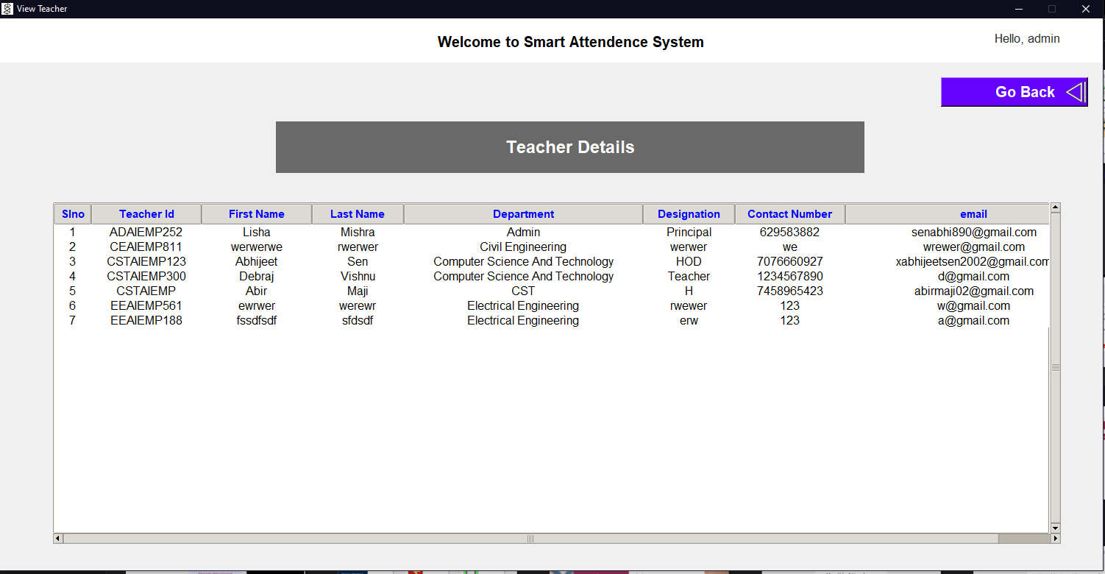

All Teacher’s Records

* **ADMIN ACCOUNT SETTINGS**|:

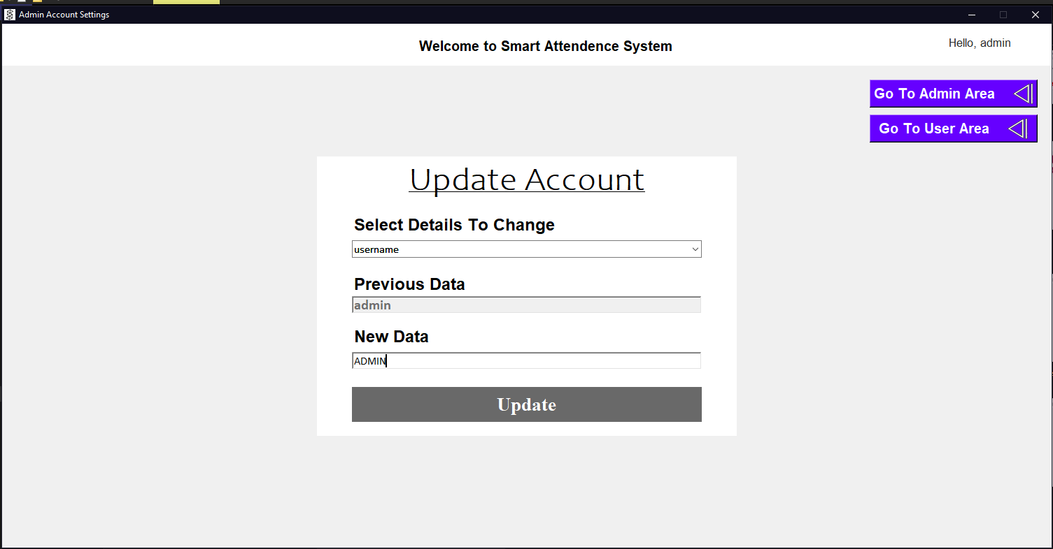

Update Admin Username OR Password

* **LOGINER ACCOUNT UPDATE:**

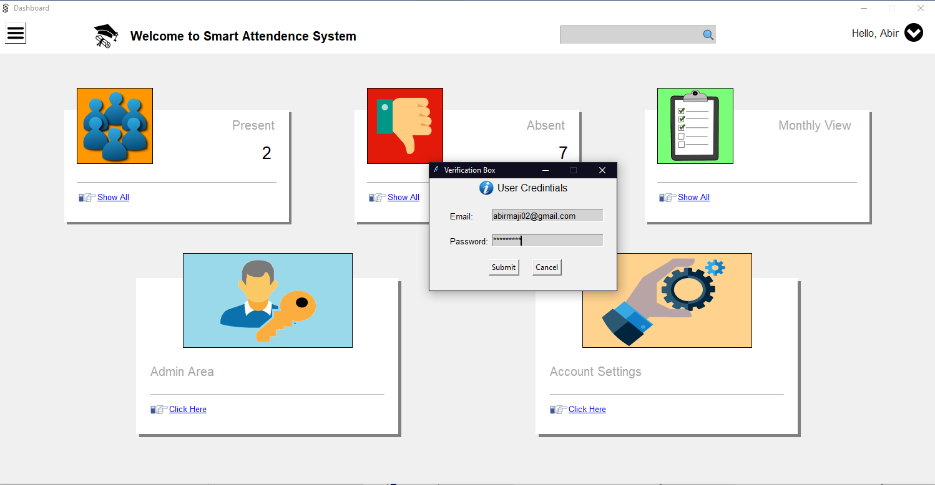

User’s Verification Box

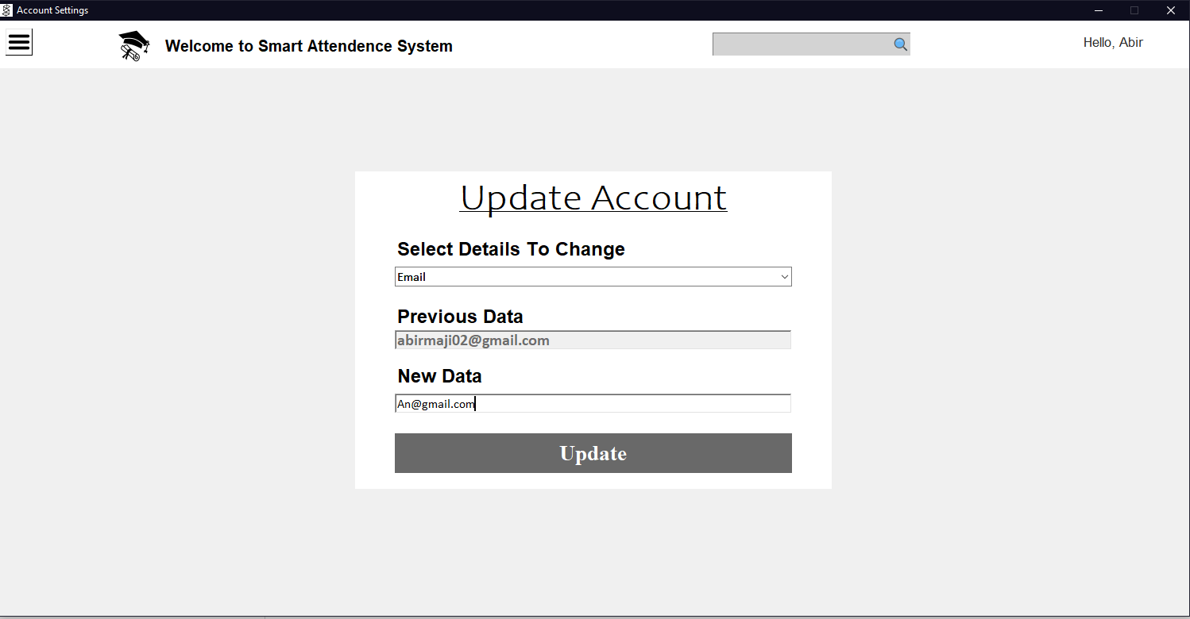

User’s account update

* **TODAY ATTENDENCE:**

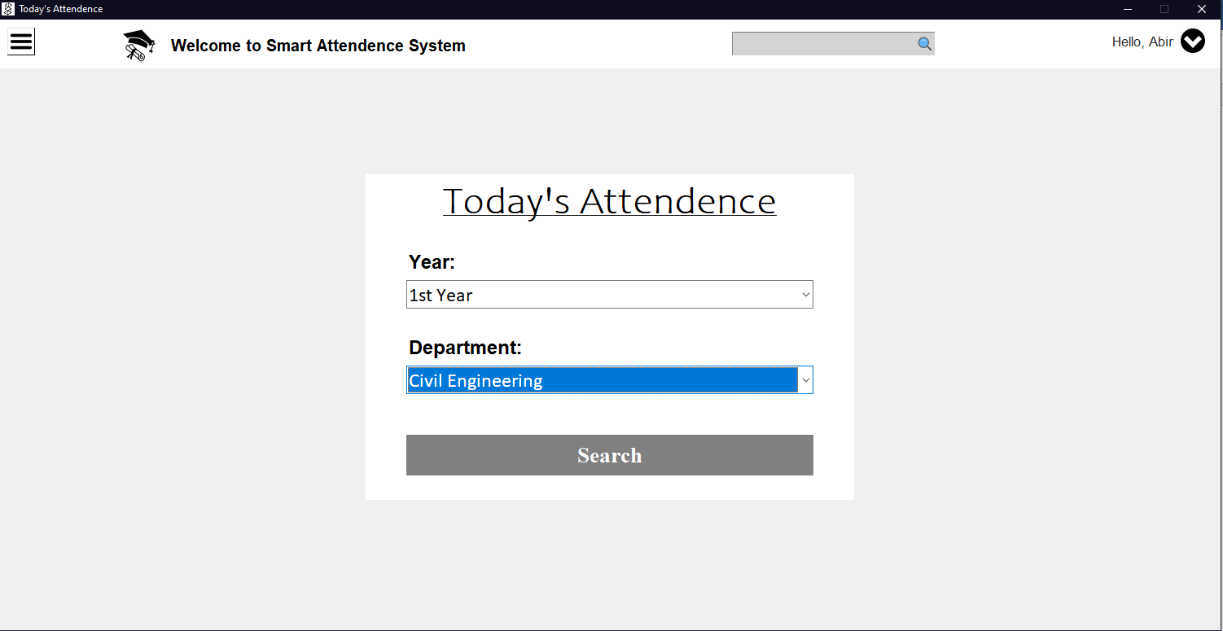

Search Box Today Attendance

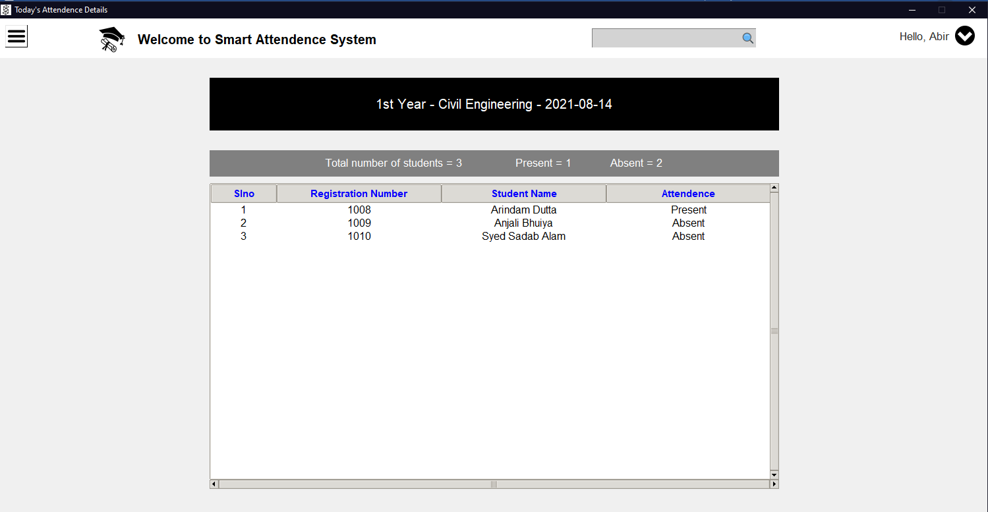

Todays Attendance Searched Data

* **PREVIOUS ATTENDANCE:**

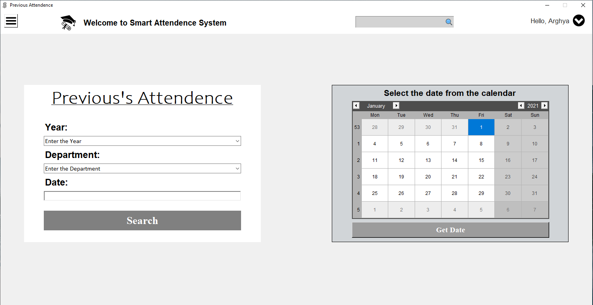

Search Using as per User Needed Date on Clicking Get Date

* **ADD STUDENTS DETAILS:**

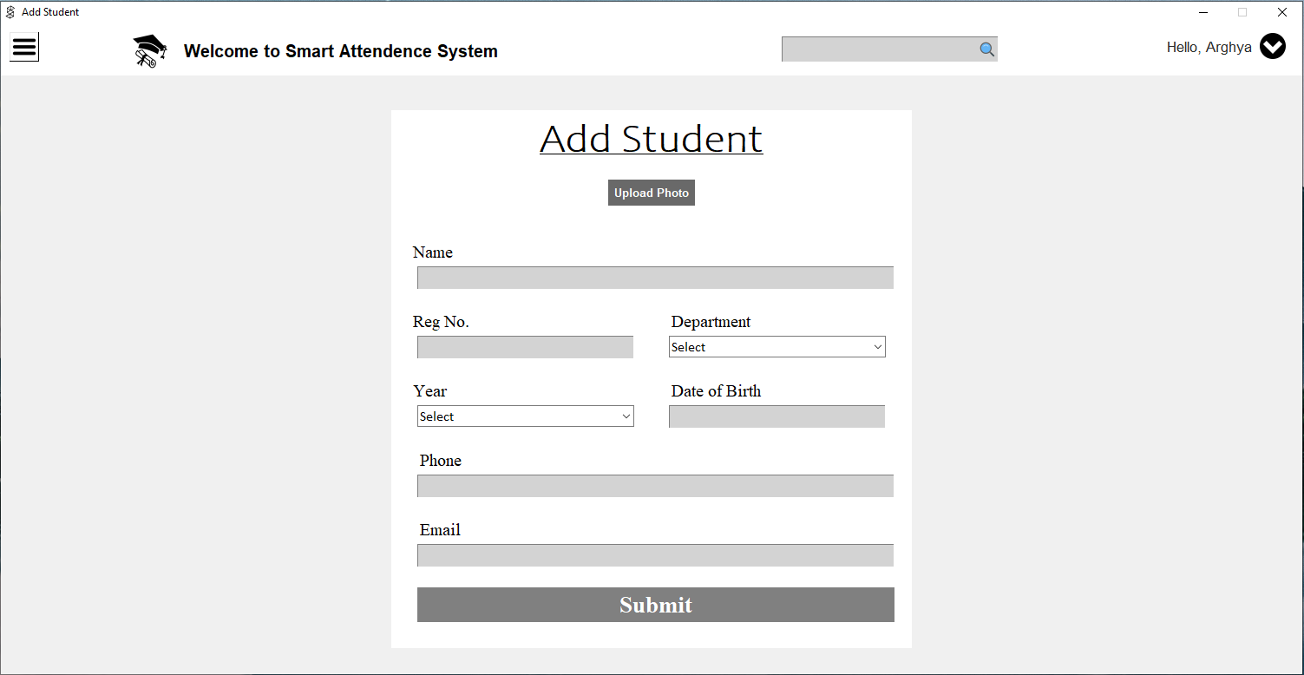

Add New Students Form

* **STUDENTS DETAILS:**

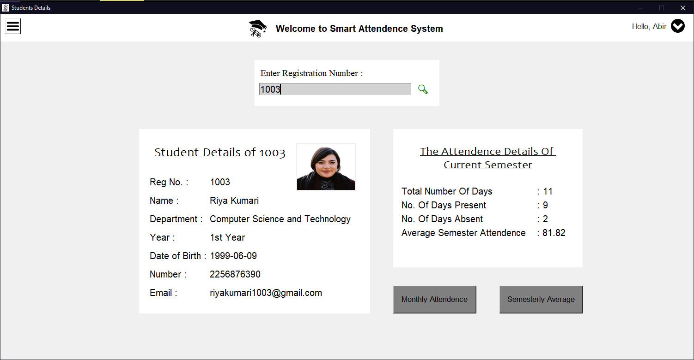

Searched Students Details

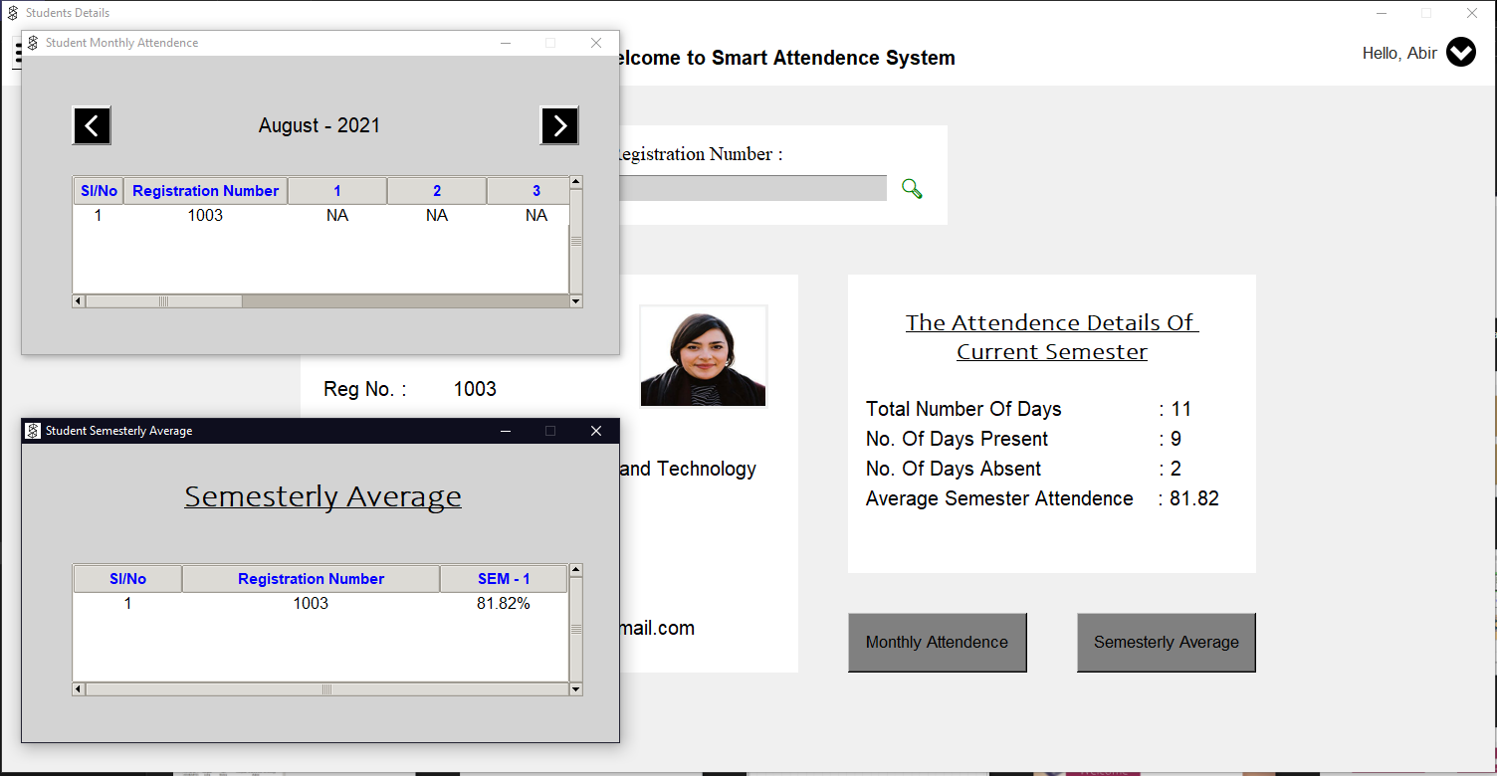

Searched Students Monthly & Semesterly Attendance

* **UPDATE STUDENTS RECORDS:**

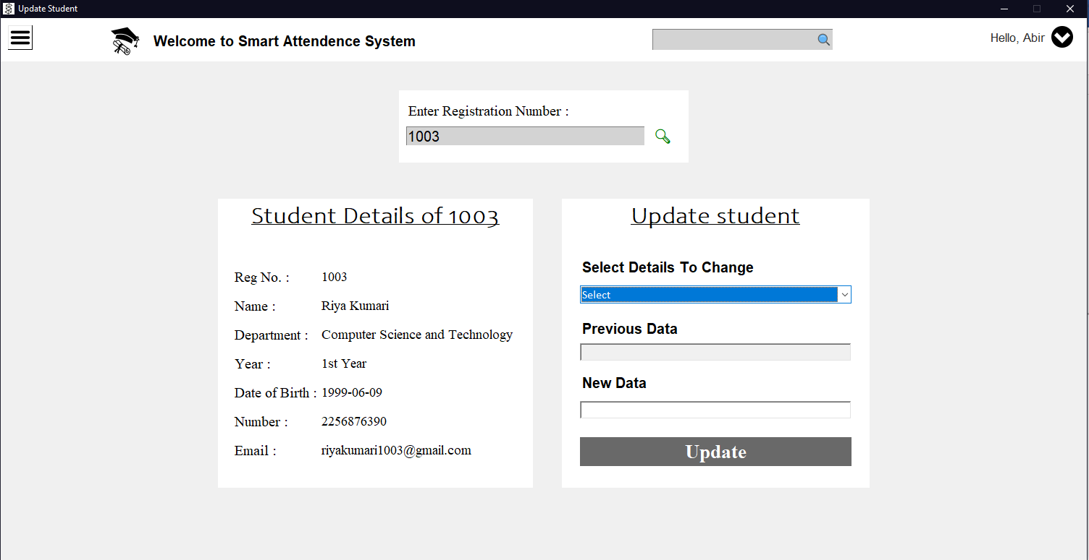

Update Students Details

* **DELETE STUDENTS:**

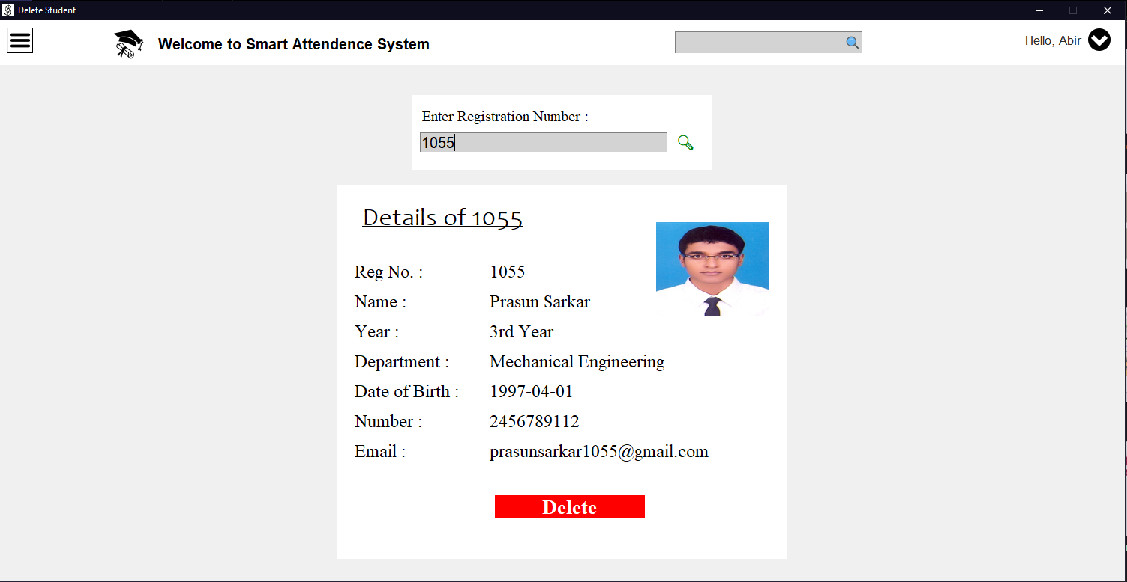

Delete Studentsdetails

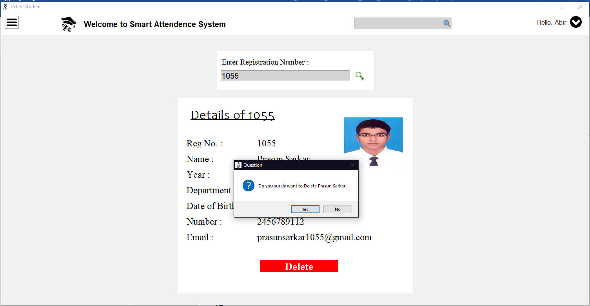

Warning Box

* **SEMESTER AVERAGE:**

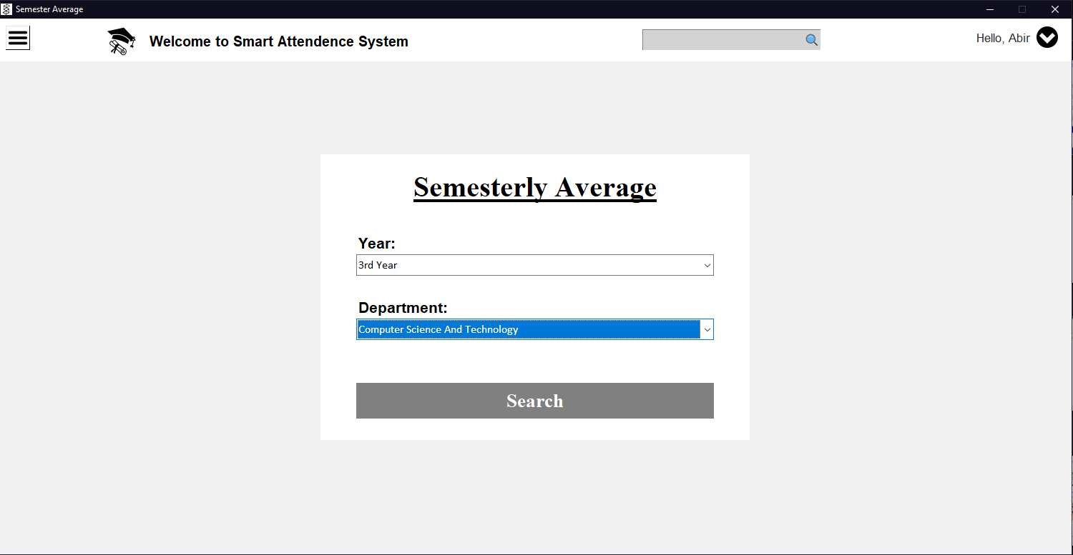

Search Department & Year Wise

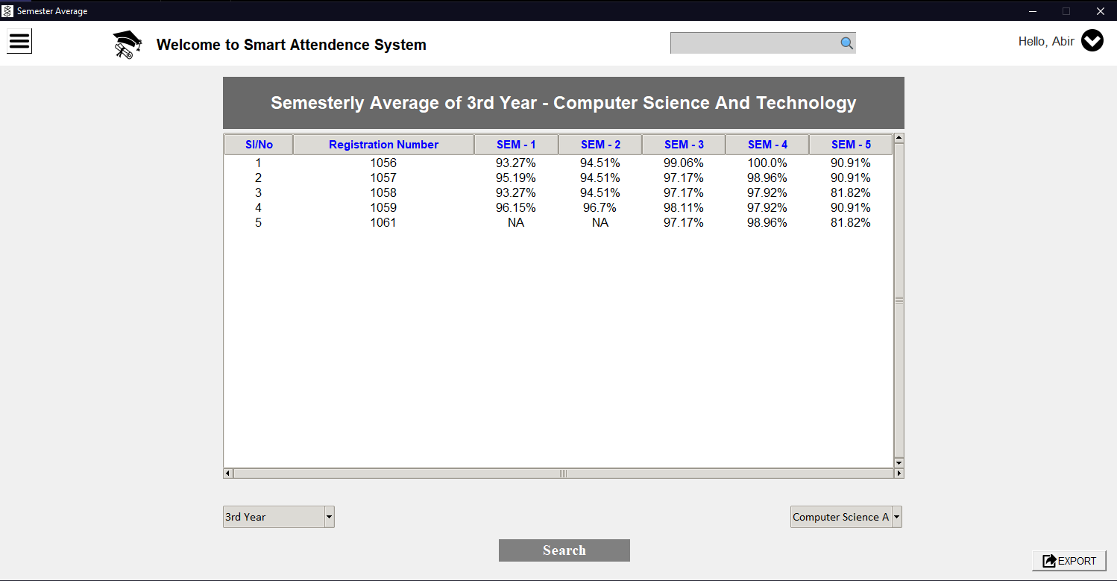

Search Semester Average

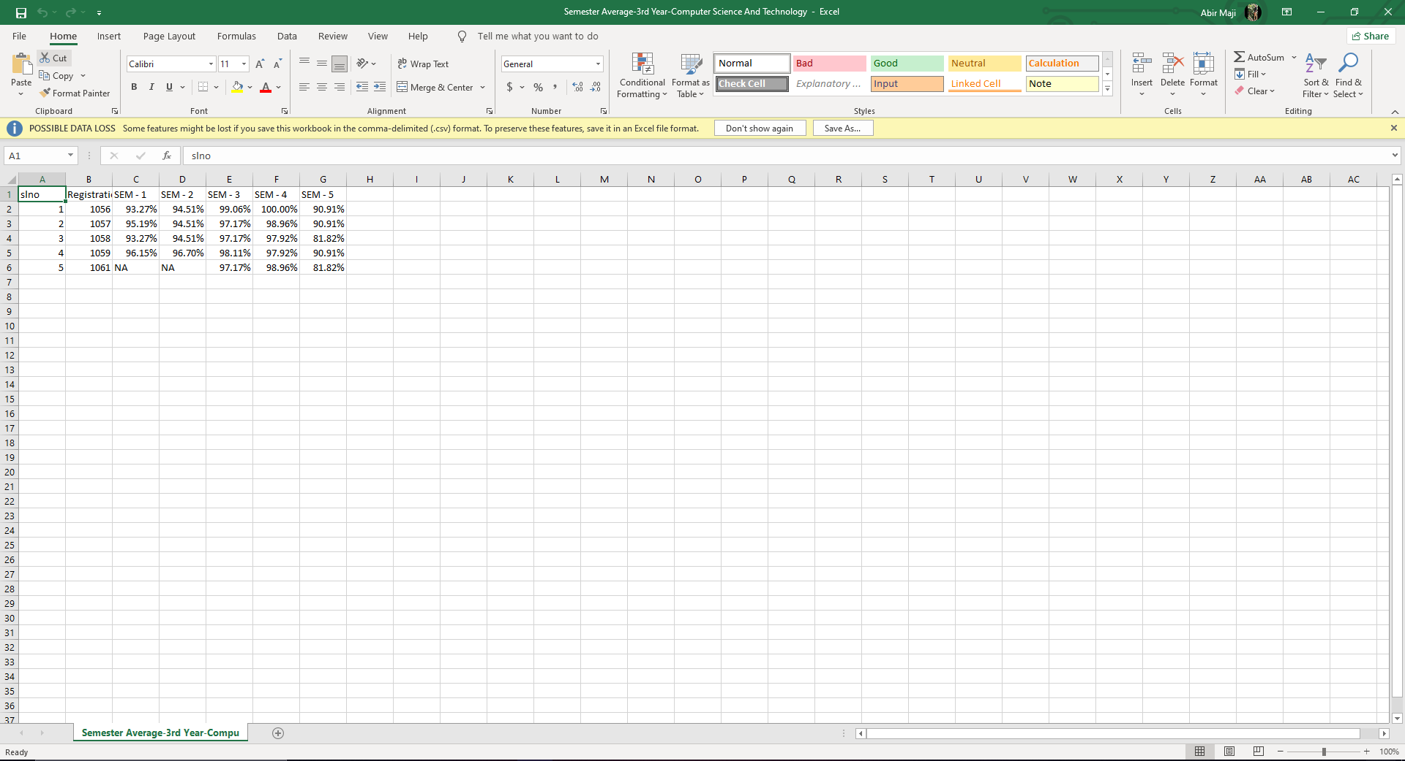

Exported Semester Average Excel Sheet

* **LOGOUT:**

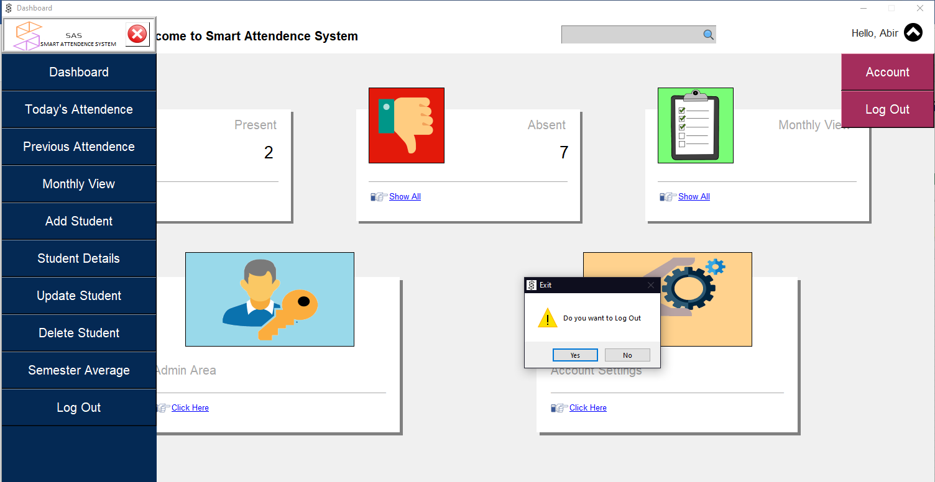

Logout Warning

***FACE RECOGNITION SOFTWARE***

* **FRONT PAGE:**



Front Page

* **STAFF LOGIN PAGE**:

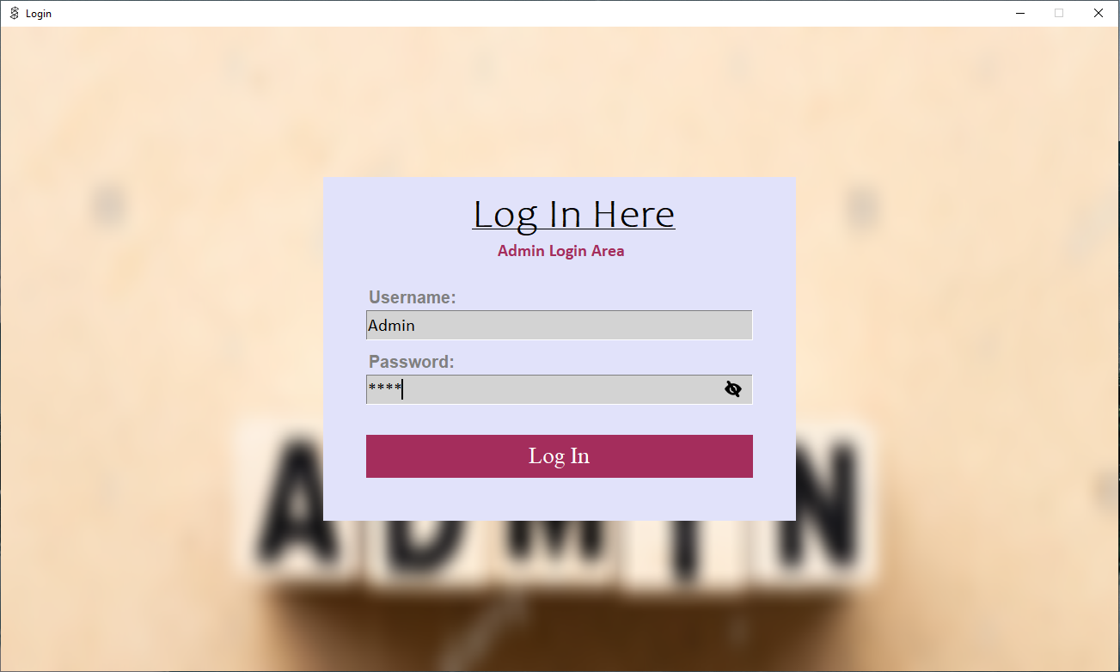

Staff Login

* **DASHBOARD:**

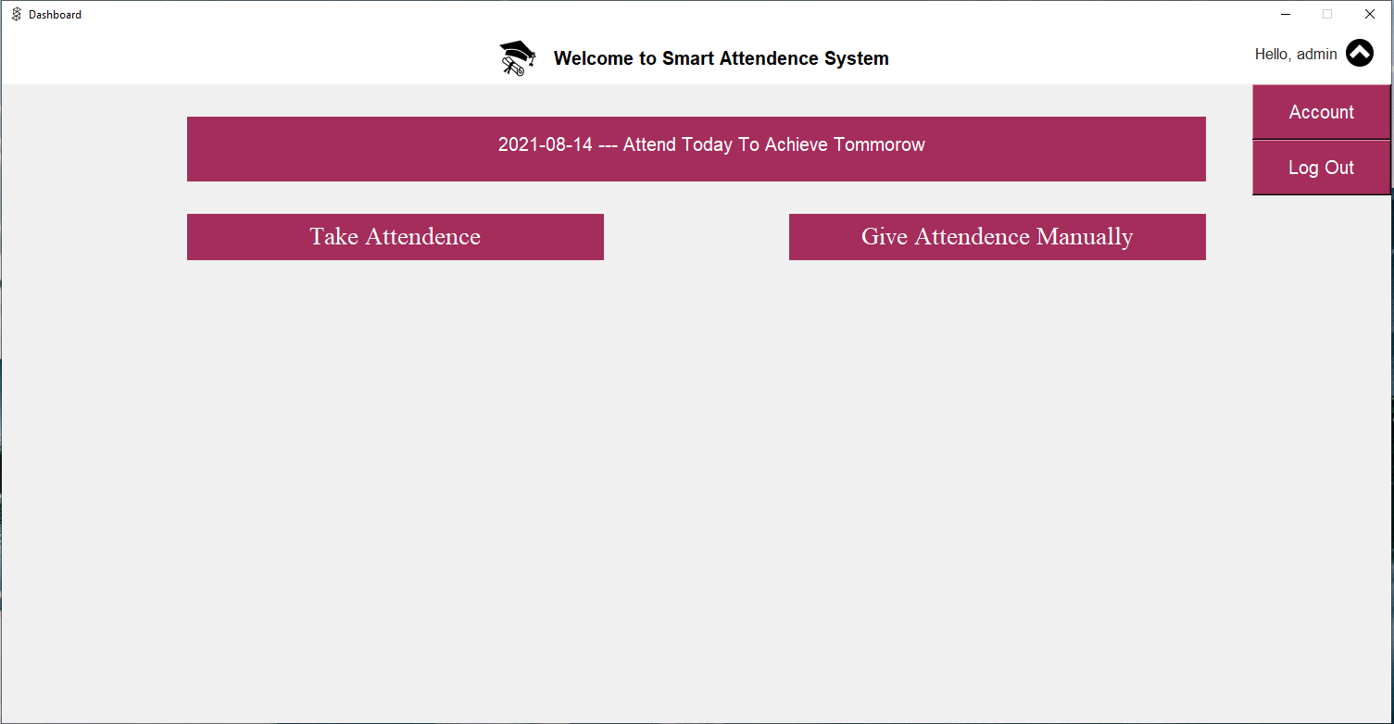

Dashboard

* **GIVE ATTENDANCE MANUALLY**:

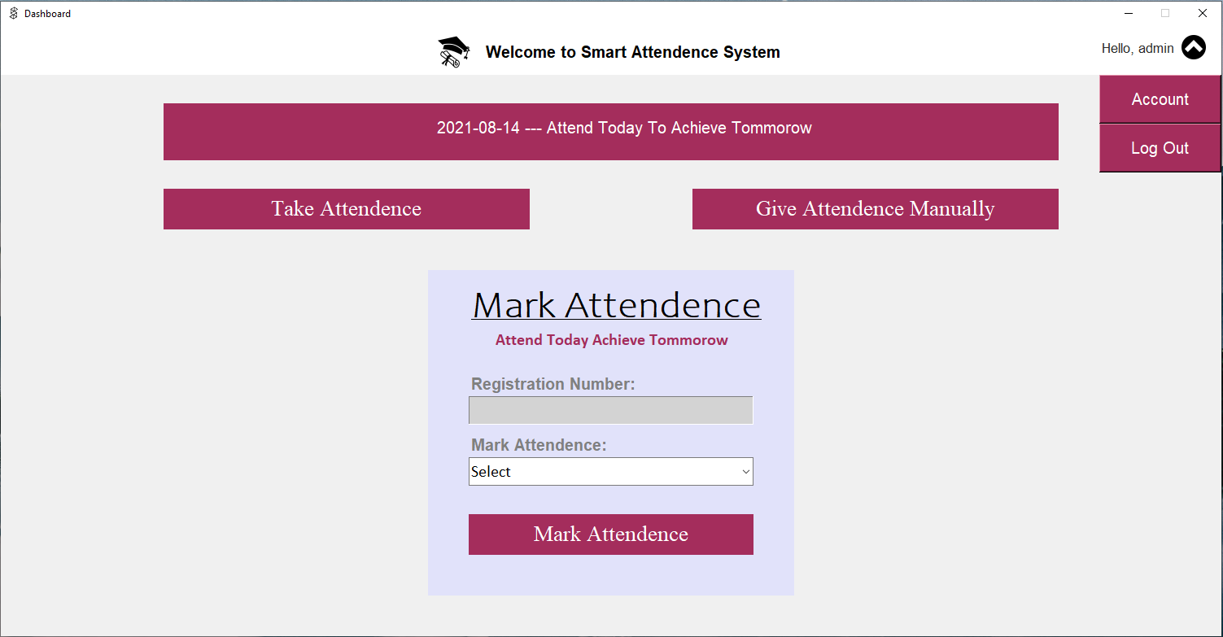

Give Attendance Manually

* **TAKE ATTENDANCE:**

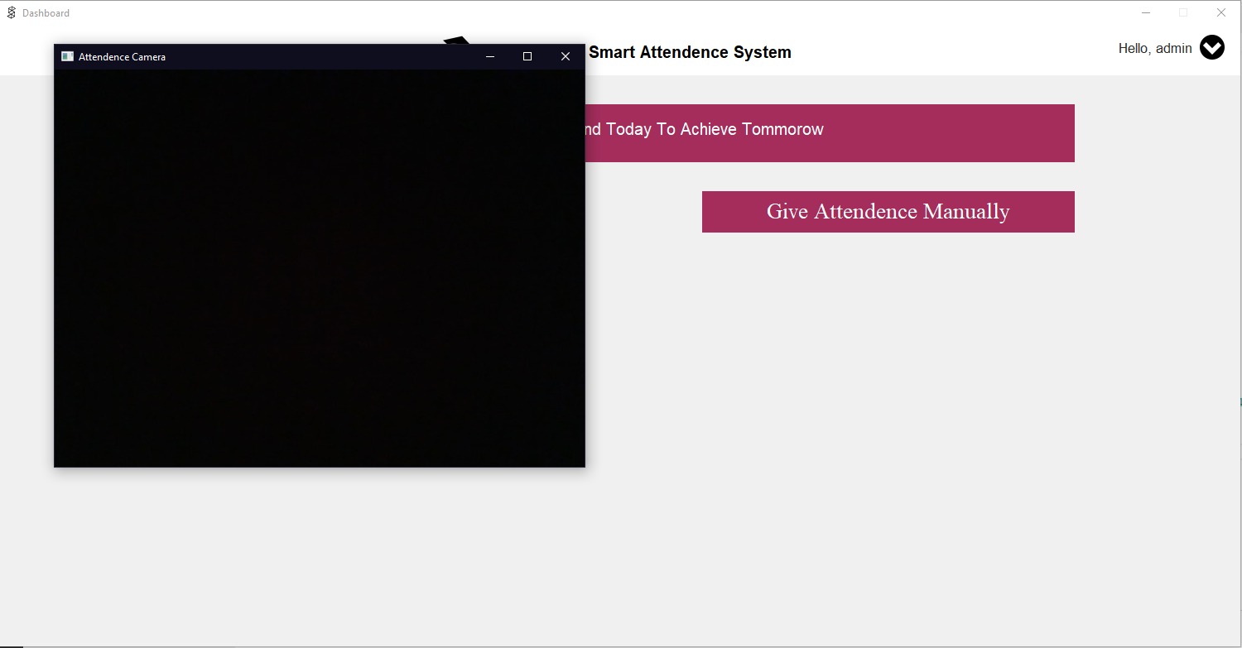

Taking Attendance using Face

**CHAPTER 10**

***REFERENCES***

**WEBSITES:-**

* [**https://www.geeksforgeeks.org/**](https://www.geeksforgeeks.org/)
* [**https://github.com/**](https://github.com/)
* [**https://www.youtube.com/**](https://www.youtube.com/)